A Generic Container
The purpose of this exercise is to make the star container developed previously a generic package for further re-use.
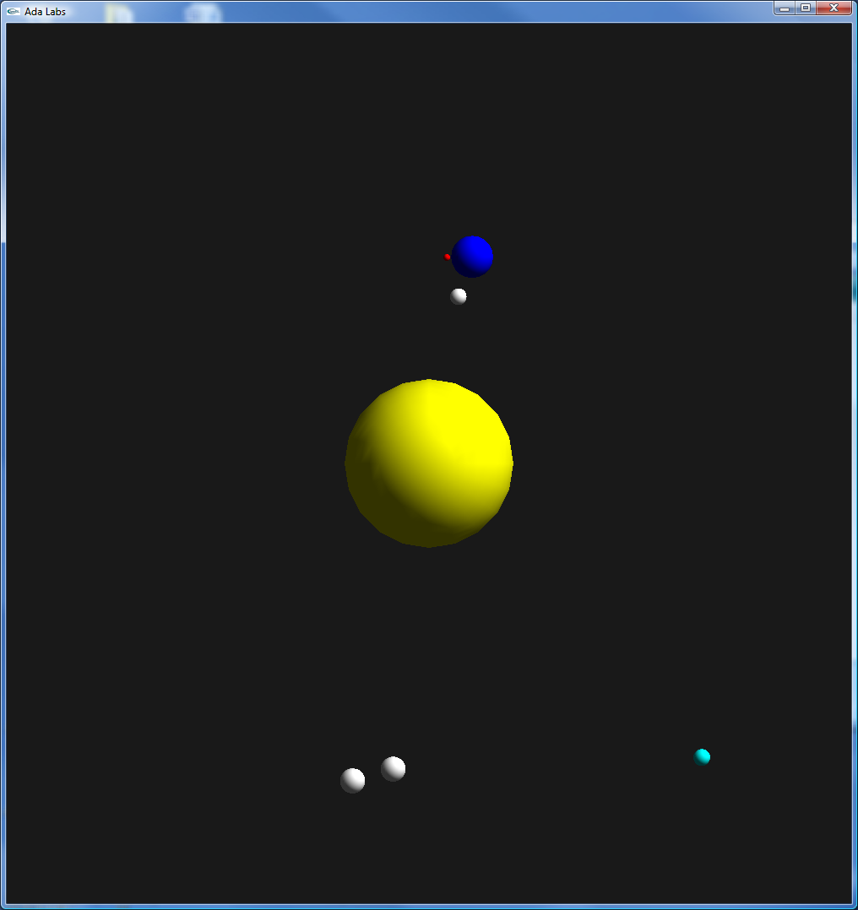 | Question 1  Look at the package Stars.Systems. The same kind of implementation could be used to store different kind of objects, not only stars. Create a generic package Containers based on the code of Stars.Systems, but which is using as formal parameters Object_Type (object contained in the container), Object_Access (a pointer to the objects of the container), No_Object (a constant identifying an invalid object) and Default_Object (a pointer to a default object).  Question 2  Replace Stars.Systems by an instance of Containers.

