

Practices for Secure Software Report

Table of Contents
Document Revision History 3
Client 3
Instructions 3
Developer 4
1. Algorithm Cipher 4
2. Certificate Generation 4
3. Deploy Cipher 5
4. Secure Communications 5
5. Secondary Testing 5
6. Functional Testing 6
7. Summary 7
8. Industry Standard Best Practices 7

Document Revision History

Version | Date | Author | Comments
1.0 | October 18, 2026 | Esteban Garcia | Completed report

Client



Instructions

Submit this completed practices for secure software report. Replace the bracketed text with the relevant information. You must document your process for writing secure communications and refactoring code that complies with software security testing protocols.

- Respond to the steps outlined below and include your findings.
- Respond using your own words. You may also choose to include images or supporting materials. If you include them, make certain to insert them in all the relevant locations in the document.
- Refer to the Project Two Guidelines and Rubric for more detailed instructions about each section of the template.

Developer
Esteban Garcia

Algorithm Cipher

For this application, I recommend TLS 1.3 with AES-256-GCM for the connection and SHA-256 for the data checksum. They solve different problems: AES-GCM encrypts and authenticates traffic, while SHA-256 makes a 256-bit digest that can be compared with a trusted expected value; hashing does not encrypt the text. My local handshake selected TLS_AES_256_GCM_SHA384 with X25519 key exchange and an RSA certificate, while the Java endpoint separately used SHA-256 for the sample data (Rescorla, 2018; National Institute of Standards and Technology [NIST], 2015). TLS derives fresh symmetric traffic keys from the key exchange and uses random values and nonces managed by the Java TLS provider. The certificate uses an asymmetric 3072-bit RSA key to identify the local server, not to encrypt every response. AES and SHA-2 are sensible current choices compared with older DES/3DES and MD5 or SHA-1. I used the platform cryptography instead of inventing those details in application code. A digest sent beside untrusted data would not establish who sent it, so this demonstration checks against a known expected digest and uses TLS to protect the connection.

Certificate Generation
I generated a 3072-bit RSA self-signed certificate with Java Keytool, signed it with SHA256withRSA, and exported the public certificate as certificates/artemis-localhost.cer. The subject and subject alternative name are for localhost and 127.0.0.1. Keytool confirmed the CER file, dates, signature, and fingerprint shown below. This certificate is appropriate for a local demonstration, but a production browser would need a certificate chained to a trusted authority (Oracle, n.d.).

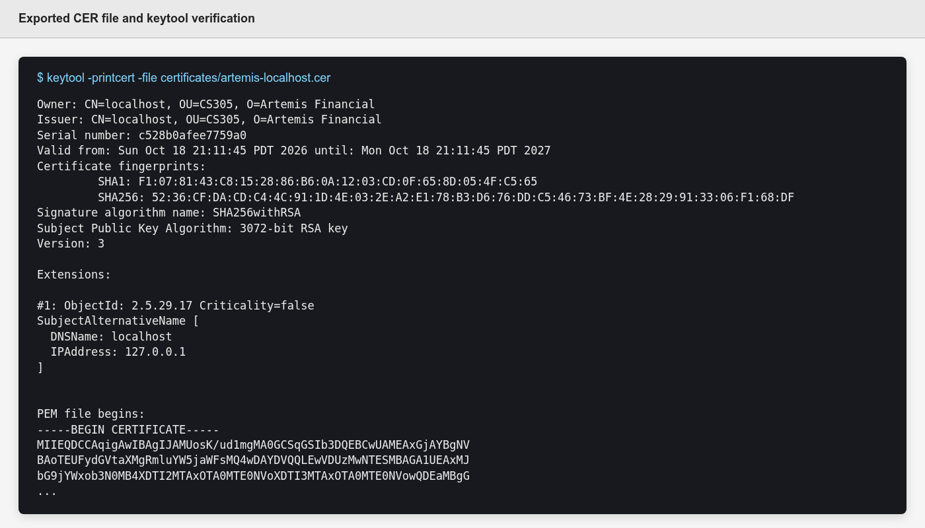

Deploy Cipher
HashController.java hashes the UTF-8 bytes of a fixed string containing my name, the course project, and Artemis Financial. The endpoint displays the 64-character SHA-256 checksum and compares the computed bytes with the stored expected digest using MessageDigest.isEqual. The result is PASS for the original string. A unit test changes the string and confirms that the same expected digest no longer verifies, which checks the logic instead of only printing a hash.

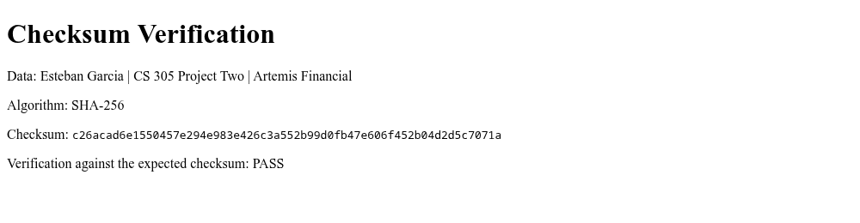

Secure Communications
I replaced the placeholder settings in application.properties with an HTTPS listener on port 8443, the PKCS12 keystore path and alias, and a password read from SSL_KEYSTORE_PASSWORD. The browser screenshot below shows the /hash page at https://localhost:8443 with my name, the SHA-256 checksum, and a PASS result. Its address bar still says "Not Secure" because the self-signed certificate is not trusted by that browser. I also tested the endpoint with curl using the exported CER as the trusted certificate; that request returned HTTP 200, verified localhost, and negotiated TLS 1.3 with TLS_AES_256_GCM_SHA384. The local connection can be validated when the certificate is explicitly trusted, but the browser screenshot does not show public CA trust.

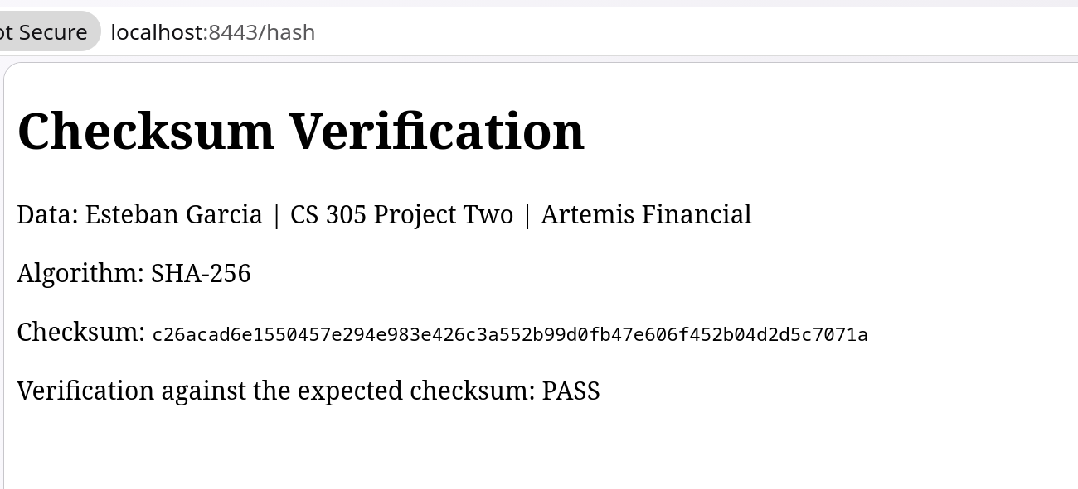

Secondary Testing
I reran OWASP Dependency-Check 13.0.0 after refactoring and compared the artifact/CVE list with the saved baseline. Both reports show 14 vulnerable dependency entries and 254 finding references, with no new artifact or CVE; the new code added no Maven library. Older Spring Boot 2.2.4 dependencies such as SnakeYAML 1.25 and Tomcat 9.0.30 remain flagged, so this is not a clean bill of health. The cached NVD data was last modified September 13, 2026, and needs a fresh online scan before deployment. The full secondary report is attached.

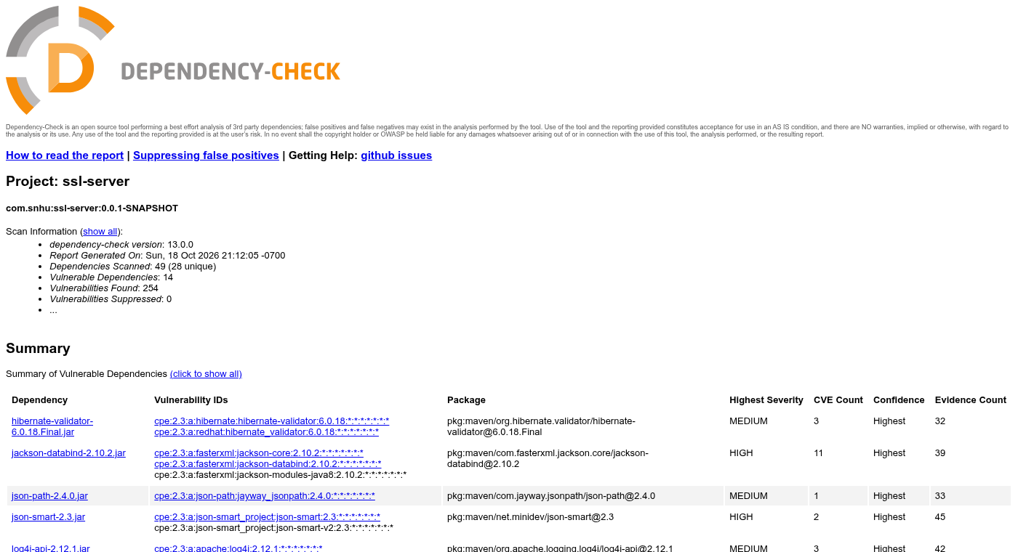

Functional Testing
Manual review found no syntax error in the starter Java class, but the app had no /hash route and its SSL settings still contained unresolved placeholders. I added a fixed-string controller, configured HTTPS, and kept the demonstration password out of the properties file. Maven ran three tests without errors: context startup, a known digest, and rejection of altered data. I also checked the live endpoint over HTTPS. Before production, the team still needs a CA-issued certificate, access controls if customer data is exposed, and dependency upgrades.

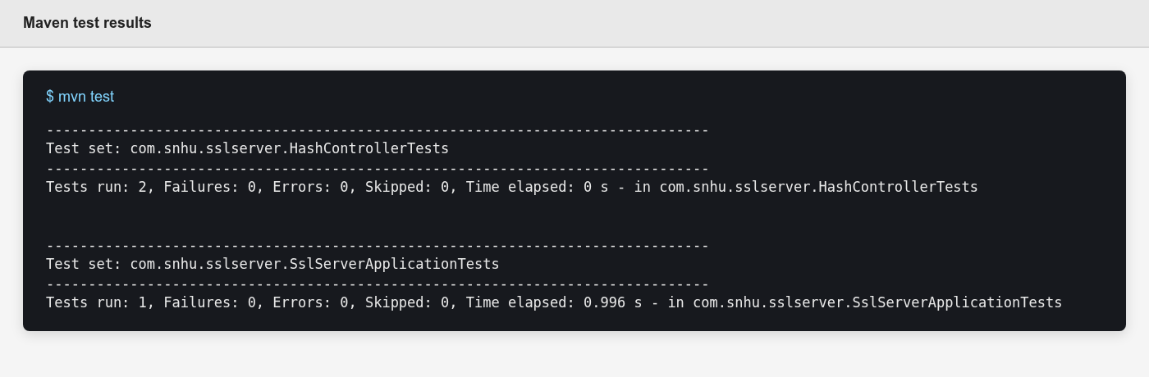

Summary

The refactor adds a checksum check in HashController.java, HTTPS settings in application.properties, a local PKCS12 keystore and exported CER file, focused tests, and an updated Dependency-Check plug-in in pom.xml. Using the assessment process flow, the relevant areas were Architecture Review, Cryptography, Client/Server, APIs, Code Error, Code Quality, and controller and plug-in code review. I did not claim data-access or input-validation changes because this sample has no database and the new endpoint hashes only a fixed string. The layers are a reproducible digest comparison, encrypted transport, functional tests, and a second dependency scan. This works as a local security demonstration, but the self-signed certificate and existing library findings keep it from being ready for a public financial application.

Industry Standard Best Practices

I used Java's standard MessageDigest and TLS implementation rather than a custom cipher, encoded the data as UTF-8, checked the expected digest with a timing-safe comparison, and avoided placing the keystore password directly in the properties file. The endpoint also sends Cache-Control: no-store and does not accept or display customer input. The negative test, live HTTPS request, and before/after dependency scans gave me different ways to catch a coding or configuration mistake. These practices reduce the chance that a small feature introduces a new weakness, but they do not erase the vulnerabilities already present in the older dependency tree. For a real deployment, the team should replace the demo key, use a CA-issued certificate, protect secrets outside the project archive, and upgrade affected libraries (OWASP Foundation, n.d.).

References
National Institute of Standards and Technology. (2015). Secure Hash Standard (FIPS PUB 180-4). https://csrc.nist.gov/pubs/fips/180-4/upd1/final
Oracle. (n.d.). The keytool command. https://docs.oracle.com/en/java/javase/17/docs/specs/man/keytool.html
OWASP Foundation. (n.d.). Cryptographic storage cheat sheet. https://cheatsheetseries.owasp.org/cheatsheets/
Cryptographic_Storage_Cheat_Sheet.html
Rescorla, E. (2018). The Transport Layer Security (TLS) Protocol Version 1.3 (RFC 8446). https://www.rfc-editor.org/rfc/rfc8446

