HW1.R

Usuario

2023-05-25

#Esteban  
#25/02/2023  
# Tarea 1. Primer análisis en R  
  
# PARTE 2. Problemas ----------------------------------------------------  
  
  
# Problema 1  
  
Pinus <- 3140  
Mezquite <- 1453  
Encinos <- 450  
Teka <- 1200  
Juiperos <- 720  
  
superficie <- c(Pinus, Mezquite, Encinos, Teka, Juiperos)   
  
barplot(superficie)

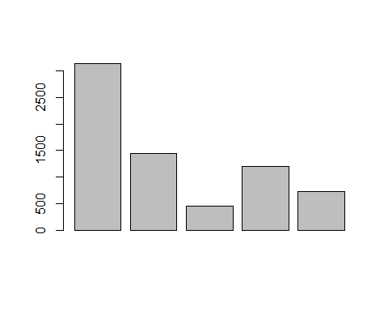

sort(superficie)

## [1] 450 720 1200 1453 3140

barplot(sort(superficie, decreasing = TRUE))

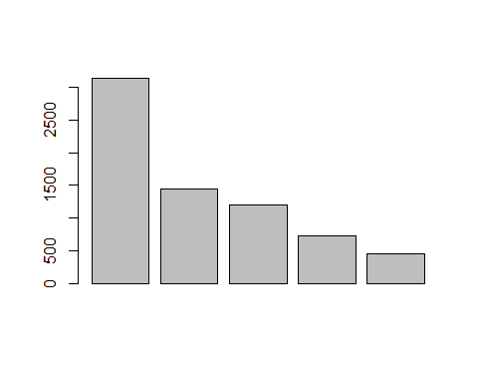

mean(superficie)

## [1] 1392.6

# Problema 2  
  
cajas <- c(1:30)  
germinacion <- c(4, 1, 6, 2, 4, 2, 4, 2, 4, 6, 3, 5, 3, 2, 5, 4, 0, 5, 4, 2, 4, 5, 3, 5, 3, 5, 4, 3, 6, 2)   
mean(germinacion)

## [1] 3.6

??absolute

## starting httpd help server ... done

?sd  
sd(germinacion, na.rm = FALSE)

## [1] 1.522249

# Problema 3  
  
Prosopis <- c(1:25)  
altura <- c(38, 14, 44, 11, 9, 21, 39, 28, 41, 4, 35, 24, 36, 12, 20, 31, 24, 25, 10, 21, 11, 36, 37, 20, 26)  
mean(altura)

## [1] 24.68

sd(altura, na.rm = FALSE)

## [1] 11.54599