Tratamiento-G.R

Usuario

2023-05-26

#Esteban Hernandez  
#25/05/2023  
  
#Inportar datos  
  
setwd("C:/RepositorioGitt/D_experimental/Scripts")  
germ <- read.csv("plantas.csv" , header = TRUE)  
germ$Trata <- as.factor(germ$Trata)   
  
#grafica  
  
boxplot(germ$PG ~ germ$Trata,  
 col="green",  
 xlab="Trata GERMINATIVO",  
 ylab="% GERMINACION")

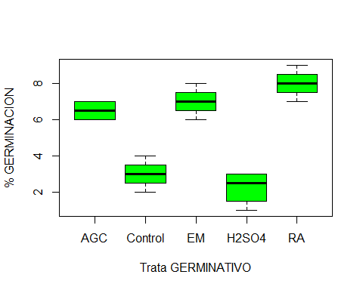

#ordenar los tratamientos  
  
levels(germ$Trata)

## [1] "AGC" "Control" "EM" "H2SO4" "RA"

germ$Trata <- factor(germ$Trata, levels = c("Control","EM","RA","AGC","H2SO4"))  
levels(germ$Trata)

## [1] "Control" "EM" "RA" "AGC" "H2SO4"

tapply(germ$PG, germ$Trata, mean)

## Control EM RA AGC H2SO4   
## 3.00 7.00 8.00 6.50 2.25

tapply(germ$PG, germ$Trata, var)

## Control EM RA AGC H2SO4   
## 0.6666667 0.6666667 0.6666667 0.3333333 0.9166667

#anova  
  
germ.aov <- aov(germ$PG ~ germ$Trata)  
summary(germ.aov)

## Df Sum Sq Mean Sq F value Pr(>F)   
## germ$Trata 4 104.80 26.20 40.31 7.42e-08 ***  
## Residuals 15 9.75 0.65   
## ---  
## Signif. codes: 0 '***' 0.001 '**' 0.01 '*' 0.05 '.' 0.1 ' ' 1

#prueba de tuki  
  
TukeyHSD(germ.aov, conf.level = 0.95)

## Tukey multiple comparisons of means  
## 95% family-wise confidence level  
##   
## Fit: aov(formula = germ$PG ~ germ$Trata)  
##   
## $`germ$Trata`  
## diff lwr upr p adj  
## EM-Control 4.00 2.2396122 5.7603878 0.0000356  
## RA-Control 5.00 3.2396122 6.7603878 0.0000024  
## AGC-Control 3.50 1.7396122 5.2603878 0.0001587  
## H2SO4-Control -0.75 -2.5103878 1.0103878 0.6862491  
## RA-EM 1.00 -0.7603878 2.7603878 0.4332120  
## AGC-EM -0.50 -2.2603878 1.2603878 0.9009428  
## H2SO4-EM -4.75 -6.5103878 -2.9896122 0.0000045  
## AGC-RA -1.50 -3.2603878 0.2603878 0.1140897  
## H2SO4-RA -5.75 -7.5103878 -3.9896122 0.0000004  
## H2SO4-AGC -4.25 -6.0103878 -2.4896122 0.0000175

##entre EM- ctrl diferencia de 4% y SI hay dif  
##entre RA- ctrl diferencia de 5% y SI hay dif  
##entre AGC- ctrl diferencia de 3% y SI hay dif  
  
plot(TukeyHSD(germ.aov), las =1, col="green")

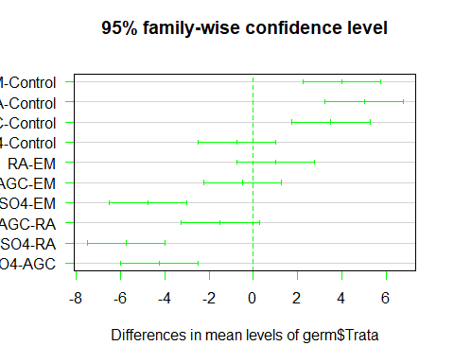

#agreggar letra de diferencias  
  
boxplot(germ$PG ~ germ$Trata,  
 col="green",  
 xlab="Trata GERMINATIVO",  
 ylab="% GERMINACION",  
 ylim=c(0,10))  
text(1,4.2,"a", col="red")  
text(2,8.3,"b", col="blue")  
text(3,9.4,"b", col="blue")  
text(4,7.4,"b", col="blue")  
text(5,3.3,"a", col="red")

