IE Agency // Sitecore Module
Google Maps for Sitecore
Documentation
prepared for Sitecore Shared Source
by Heiko Franz
on 10/11/2011
version 1.0

Table of Contents
1. Preface 3
2. Introduction 4
2.1. How to install 4
2.2. How to configure a map 6
2.3. How to add a map using the Page Editor 9
2.4. How to add a map using the Content Editor 11
3. Advanced Topics 12
3.1. How to use custom icons 12
3.2. Using multiple versions and languages 12
3.3. What is installed? 12
3.4. How to change the rendering of a map 13
3.5. How to build 13
4. Known Issues / Limitations 13
5. References / Remarks 14

Preface
This module allows to add custom maps to a Sitecore project to display office locations, tour stops or similar points of interest. It integrates the Google Maps API with Sitecore and currently supports the following:
- Add markers, lines and polygons
- Add info windows to markers and polygons
- Use custom icons for markers
- User friendly administration interface
- Fully customise the map (enable or disable any control, set maximum and minimum zoom level, ...)
- Flexible and extensible - use a custom Sublayout to match the requirement of your project without having to rebuild the module
- Rely on the current version 3 of the Google Maps JavaScript API
- Designed to work in Sitecore 6.5 - tested in Sitecore 6.2, 6.3 and 6.4
The module is a redevelopment of the Sitecore Maps module initially published by Timothy Ward in 2009.
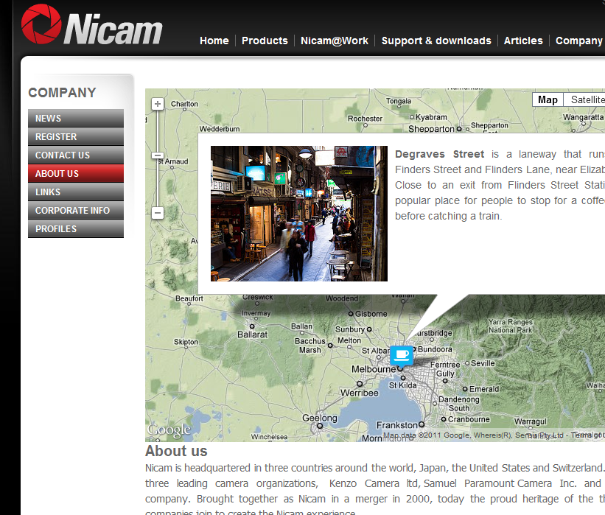

Introduction

How to install
Always backup your Sitecore installation and database before installing a new module.
- Download the module package and browse to the Desktop of your Sitecore installation.
- Launch the Installation Wizard from the Development Tools:
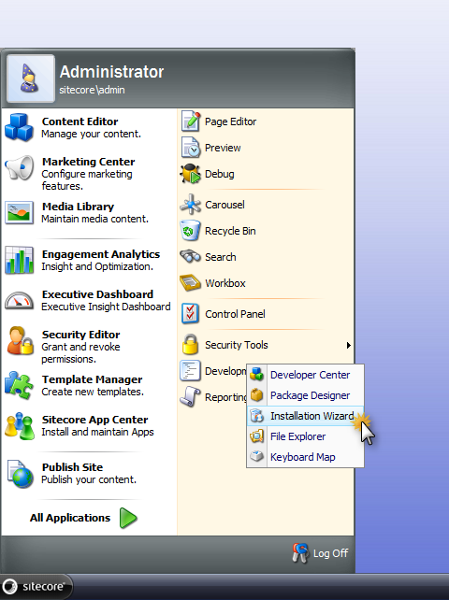
- Upload and install the package. Chose to overwrite existing items or files if you have used a previous version of the module.
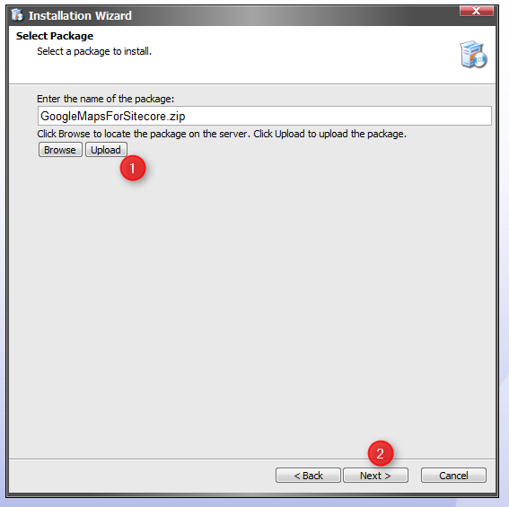
- Restart the Sitecore client after the installation was successful.
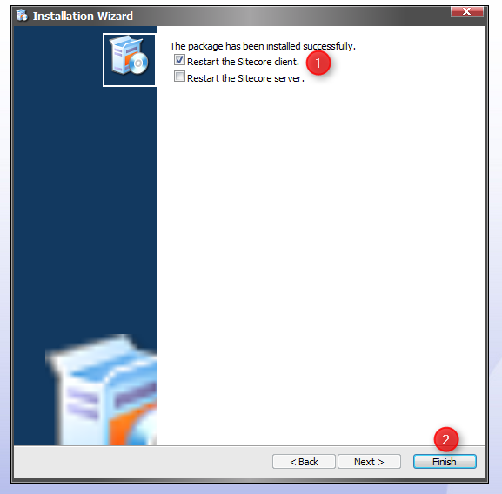
- Add the newly added Sublayout to the list of allowed controls for every placeholder that you want to hold a map. To do this, open the Content Editor and browse to /sitecore/Layout/Placeholder Settings. Add the Google Maps Control from Sublayouts / Modules:
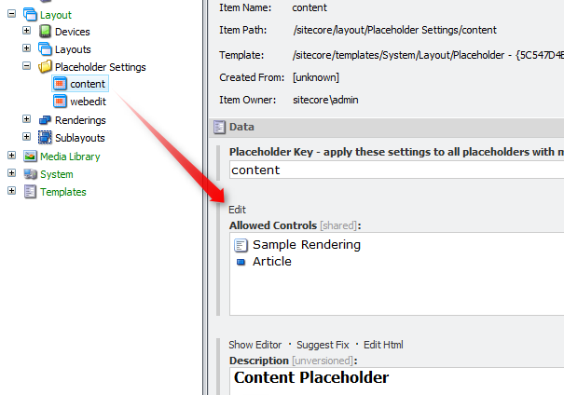
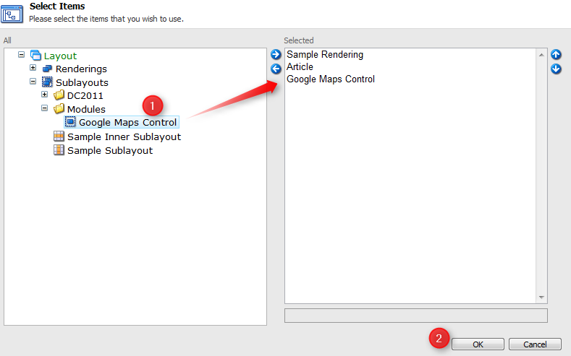
- Publish the following items:
- Sublayouts\Modules\Google Maps Control
- Media Library\Google Maps Data (if you want to use the demo map)
- Content\Maps (if you want to use the demo map)
The module is now ready to use.
The following chapters explain how to configure a new map and how to add it to a page. Advanced topics like custom icons are outlined in later chapters.

How to configure a map
Maps are configured using the content editor. By default, all maps are stored in \sitecore\Content\Maps (but you can store them anywhere in your project). The following explains how to add a new map:
- Browse to \sitecore\Content\Maps
- Insert a new Google Map item (check the insert options if this is not available)
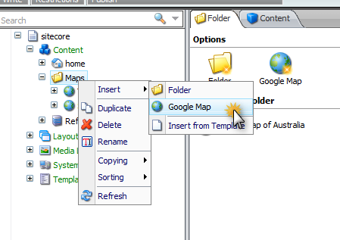
- Adjust the settings of the map. You can specify:
  - The initial position and zoom level of the map. Click "Show Map" to find a location and zoom level using the editor
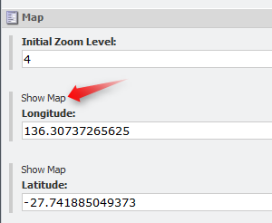
  - What map types to you want to use? The top one is the initial map type. The map defaults to a roadmap if no type is selected.
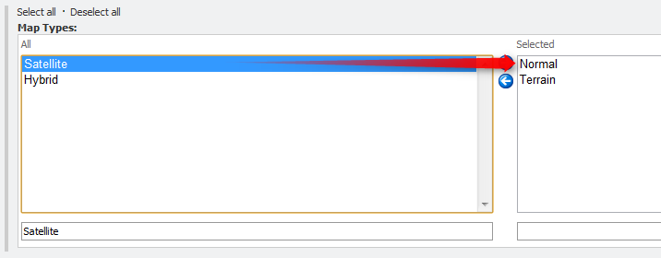
  - The size of the map on the page
  - (optional) A custom cursor for dragging
  - (optional) custom settings for the map
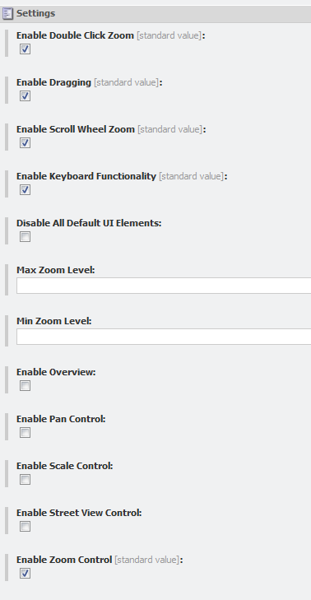
- Right click on the map to insert a new marker, line or polygon
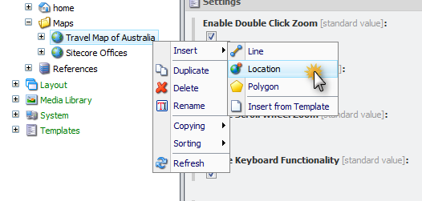
- (optional) Enter content for a info window for the marker (to appear in a box when you click on the marker) in the "Text" field. You can use any HTML, add images and links.
- Click "Show Map" to specify the location of the marker on the map. Click on a location on the map, then click save and close.
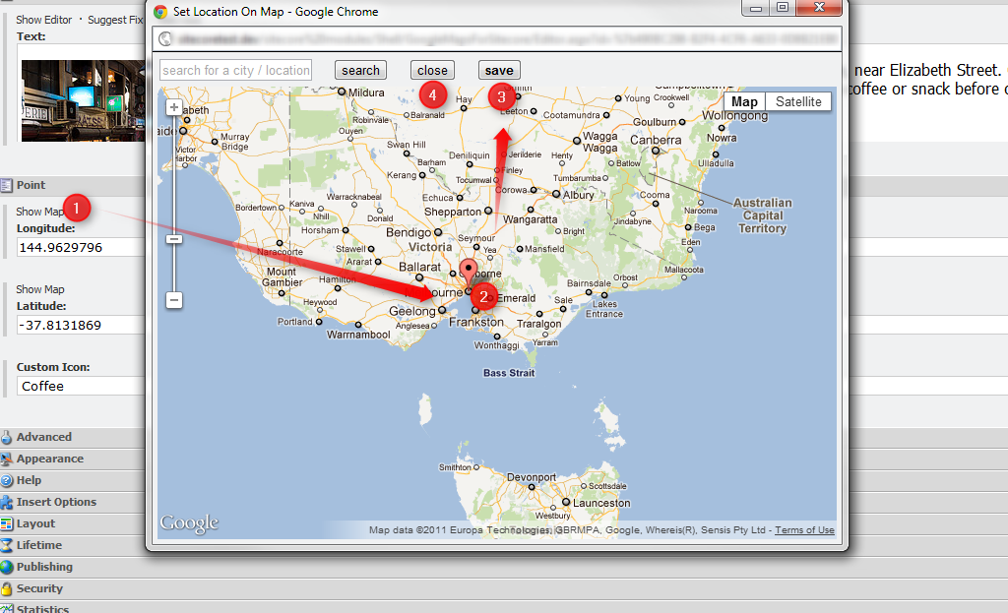
- You can search for an address or location using the search box in the top left.
- You can pick a custom icon from the list if icons. The default red drop pin will be used if no icon is specified. You can define your own custom icons. See the chapter in the advanced topics for details.
- Lines and polygons consist of multiple points. Click on "Show Map" to display an editor. You can add points to the map by clicking, move them around or remove one point by clicking on it. Click save and close to finish editing.
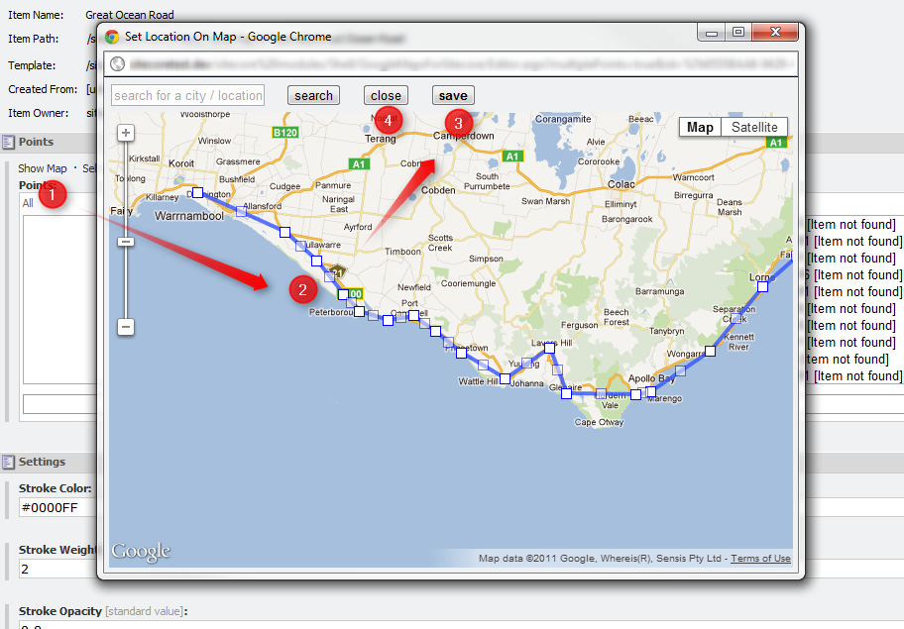
- You can specify the stroke colour (as HTML/CSS colour code), the stroke weight (pixel value) and stroke opacity (between 0 and 1). Additionally, you can specify the fill colour and opacity for a polygon and whether the polygon is clickable.
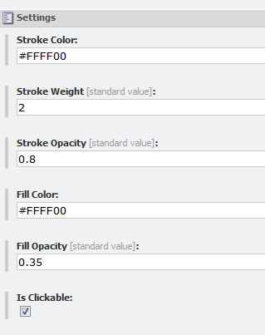

How to add a map using the Page Editor
Once a map is configured, it can be added to a page using the Page Editor or Content Editor. If you are using the Page Editor, browse to the page that you want to add the map to.
- Click "Component" in the "Home" tab to add a new component. Click "Add to here" at the placeholder position that you want to add the map to.
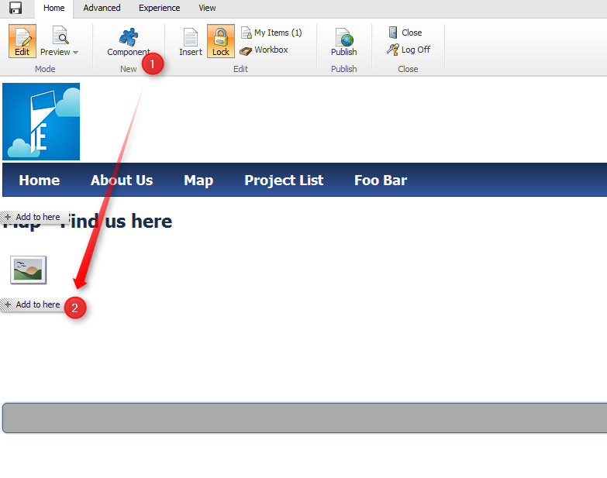
- Select "Google Maps Control" from the list of renderings. Check your placeholder settings if the Google Map control is not in the list. Tick the box "Open the Properties dialog box immediately" if you are using Sitecorein version 6.3 or earlier.
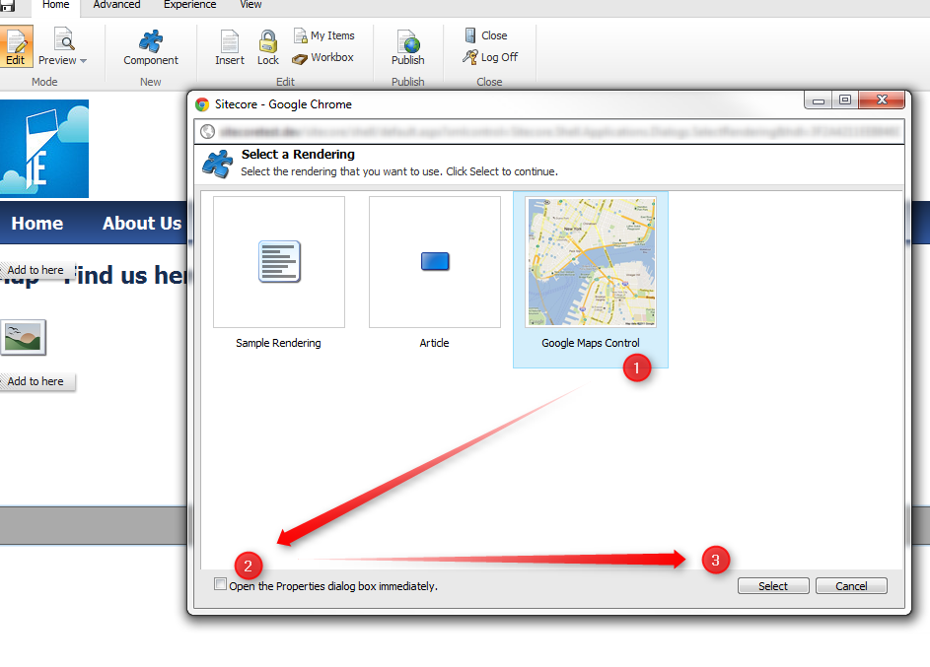
- If you are using Sitecore 6.4 or newer, you are able to select a map to display in the following dialog or choose to create a new map.
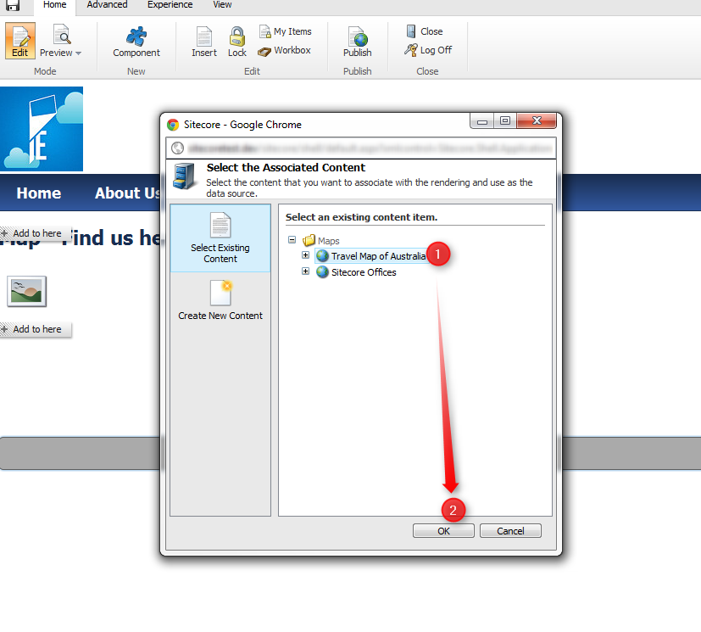
- For older versions of Sitecore, you have to manually set the "Data Source" in the Sublayout properties. Click on "Insert link" and select the map that you created earlier in \sitecore\Content\Maps
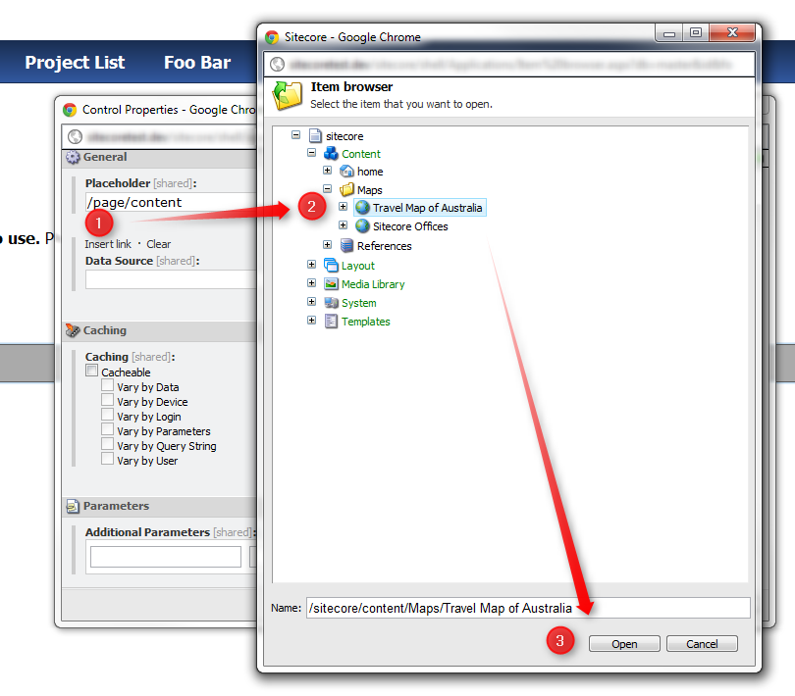

How to add a map using the Content Editor
To add a map using the Content Editor browse to the item that should display the map and click "Details" in the "Presentation" tab of the ribbon. Click "Edit" for the appropriate device, select "Controls" and "Add". Add the Sublayout from Sublayouts\Modules\Google Maps Control to the desired placeholder and set the data source as described in the previous chapter.
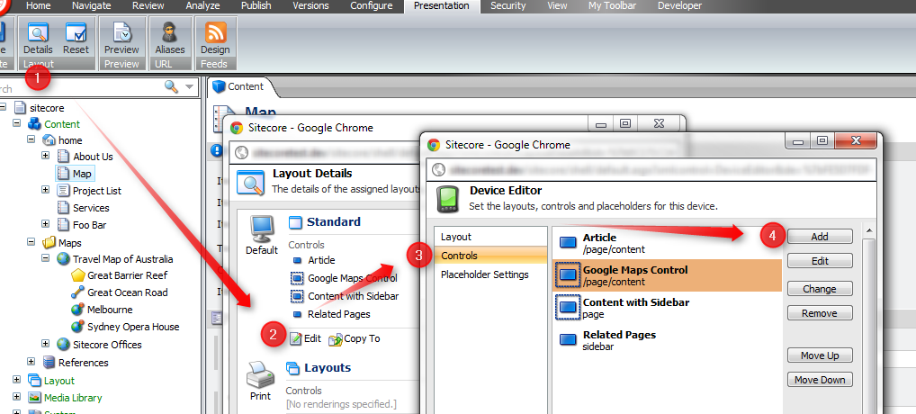

Advanced Topics

How to use custom icons
The Google Maps API supports custom icons for markers on a map. See http://www.powerhut.co.uk/googlemaps/custom_markers.php for details.
All custom icons are stored in \sitecore\System\Modules\Google Maps Settings\Custom Icons.
An icon consists of
- An image - PNG format
- A drop shadow image (optional) - PNG format
- Anchor - x and y position of where the icon is "pointing to" on the map
- Shadow Anchor - x and y position to anchor the shadow
- Clickable polygon - limits the area of the icon that is click-able, enter as a list of x and y positions
See the Google Maps API for more details and examples on custom icons.

Using multiple versions and languages
The module supports multiple versions and languages for maps just like any other item in Sitecore. Simply select the version and language from the "Versions" tab in the ribbon.
When translating a map to a new language, ensure that you transfer all module items into that language (including folders, settings, map types).

What is installed?
The module installed the following components:
- Files:
  - \bin\GoogleMapsForSitecore.dll
the code for both backend and frontend
  - \sitecore modules\Web\GoogleMapsForSitecore\GoogleMap.ascx
the usercontrol / sublayout rendering a map
  - \sitecore modules\Shell\GoogleMapsForSitecore\Editor.aspx, and some .png files
the editor used in the Sitecore console to edit markers or other elements on the map
  - \App_Config\Include\GoogleMapsForSitecoreCommands.config
configuration file for the custom commands on the map
- Core Database - 2 new field types to store a single point on the map as latitude and longitude as well as a multilist field that stores multiple points for a line and polygon.
- Master Database
  - Templates in Templates\Google Maps
  - Settings in System\Modules\Google Maps Settings
  - 2 images in Media Library\Google Maps Data
  - 1 new Sublayout in Layout\Sublayouts\Modules\Google Maps Control
  - demo map with markers etc in Content\Maps

How to change the rendering of a map
It is possible to create a custom front end for a map without having to rebuild the module. Simply create a Sublayout / user control that inherits from GoogleMapsForSitecore.Layouts.GoogleMap. This class has a public property CurrentMap of type GMap that contains all data needed to display the map. To display the map using JavaScript, simply call GoogleMapsForSitecore.Utilities.JSON(CurrentMap) to turn the map into a JSON object.

How to build
This project needs to be built against a Sitecore instance. Update the <SitecorePath> property in the project files GoogleMapsForSitecore\GoogleMapsForSitecore.csproj to point at the website folder of an existing Sitecore instance (tested with Sitecore 6.5).
The following files need to be copied across to the Sitecore installation to test the build:
- \bin\GoogleMapsForSitecore.dll
- \sitecore modules\Web\GoogleMapsForSitecore\GoogleMap.ascx
- \sitecore modules\Shell\GoogleMapsForSitecore\Editor.aspx, all .png files
- \App_Config\Include\GoogleMapsForSitecoreCommands.config
The project contains post build action that copies the files across. View the bottom of the GoogleMapsForSitecore.csproj for details and to disable the copy target if not needed.
Take the following steps to make the project part of an existing Visual Studio project with Sitecore:
- install the module as described in this document.
- put the GoogleMapsForSitecore.dll in a dependencies folder and reference it in your project.
- use the GoogleMap sublayout that comes with this module or create your own one by creating a usercontrol that inherits from GoogleMapsForSitecore.Layouts.GoogleMap as described above.

Known Issues / Limitations
It is currently not possible to change the content or settings of a map within the Page Editor, this feature might be added in later versions.
The Google Maps API usage limitations apply. Refer to http://code.google.com/apis/maps/faq.html#usagelimits
Item Not Found - When working with lines or polygons, the field type shows [Item Not Found] in the list next to all points. This is a known bug and does not affect the module in any way.
The heavy usage of Javascript on the map can slow down the Page Editor. A later version of this module can introduce a setting that disables the map while the page is open for editing in Page Editor mode.
The module supports maps in different languages (by creating map items in different languages) but there are currently no translations available for the Sitecore admin console of the module.

References / Remarks
Thanks to Timothy Ward at Sitecore Australia for building the initial version of this Google Maps module on Sitecore shared source.
Also thanks to the .NET team at IE Media for beta testing and providing feedback.
The following resources were used during development:
- Google Maps Javascript API V3 Reference
http://code.google.com/apis/maps/documentation/javascript/reference.html
- Google Maps API V3 Enable Editing Polylines
http://snipplr.com/view/38270/google-maps-api-v3--enableediting-polylines/
- Using the DataSource Filed with Sitecore Sublayouts - Mark Ursino
http://firebreaksice.com/using-the-datasource-field-with-sitecore-sublayouts/

