Part 2: Multi-layer perceptron

Using WEKA load and run ANN (multilayer perceptron) example and analyse the inputs and outputs.

Move around the factors such as learning rate, number of layers and number of nodes. Record the behaviour of the network. We are interested in observing if it converges or not, how long it takes to learn, and how precise it is. These measurements and comparisons should be included in your report. Find an interesting training set [here](https://archive.ics.uci.edu/ml/datasets.html) and use it to train a network.

Report

The report should have two sections, one for each part of this lab.

Part 1

Create a scatter plot of the training set of the linearly_separable example in the [tests](https://www.alphagrader.com/assignments/17/tests) section. Use different colors or symbols for the two classes. Draw the line that the perceptron algorithm found. Include the mathematical equation of the line in your report.

Part 2

Write an analysis of training the ANN with different parameters. Include an image of the network, the parameters used, and the error and time it took to train each network. Write a brief reflection about what you think is happening in the different ANNs, and why the ANN is behaving like it is. How did the choice of parameters influence the behavior of the ANN?

Other interesting aspects you could include in your reflection are:

* Explanations as to what are ANNs good for.
* Where would you use them?
* Are they worth the effort implementing or not?
* What kinds of problems do they not solve?

Evaluation

Based on modelling, implementation, report, and your insights about the effect of parameters to train an ANN.

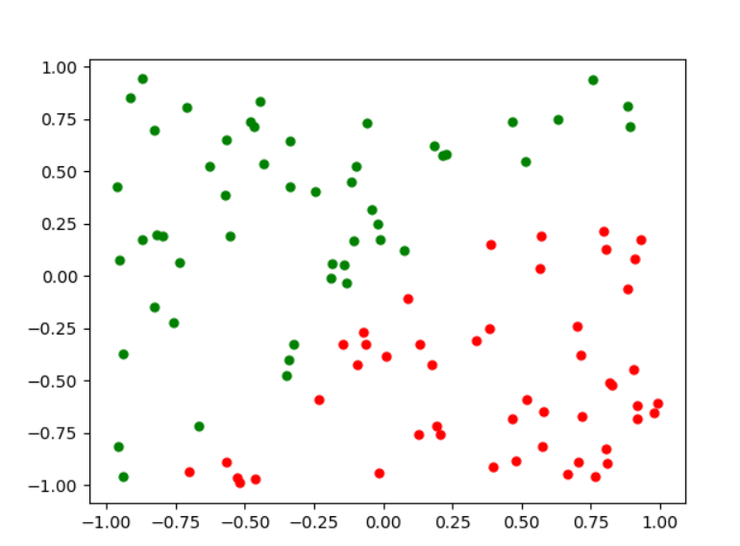

The orange line represents the data linearly separated.

This line is represented by the function:

1 if x0 * 0.0124 + x1 * - 0.014255 > threshold else 0

**What are ANNs good for?**

* Generalizing data
* Grouping data
* Understanding the relationships between variables are vaguely understood.

**Where would you use them?**

* Image recognition
* Social networks
* Speech recognition
* Videogame AI.

**Are they worth the effort implementing or not?**

It is. The accuracy for prediction is accurate if the correct data is given, anyway it can take a lot of time of training. It can be useful to find patterns in information, such as the movies tastes of the people given a test set of movies historical of a person.

**What kinds of problems do the not solve?**

It cannot solve problems such as understanding the natural language, problems of the kind question-answer cannot be modeled with this paradigm.