By plotting the one neutron separation energies, $S_{n}=BE\left(N,Z\right)-BE(N-1,Z)$, we are able to find evidence for shell closures. The evidence for shell closure is the sudden decrease in separation energy due to the neutrons going to higher valence shells with are more loosely bound. Looking at the figures of one neutron separation energies below for the six isotopes Oxygen (O), Calcium (Ca), Nickel (Ni), Tin (Sn), and Lead (Pb) we see evidence of shell closures. The set of shell closures appears for 24O, 40Ca ,48Ca, 56Ni, 100Sn, 132Sn, and 208Pb.

Fig 1.1 A shell closure at 24O results in a larger change of the neutron separation energy.

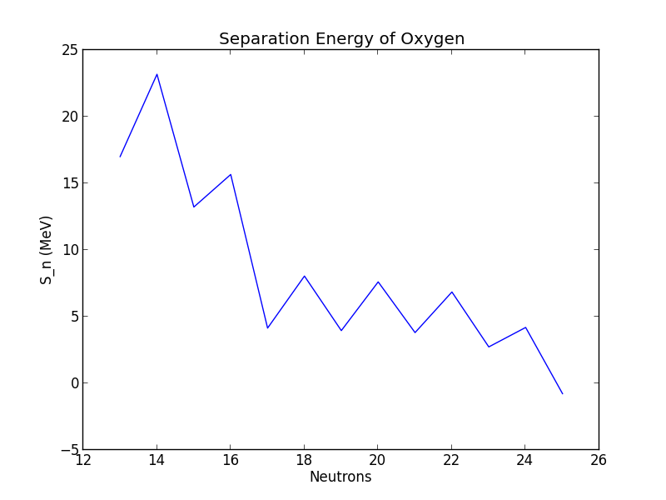

Fig 1.2 A shell closure at 40Ca results and evidence of a possible closure at 48Ca.

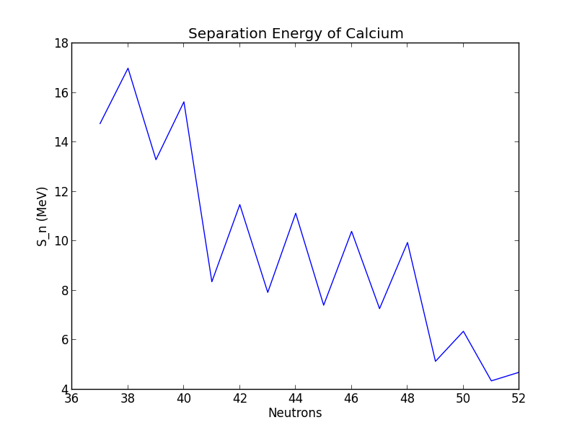

Fig 1.3 Evidence of shell closure at 56Ni.

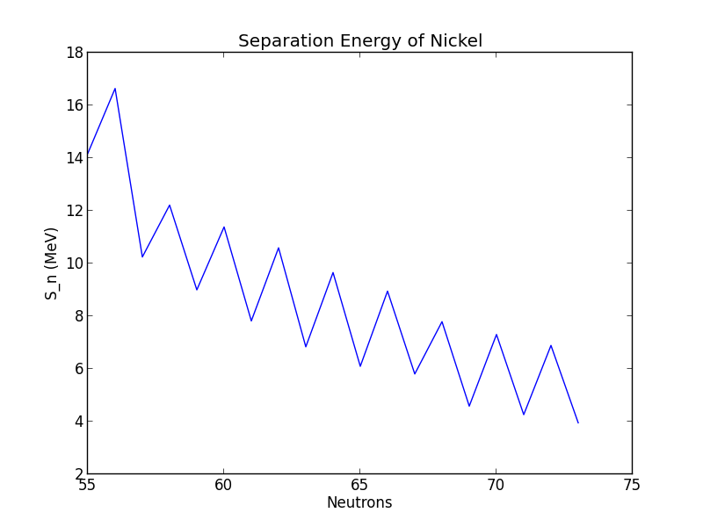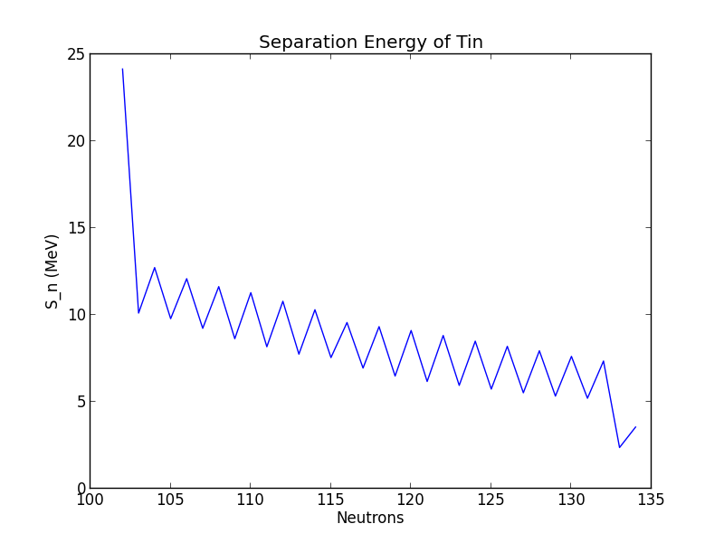

Fig 1.4 Evidence of shell closure at 100Sn.

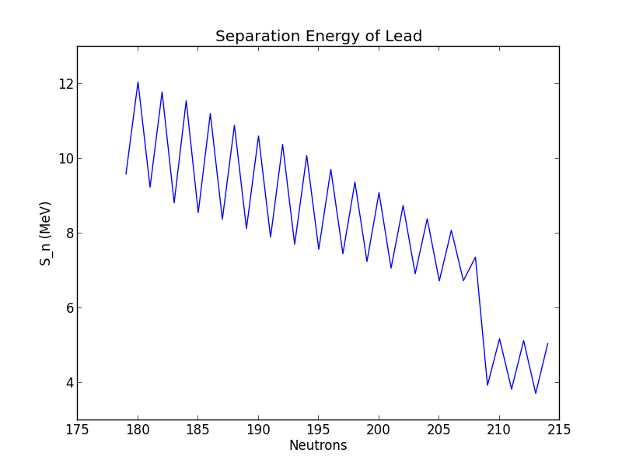

Fig 1.5 Evidence of shell closure at 208Pb.

In Fig 1.6 we plot the experimental data against a liquid drop model by Alex Brown. This particular liquid drop is parameterized as



As you can see, the liquid drop model has quite a bit of success in describing the binding energy of the experimental data. In the same figure we turn on sequentially the different terms in the liquid drop model by setting the parameters to the desired values above. I.e. for “Volume ON” we set a1 =15.49 and all other parameters to 0. We can see something interesting when we turn the Coulomb term on where jumps appear from the Z dependence of the Coulomb force. This feature is nearly canceled when we switch on the symmetry energy term.

Fig1.6 Binding energy of Brown’s liquid drop. Also parameters are sequentially turned on. To show their effects.

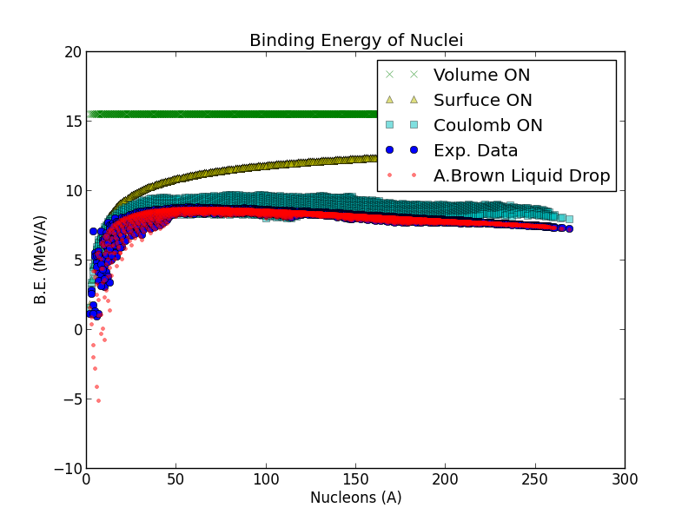

We define the neutron drip line as the point in which the one neutron separation energy becomes negative. Meaning the next nuclei is unstable with respect to neutron emission and is very short lived. Using Alex Brown’s model above we can calculate the expected neutron drip line and plot it against the experimentally known nuclei in Fig. 1.7. We note that at high nucleon numbers many nuclei that are within the neutron drip line have not been measured. Also at light nuclei the predictive power of the liquid drop model suffer. We see this as some of the experimental data is cut off by our liquid drop neutron drip line. Although with a closer inspection the neutron drip line is only a few off from experimentally determined drip line. Take for example the experimentally known 24O drip line compares with our predicted 22O in this model.

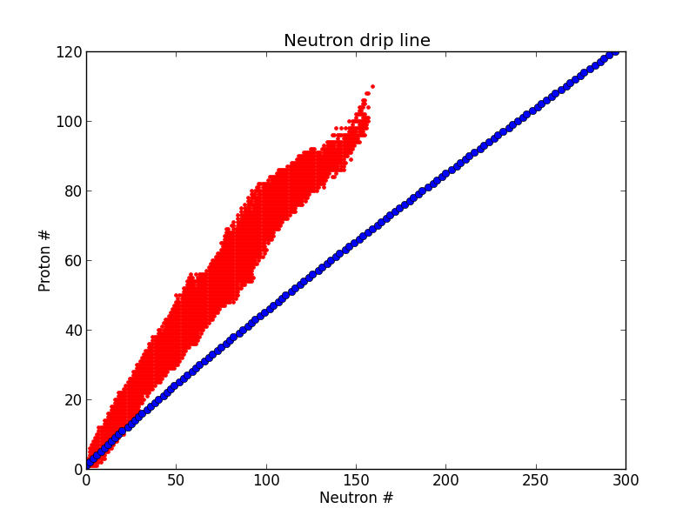

Fig 1.7. In red is the experimentally measured nuclei. In blue is the theoretical predicted neutron drip line.

Below in Fig 1.8 we show the predictive power of the liquid drop model by plotting the residuals of the prediction to experiment. As you can see at such light nuclei the liquid drop model suffers presumably because of microscopic considerations not taken into the phenomelogical liquid drop model who’s success is in determining bulk properties and not quantum effects.

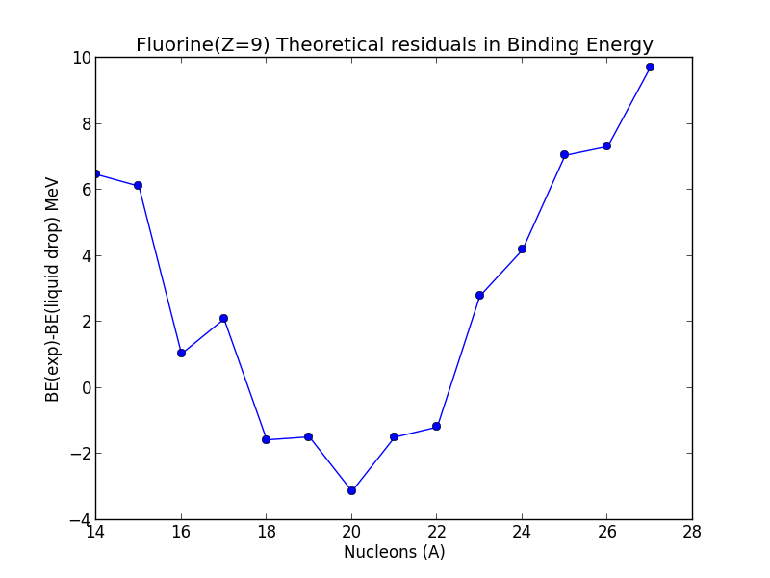

Fig 1.8 Residual plot comparing theory and experiment.