**ESTEE TCHEAU**

[esteetcheau@gmail.com](mailto:esteetcheau@gmail.com) <https://github.com/esteetcheau>

EDUCATION

* **University of California, Los Angeles** ………….......................................................*Los Angeles, CA* ***2020 - 2022***

*Pursuing B.S. in Computer Science*   *GPA: 3.55*

*Technical Breadth Area - Technology Management Tau Sigma National Honor Society*

*Dean’s Honors List Golden Key International Honour Society*

* **College of San Mateo** ………………….......................................................................…*San Mateo, CA* ***2016 - 2020***

*Certificate Program, University Transfer: IGETC/UC GPA: 3.9*

*Dean’s List – 6 Semesters Phi Theta Kappa - Beta Xi Eta Chapter*

*Magna Cum Laude  
Associate in Science, Mathematics*

*Associate in Science-Transfer, Mathematics*

*Associate in Science, Computer & Information Science*

*Associate in Arts-Transfer, Economics*

*Associate in Arts, Social Science*

*Associate in Science, Physics*

*Associate in Science-Transfer, Physics*

*The American Mathematical Association of Two-Year Colleges Student Mathematics League*

SKILLS

**Programming:** Python, Java, C++, JavaScript, HTML & CSS, Git, React, Node.js, Emacs, Shell Scripting, Linux, Assembly Language, OCaml, Web Development

**Foreign Languages, Arts, & Music:** French, Dance, Piano, Guitar, UCLA Taekwondo Club

**Film:** Photography, Photo-Editing, Adobe Photoshop, Adobe Lightroom, CorelDRAW

**Technologies:** Microsoft Word, Microsoft PowerPoint, Microsoft Excel, Slack

**Writing & Public Speaking:** Participated in numerous debates in high school & gave several live speeches, able to efficiently produce organized reports, write concise papers, & perform engaging and informative presentations.

SAMPLE PROJECTS & INTERNSHIPS

**WingSpan -- Web App Development 2021:** Python with Django, JavaScript with Node.js/React.js, Google/Twitter API

**Titanic Panic -- 3D Game Development 2020:** JavaScript’s tiny graphics library

**Petstagram -- Web App Development 2021:** JavaScript with Node.js/React.js, Firebase

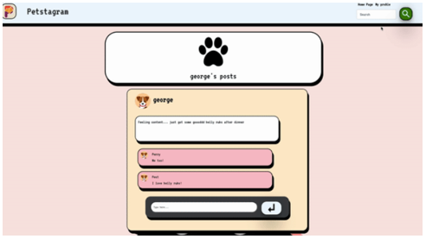*

Web based interactive game

Sentiment analytics on Twitter keywords

*s.

**American CryptoFed -- Internship 2021:** Ported MATLAB to Python for Linear Quadratic Estimator simulation

**Differential Equations Modeling**

**Challenge -- 2019:** Tri-parametric kinetic

& potential energy model

**Portfolio Website Creation -- 2021:** JavaScript, HTML, CSS

Showcases personal bio/achievements, LinkedIn &

GitHub links, projects, and photography collection

* Generated graphs showing changes in estimations of
* states with a Kalman Filter

Creation of mathematical models to land a

probe on a selected asteroid

ADDITIONAL EXPERIENCES

* **Hillsong,** Photographer & Photo Editor..............................................................*San Francisco, CA* ***2017-2019***
* Canon Rebel T7 & Adobe Lightroom. Photography seminars & social media content
* **Bayer Ballet Academy,** Receptionist...................................................................*Mountain View, CA* ***2018-2019***
* Facilities management. Videography. Parent/Student communications. Dance music playlist creation.