Alumno | Estela Romero Muñoz
 | Práctica Final Individual - Extractores de Datos

Ejercicio 1

[cloudera@quickstart ~]$ rm -rf ~/.flume/file-channel/*

[cloudera@quickstart ~]$ wget https://gist.github.com/fjavieralba/ab129e84241623916acd/raw/fd0e221e22a6355453a18b213c74e386c58d9a5f/syslog_generator.py

[cloudera@quickstart ~]$ sudo cp /etc/flume-ng/conf/spool-to-hdfs.properties /etc/flume-ng/conf/syslog-to-hdfs.properties

[cloudera@quickstart ~]$ sudo nano /etc/flume-ng/conf/syslog-to-hdfs.properties

agent1.sources = source1
agent1.sinks = sink1
agent1.channels = channel1
agent1.sources.source1.channels = channel1
agent1.sinks.sink1.channel = channel1
agent1.sources.source1.type = syslogudp
agent1.sources.source1.port = 5140
agent1.sources.source1.host = localhost
agent1.sinks.sink1.type = hdfs
#especificamos la ruta destino en hdfs:
agent1.sinks.sink1.hdfs.path = /tmp/flume/syslog
#prefijo para los ficheros que cree flume
agent1.sinks.sink1.hdfs.filePrefix = events
#prefijo para los ficheros que estan siendo escritos:
agent1.sinks.sink1.hdfs.inUsePrefix = _
#tipo de fichero de salida, en este caso queremos texto plano:
agent1.sinks.sink1.hdfs.fileType = DataStream
agent1.channels.channel1.type = file

[cloudera@quickstart ~]$ flume-ng agent --conf-file /etc/flume-ng/conf/syslog-to-hdfs.properties --name agent1 --conf /etc/flume-ng/conf/ -Dflume.root.logger=INFO,console

En otra consola:
[cloudera@quickstart ~]$ python syslog_generator.py Estela Romero

[cloudera@quickstart ~]$ hdfs dfs -ls /tmp/flume/syslog
Found 43 items
-rw-r--r-- 1 cloudera supergroup 241 2017-04-10 06:11 /tmp/flume/syslog/events.1491829860829
-rw-r--r-- 1 cloudera supergroup 250 2017-04-10 06:11 /tmp/flume/syslog/events.1491829860830
-rw-r--r-- 1 cloudera supergroup 250 2017-04-10 06:11 /tmp/flume/syslog/events.1491829860831
-rw-r--r-- 1 cloudera supergroup 250 2017-04-10 06:11 /tmp/flume/syslog/events.1491829860832
-rw-r--r-- 1 cloudera supergroup 250 2017-04-10 06:11 /tmp/flume/syslog/events.1491829860833
-rw-r--r-- 1 cloudera supergroup 250 2017-04-10 06:11 /tmp/flume/syslog/events.1491829860834
-rw-r--r-- 1 cloudera supergroup 250 2017-04-10 06:11 /tmp/flume/syslog/events.1491829860835
-rw-r--r-- 1 cloudera supergroup 250 2017-04-10 06:11 /tmp/flume/syslog/events.1491829860836
-rw-r--r-- 1 cloudera supergroup 250 2017-04-10 06:11 /tmp/flume/syslog/events.1491829860837
-rw-r--r-- 1 cloudera supergroup 251 2017-04-10 06:11 /tmp/flume/syslog/events.1491829860838
-rw-r--r-- 1 cloudera supergroup 260 2017-04-10 06:11 /tmp/flume/syslog/events.1491829860839
-rw-r--r-- 1 cloudera supergroup 260 2017-04-10 06:11 /tmp/flume/syslog/events.1491829860840
-rw-r--r-- 1 cloudera supergroup 260 2017-04-10 06:11 /tmp/flume/syslog/events.1491829860841
-rw-r--r-- 1 cloudera supergroup 260 2017-04-10 06:11 /tmp/flume/syslog/events.1491829860842
-rw-r--r-- 1 cloudera supergroup 260 2017-04-10 06:11 /tmp/flume/syslog/events.1491829860843
-rw-r--r-- 1 cloudera supergroup 260 2017-04-10 06:11 /tmp/flume/syslog/events.1491829860844
-rw-r--r-- 1 cloudera supergroup 260 2017-04-10 06:11 /tmp/flume/syslog/events.1491829860845
-rw-r--r-- 1 cloudera supergroup 260 2017-04-10 06:11 /tmp/flume/syslog/events.1491829860846
-rw-r--r-- 1 cloudera supergroup 260 2017-04-10 06:11 /tmp/flume/syslog/events.1491829860847
-rw-r--r-- 1 cloudera supergroup 260 2017-04-10 06:11 /tmp/flume/syslog/events.1491829860848
-rw-r--r-- 1 cloudera supergroup 260 2017-04-10 06:11 /tmp/flume/syslog/events.1491829860849
-rw-r--r-- 1 cloudera supergroup 260 2017-04-10 06:11 /tmp/flume/syslog/events.1491829860850
-rw-r--r-- 1 cloudera supergroup 260 2017-04-10 06:11 /tmp/flume/syslog/events.1491829860851
-rw-r--r-- 1 cloudera supergroup 260 2017-04-10 06:11 /tmp/flume/syslog/events.1491829860852
-rw-r--r-- 1 cloudera supergroup 260 2017-04-10 06:11 /tmp/flume/syslog/events.1491829860853
-rw-r--r-- 1 cloudera supergroup 260 2017-04-10 06:11 /tmp/flume/syslog/events.1491829860854
-rw-r--r-- 1 cloudera supergroup 260 2017-04-10 06:11 /tmp/flume/syslog/events.1491829860855
-rw-r--r-- 1 cloudera supergroup 260 2017-04-10 06:11 /tmp/flume/syslog/events.1491829860856
-rw-r--r-- 1 cloudera supergroup 260 2017-04-10 06:11 /tmp/flume/syslog/events.1491829860857
-rw-r--r-- 1 cloudera supergroup 260 2017-04-10 06:11 /tmp/flume/syslog/events.1491829860858
-rw-r--r-- 1 cloudera supergroup 260 2017-04-10 06:11 /tmp/flume/syslog/events.1491829860859
-rw-r--r-- 1 cloudera supergroup 260 2017-04-10 06:11 /tmp/flume/syslog/events.1491829860860
-rw-r--r-- 1 cloudera supergroup 260 2017-04-10 06:11 /tmp/flume/syslog/events.1491829860861
-rw-r--r-- 1 cloudera supergroup 260 2017-04-10 06:11 /tmp/flume/syslog/events.1491829860862
-rw-r--r-- 1 cloudera supergroup 260 2017-04-10 06:11 /tmp/flume/syslog/events.1491829860863
-rw-r--r-- 1 cloudera supergroup 260 2017-04-10 06:11 /tmp/flume/syslog/events.1491829860864
-rw-r--r-- 1 cloudera supergroup 260 2017-04-10 06:11 /tmp/flume/syslog/events.1491829860865
-rw-r--r-- 1 cloudera supergroup 260 2017-04-10 06:11 /tmp/flume/syslog/events.1491829860866
-rw-r--r-- 1 cloudera supergroup 260 2017-04-10 06:11 /tmp/flume/syslog/events.1491829860867
-rw-r--r-- 1 cloudera supergroup 260 2017-04-10 06:11 /tmp/flume/syslog/events.1491829860868
-rw-r--r-- 1 cloudera supergroup 260 2017-04-10 06:11 /tmp/flume/syslog/events.1491829860869
-rw-r--r-- 1 cloudera supergroup 260 2017-04-10 06:11 /tmp/flume/syslog/events.1491829860870
-rw-r--r-- 1 cloudera supergroup 130 2017-04-10 06:11 /tmp/flume/syslog/events.1491829860871

[cloudera@quickstart ~]$ hdfs dfs -cat /tmp/flume/syslog/events.1491829860829
<14>Estela: message #1
<14>Estela: message #2
<14>Estela: message #3
<14>Estela: message #4
<14>Estela: message #5
<14>Estela: message #6
<14>Estela: message #7
<14>Estela: message #8
<14>Estela: message #9
<14>Estela: message #10

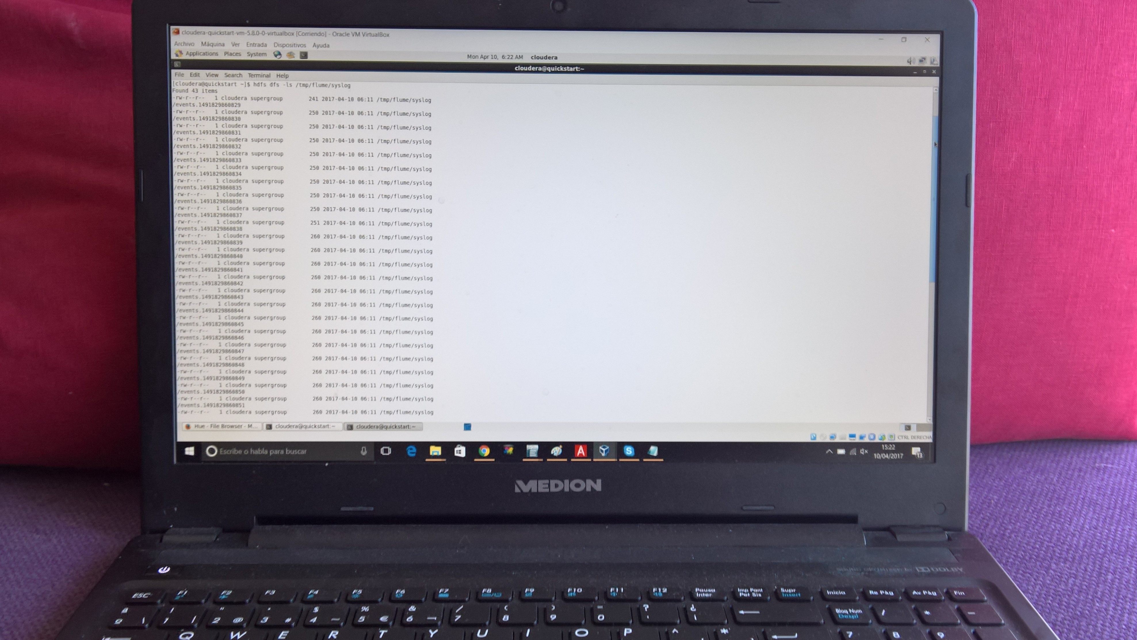

Ejercicio 2
1. Los archivos de configuración son (cada uno de ellos con estas tres líneas diferentes):
server.properties | server2.properties | server3.properties
broker.id = 0 | broker.id = 1 | broker.id = 2
listeners = PLAINTEXT://:9092 | listeners = PLAINTEXT://:9093 | listeners = PLAINTEXT://:9094
log.dirs = /kafka-logs | log.dirs = /kafka-logs2 | log.dirs = /kafka-logs3
Los dos primeros están ya creados de los ejercicios de clase. Para el tercero:
[cloudera@quickstart ~]$ sudo cp /etc/kafka/conf/server2.properties /etc/kafka/conf/server3.properties
[cloudera@quickstart ~]$ sudo nano /etc/kafka/conf/server3.properties
Y lo modificamos.
Arrancamos los brokers:
[cloudera@quickstart ~]$ /usr/lib/kafka/bin/kafka-server-start.sh /etc/kafka/conf/server.properties
Salida:
2017-04-11 05:38:21,880] INFO starting (kafka.server.KafkaServer)
[2017-04-11 05:38:21,895] INFO Connecting to zookeeper on localhost:2181 (kafka.server.KafkaServer)
[2017-04-11 05:38:21,925] INFO Starting ZkClient event thread. (org.I0Itec.zkclient.ZkEventThread)
[2017-04-11 05:38:21,930] INFO Client environment:zookeeper.version=3.4.5-cdh5.4.0-SNAPSHOT--1, built on 04/01/2015 08:35 GMT (org.apache.zookeeper.ZooKeeper)
[2017-04-11 05:38:21,930] INFO Client environment:host.name=quickstart.cloudera (org.apache.zookeeper.ZooKeeper)
[2017-04-11 05:38:21,930] INFO Client environment:java.version=1.7.0_67 (org.apache.zookeeper.ZooKeeper)
[2017-04-11 05:38:21,930] INFO Client environment:java.vendor=Oracle Corporation (org.apache.zookeeper.ZooKeeper)
[2017-04-11 05:38:21,930] INFO Client environment:java.home=/usr/java/jdk1.7.0_67-cloudera/jre (org.apache.zookeeper.ZooKeeper)
[cloudera@quickstart ~]$ /usr/lib/kafka/bin/kafka-server-start.sh /etc/kafka/conf/server2.properties
Salida:
[2017-04-11 05:40:35,812] INFO starting (kafka.server.KafkaServer)
[2017-04-11 05:40:35,819] INFO Connecting to zookeeper on localhost:2181 (kafka.server.KafkaServer)
[2017-04-11 05:40:35,836] INFO Starting ZkClient event thread. (org.I0Itec.zkclient.ZkEventThread)
[2017-04-11 05:40:35,836] INFO Client environment:zookeeper.version=3.4.5-cdh5.4.0-SNAPSHOT--1, built on 04/01/2015 08:35 GMT (org.apache.zookeeper.ZooKeeper)
[2017-04-11 05:40:35,836] INFO Client environment:host.name=quickstart.cloudera (org.apache.zookeeper.ZooKeeper)
[2017-04-11 05:40:35,836] INFO Client environment:java.version=1.7.0_67 (org.apache.zookeeper.ZooKeeper)
[2017-04-11 05:40:35,836] INFO Client environment:java.vendor=Oracle Corporation (org.apache.zookeeper.ZooKeeper)
[cloudera@quickstart ~]$ /usr/lib/kafka/bin/kafka-server-start.sh /etc/kafka/conf/server3.properties
Salida:
[2017-04-11 05:41:29,559] INFO starting (kafka.server.KafkaServer)
[2017-04-11 05:41:29,564] INFO Connecting to zookeeper on localhost:2181 (kafka.server.KafkaServer)
[2017-04-11 05:41:29,579] INFO Starting ZkClient event thread. (org.I0Itec.zkclient.ZkEventThread)
[2017-04-11 05:41:29,581] INFO Client environment:zookeeper.version=3.4.5-cdh5.4.0-SNAPSHOT--1, built on 04/01/2015 08:35 GMT (org.apache.zookeeper.ZooKeeper)
[2017-04-11 05:41:29,581] INFO Client environment:host.name=quickstart.cloudera (org.apache.zookeeper.ZooKeeper)
[2017-04-11 05:41:29,581] INFO Client environment:java.version=1.7.0_67 (org.apache.zookeeper.ZooKeeper)
[2017-04-11 05:41:29,581] INFO Client environment:java.vendor=Oracle Corporation (org.apache.zookeeper.ZooKeeper)
[2017-04-11 05:41:29,581] INFO Client environment:java.home=/usr/java/jdk1.7.0_67-cloudera/jre (org.apache.zookeeper.ZooKeeper)
2.Creamos topic:
[cloudera@quickstart ~]$ kafka-topics --create --zookeeper localhost:2181 --topic practica --partitions 3 --replication-factor 3
Created topic "practica".
3.Describe:
[cloudera@quickstart ~]$ kafka-topics --describe --zookeeper localhost:2181 --topic practica
Topic:practica PartitionCount:3 ReplicationFactor:3 Configs:
Topic: practica Partition: 0 Leader: 1 Replicas: 1,2,0 Isr: 1,2,0
Topic: practica Partition: 1 Leader: 2 Replicas: 2,0,1 Isr: 2,0,1
Topic: practica Partition: 2 Leader: 0 Replicas: 0,1,2 Isr: 0,1,2
4. Producer
[cloudera@quickstart ~]$ kafka-console-producer --broker-list localhost:9092 --topic practica
Practica final
Asignatura Adquisicion de Datos
Estela Romero
5. Consumer
[cloudera@quickstart ~]$ kafka-console-consumer --zookeeper localhost 2181 --topic practica –from-beginning
Practica final
Asignatura Adquisicion de datos
Estela Romero
6.Matamos el broker con config server3.properties
[2017-04-11 05:53:41,024] INFO Terminate ZkClient event thread. (org.I0Itec.zkclient.ZkEventThread)
[2017-04-11 05:53:41,034] INFO EventThread shut down (org.apache.zookeeper.ClientCnxn)
[2017-04-11 05:53:41,035] INFO Session: 0x15b57291cb40036 closed (org.apache.zookeeper.ZooKeeper)
[2017-04-11 05:53:41,046] INFO [Kafka Server 2], shut down completed (kafka.server.KafkaServer)
7.Volvemos a ejecutar consumer
[cloudera@quickstart ~]$ kafka-console-consumer --zookeeper localhost 2181 --topic practica --from-beginning
Estela Romero
Practica final
Asignatura Adquisicion de datos
- Matamos el broker con config server2.properties
[2017-04-11 05:55:59,010] INFO [GroupCoordinator 1]: Shutdown complete. (kafka.coordinator.GroupCoordinator)
[2017-04-11 05:55:59,035] INFO Terminate ZkClient event thread. (org.I0Itec.zkclient.ZkEventThread)
[2017-04-11 05:55:59,045] INFO EventThread shut down (org.apache.zookeeper.ClientCnxn)
[2017-04-11 05:55:59,045] INFO Session: 0x15b57291cb40035 closed (org.apache.zookeeper.ZooKeeper)
[2017-04-11 05:55:59,048] INFO [Kafka Server 1], shut down completed (kafka.server.KafkaServer)
9.Volvemos a ejecutar consumer
[cloudera@quickstart ~]$ kafka-console-consumer --zookeeper localhost 2181 --topic practica --from-beginning
Estela Romero
Asignatura Adquisicion de datos
Practica final

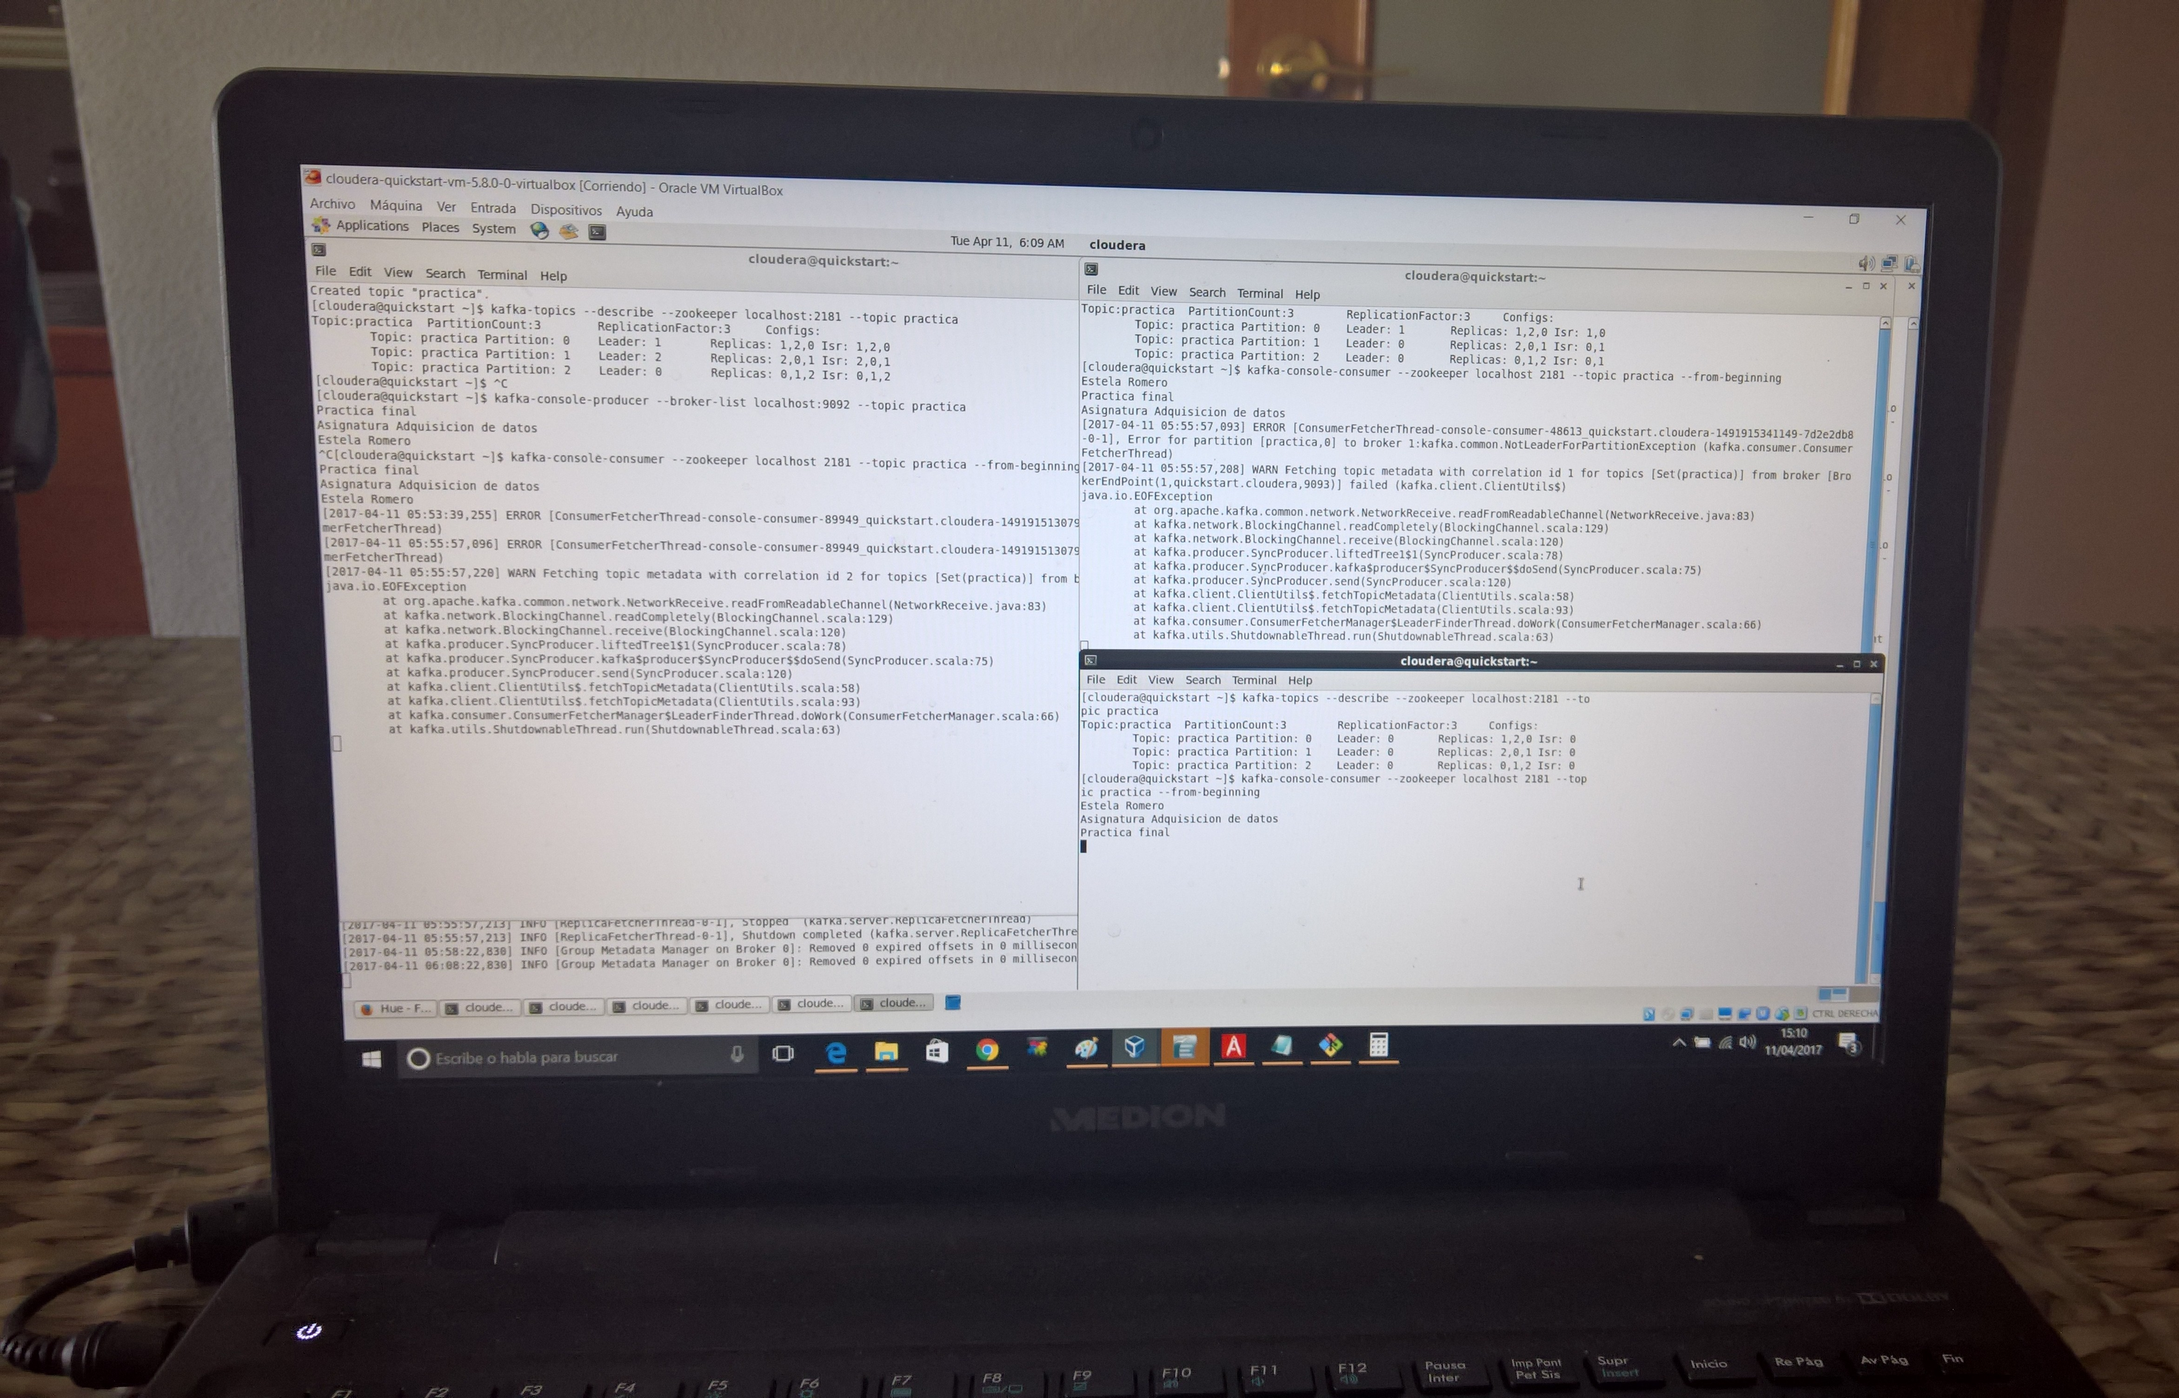

EJERCICIO 3
[cloudera@quickstart employees_db]$ sqoop import --connect jdbc:mysql://localhost/employees --table employees --where "hire_date<'1990-01-01'" --fields-terminated-by "\t" --target-dir /sqoop/veteran_employees
[cloudera@quickstart employees_db]$ hdfs dfs -ls /sqoop/veteran_employees
Found 5 items
-rw-r--r-- 1 cloudera supergroup 0 2017-04-12 04:01 /sqoop/veteran_employees/_SUCCESS
-rw-r--r-- 1 cloudera supergroup 2491230 2017-04-12 04:01 /sqoop/veteran_employees/part-m-00000
-rw-r--r-- 1 cloudera supergroup 1399680 2017-04-12 04:01 /sqoop/veteran_employees/part-m-00001
-rw-r--r-- 1 cloudera supergroup 1146512 2017-04-12 04:01 /sqoop/veteran_employees/part-m-00002
-rw-r--r-- 1 cloudera supergroup 2554729 2017-04-12 04:01 /sqoop/veteran_employees/part-m-00003
[cloudera@quickstart employees_db]$ hdfs dfs -cat /sqoop/veteran_employees/part-m-00000 |head -n 20
10001 1953-09-02 Georgi Facello M 1986-06-26
10002 1964-06-02 Bezalel Simmel F 1985-11-21
10003 1959-12-03 Parto Bamford M 1986-08-28
10004 1954-05-01 Chirstian Koblick M 1986-12-01
10005 1955-01-21 Kyoichi Maliniak M 1989-09-12
10006 1953-04-20 Anneke Preusig F 1989-06-02
10007 1957-05-23 Tzvetan Zielinski F 1989-02-10
10009 1952-04-19 Sumant Peac F 1985-02-18
10010 1963-06-01 Duangkaew Piveteau F 1989-08-24
10013 1963-06-07 Eberhardt Terkki M 1985-10-20
10014 1956-02-12 Berni Genin M 1987-03-11
10015 1959-08-19 Guoxiang Nooteboom M 1987-07-02
10018 1954-06-19 Kazuhide Peha F 1987-04-03
10021 1960-02-20 Ramzi Erde M 1988-02-10
10023 1953-09-29 Bojan Montemayor F 1989-12-17
10025 1958-10-31 Prasadram Heyers M 1987-08-17
10027 1962-07-10 Divier Reistad F 1989-07-07
10029 1956-12-13 Otmar Herbst M 1985-11-20
10033 1956-11-14 Arif Merlo M 1987-03-18
10034 1962-12-29 Bader Swan M 1988-09-21


