Video: https://youtu.be/dnoECmw9tfg

**Task 1**: SmartRF Studio ↔ SmartRF Studio

Able to transfer/receive packets in RF Studio.

**Task 2**: Importing and running the rfPacketTx example

Able to import, build, and run the rfPacketTx example.

**Task 3**: Exporting and using RF configuration

Changed RF settings

**Task 4**: Firmware TX → SmartRF Studio RX

Used both RF Studio and CCS to receive package

**Task 5**: Importing and Modifying rfPacketRx

rfPacketRx rfPacketRx was imported built and ran

**Task 6**: Firmware TX → Firmware RX

Transferred and received packets and disconnected and reconnected device.

**Task 7**: SmartRF Studio TX → Firmware RX

Transferred and received packets with connected TX launchpad to the RF Studio.

Photos:

a) RFStudio menu

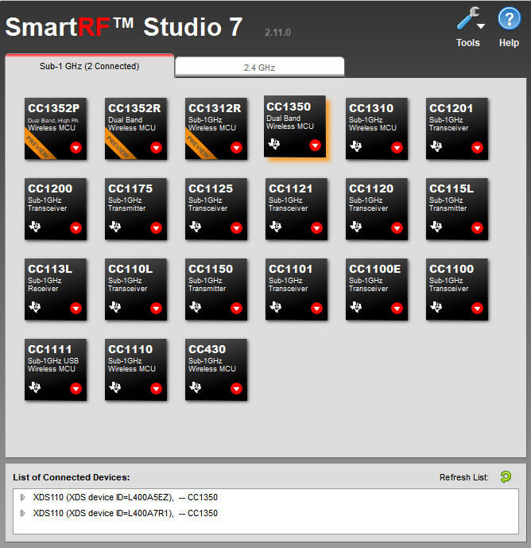

b) RX menu

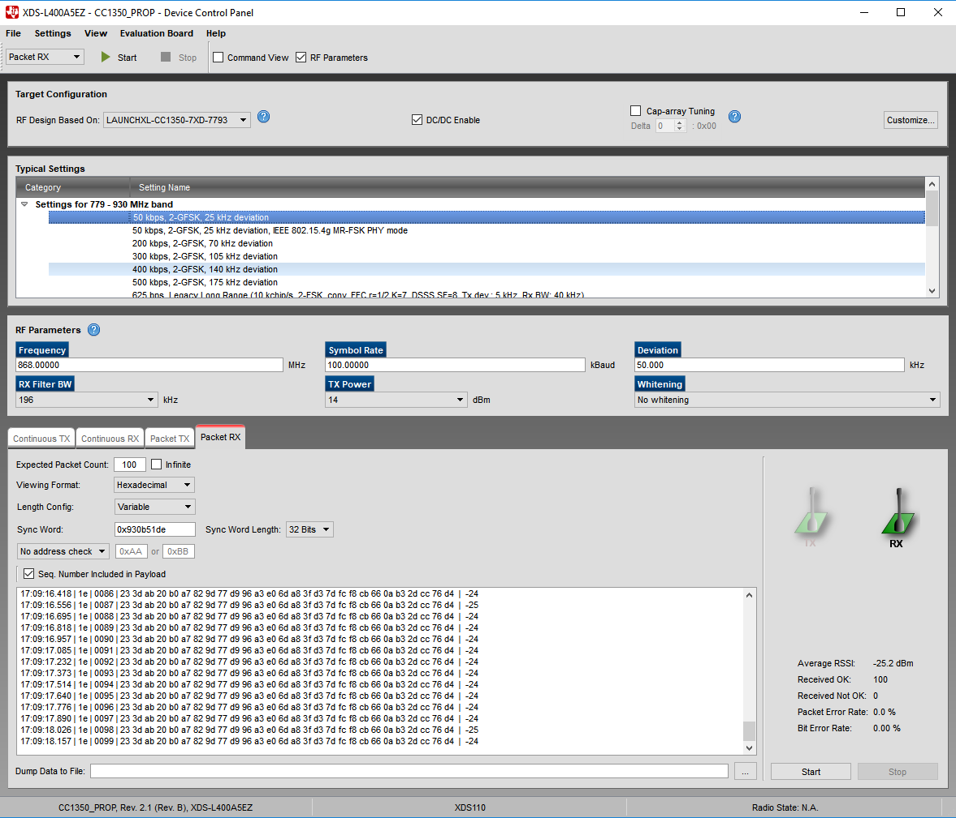

c) TX menu

