**Estellar Raganit**

**Abenezer Namaga**

CPE 403 – 1001

CC1350 LAB 04

**Task 01**: Setup Project in SCS

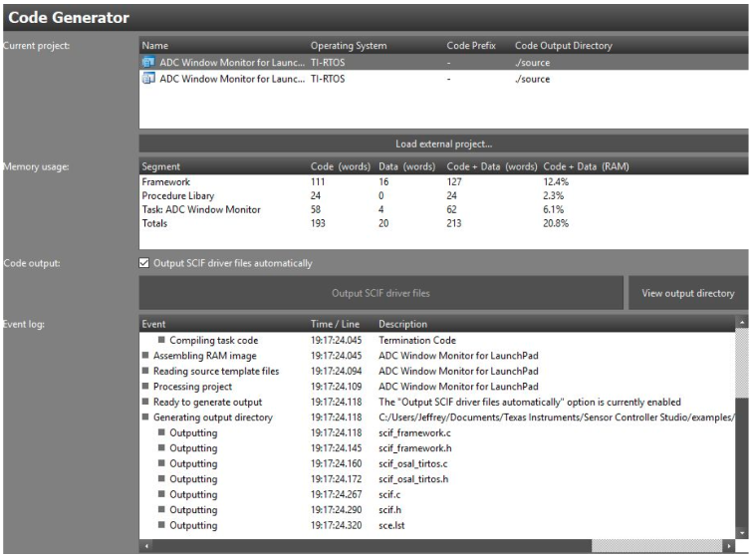

----------------------------------------------------------------------

**Task 02**: Download and Debug with SCS

Youtube Link: <https://youtu.be/OCQ_GhfZwug>

———————————————————————————————————

**Task 03**: Download and Debug with SCS

Youtube Link: <https://youtu.be/N-RwkzlwONU>

———————————————————————————————————

**Task 04**: Understand

Figure1: Graph of adc output