**Estellar Raganit**

**Abenezer Namaga**

CPE 403 – 1001

CC1350 LAB 05

**Task 01**: Building and loading the collector example

* CC1350 successfully built and stored

----------------------------------------------------------------------

**Task 02**: Building and loading the sensor example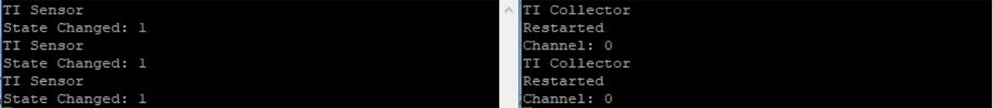

———————————————————————————————————

**Task 03**: Using the Collector and Sensor

* Collector and sensor were able to interact with each other.

———————————————————————————————————

**Task 04**: Updating the sensor's reporting rate

* Changed the reporting/polling interval for the collector example and changed the reporting interval for sensor example then they were built and loaded.