Estellar Raganit

Dr. Venki

CPE 403

12/12/18

CPE 403 FINAL PROJECT

Problem Statement:

**Main Goal**:

* We will be interfacing a sensor to the sensor node and transmits the obtained data using the TI-15.4 stack RF to the co-processor. The BBB collects all the data which will display the data and is interfaced with a co-processor which is the CC1350.

**Objectives**:

* We were able to achieve our goals by interfacing the temperature sensor, which was included in the sensor program that collected the data in Celsius which sends the data to the co-processor which would receive data and send it to the BBB.

**Schematics:**

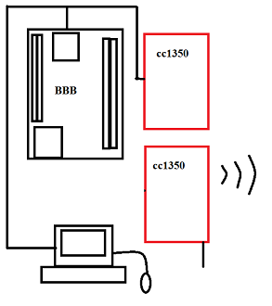

**Project Set-up:**

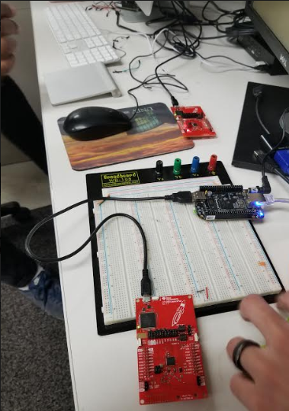

pre-requisites:

* + Virtual box Linux 14.04, 2 x CC1350 Launch Pads, BBB, Host PC
* Commands to install prerequisites
  + $ sudo apt-get instal …   (or)
  + $ git clone .... (install from src)
  + ssh root@ip address
  + scp bbb_prebuilt.tar.gz root@<bbb-ip-address>:/home/root/  (copies file to PI
  + ./run_demo.sh
  + tar -xzf bb_prebuilt.tar.gz

**Coprocessor and Sensor:**

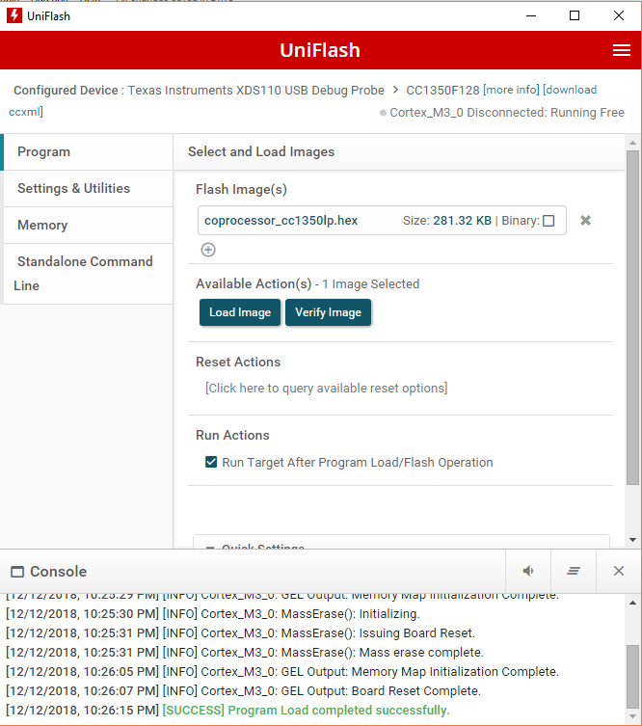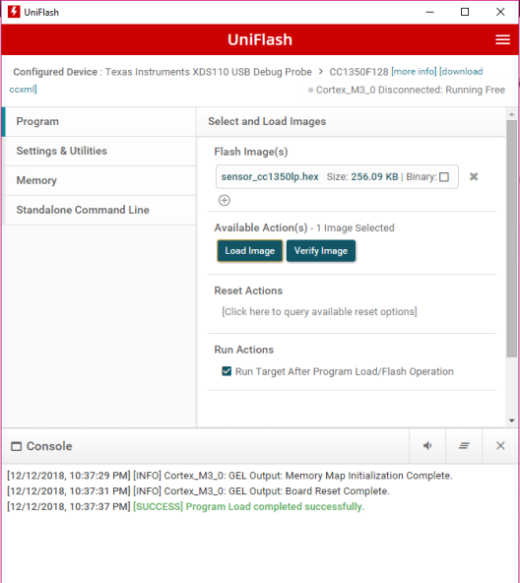

implementation details:

* Used Uniflash to load the hex files onto to our launchpads.
* Burnt a linux am335x-evm image on an SD card using Etcher
* Sent (“scp”) ziped prebuilt from linux on to to BBB and extracted in root

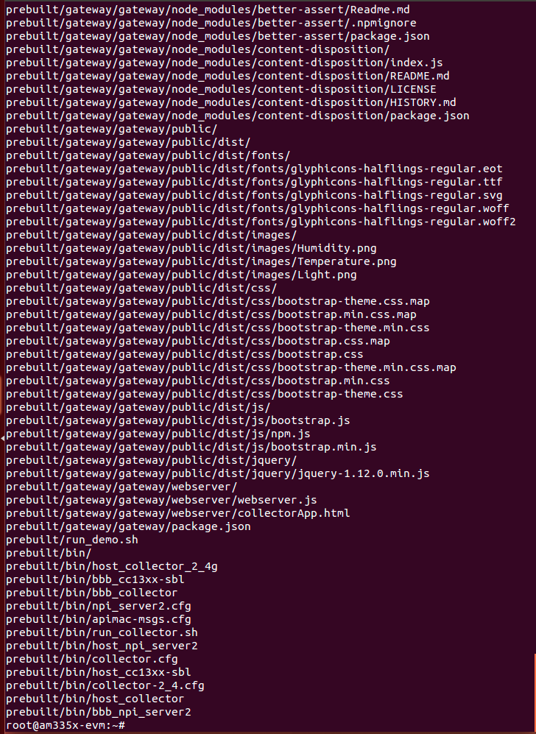

outcomes, results and conclusions:

* **Outcome – result of your project?**
  + *The outcome of our project was successful. We were able to interface a temperature sensor to the sensor board that had code written for it already. The sensor board then sent that data to the co-processor which would process the data and send it to the BBB. The BBB would then upload the data to an online source to show the temperature. We attempted to try and use Humidity and Lux since those were in the code as well but failed when we didn’t have the sensors to use.*
  + *This project is endless with the capabilities and in use in that, it can be used for a short term thing to a long term thing.  Transmitting data is very universal with this project. This can be used for home projects to projects with companies.*

**Components:**

* We used the BBB and two CC1350 boards. The temperature sensor built in the 1350 board was also used in our project.
* TI-15.4 collector app was used as our online visualization tool.
* The data we collected was visualized through the web browser.
* **DEMO: video** <https://youtu.be/x1k0bNMw_uU>

Results and Conclusions:

* + **Picture below shows the demonstration of the stack example. Run “run_demo.sh” in terminal from the prebuilt bolder. Opened up the generated link.**
  + 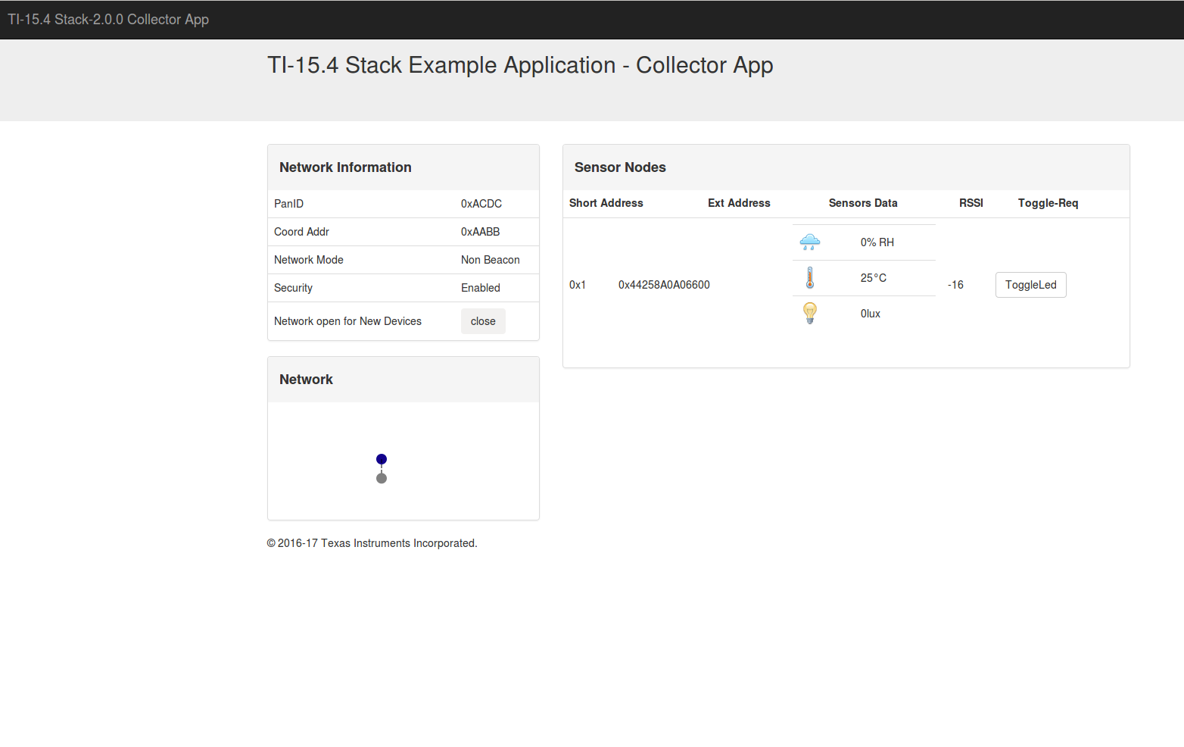

reference:

* CCS for programming CC1350: <http://processors.wiki.ti.com/index.php/Download_CCS>
* Uniflash: <http://www.ti.com/tool/uniflash>
* Linux am335x-evm: <http://software-dl.ti.com/processor-sdk-linux/esd/AM335X/latest/index_FDS.html>
* Stack overflow
* Texas Instrument website
* TI Q&A
* CCS resources
* CC1350 assignments