Database Management Lab 2

Name: Shun Zhang
CS ID: menie482
UT EID: sz4554

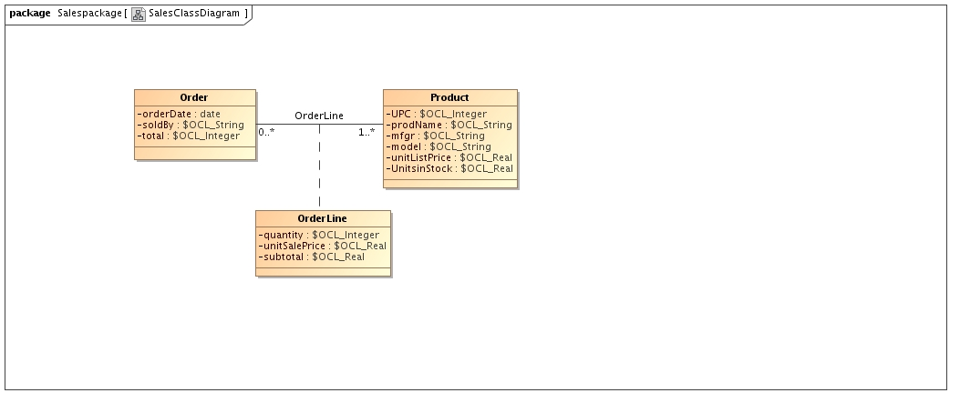
--@(#) script.ddl

CREATE SCHEMA SalesSqlPackage.Salespackage;

CREATE TABLE SalesSqlPackage.Salespackage.Order
(
orderDate date,
soldBy,
total,
id_Order integer,
PRIMARY KEY(id_Order)
);

CREATE TABLE SalesSqlPackage.Salespackage.Product
(
UPC,
prodName,
mfgr,
model,
unitListPrice,
UnitsinStock,
id_Product integer,
PRIMARY KEY(id_Product)
);

CREATE TABLE SalesSqlPackage.Salespackage.OrderLine
(
quantity,
unitSalePrice,
subtotal,
id_OrderLine integer,
fk_Orderid_Order integer NOT NULL,
fk_Productid_Product integer NOT NULL,
PRIMARY KEY(id_OrderLine),
FOREIGN KEY(fk_Orderid_Order) REFERENCES SalesSqlPackage.Salespackage.Order (id_Order),
FOREIGN KEY(fk_Productid_Product) REFERENCES SalesSqlPackage.Salespackage.Product (id_Product)
);

