Lab 3

Name: Shun Zhang
UT EID: sz4554
CS ID: menie482

All ddl files are attached separately.

Part 1
1.
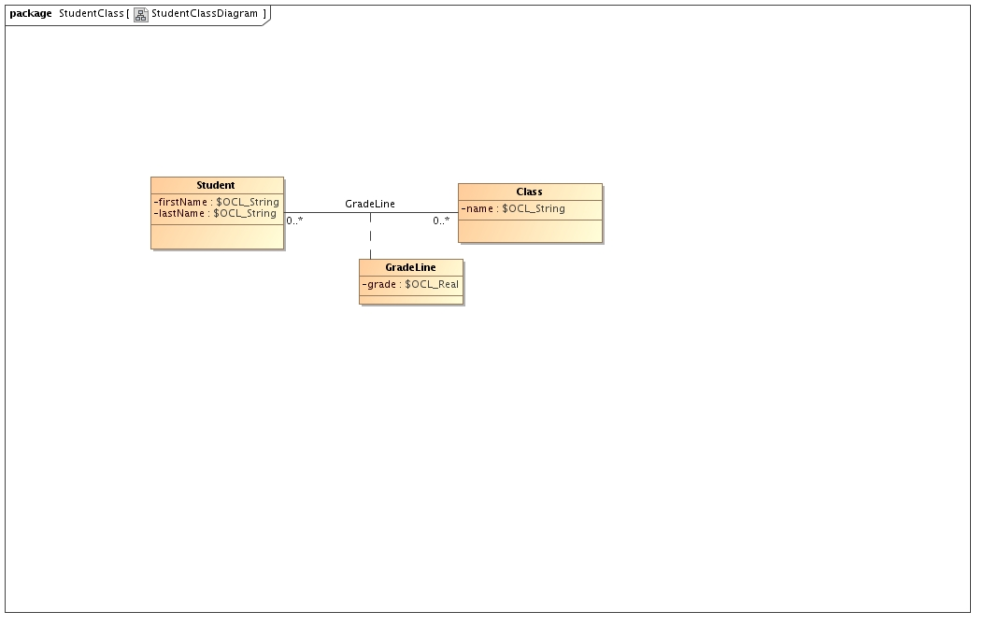
Work around:
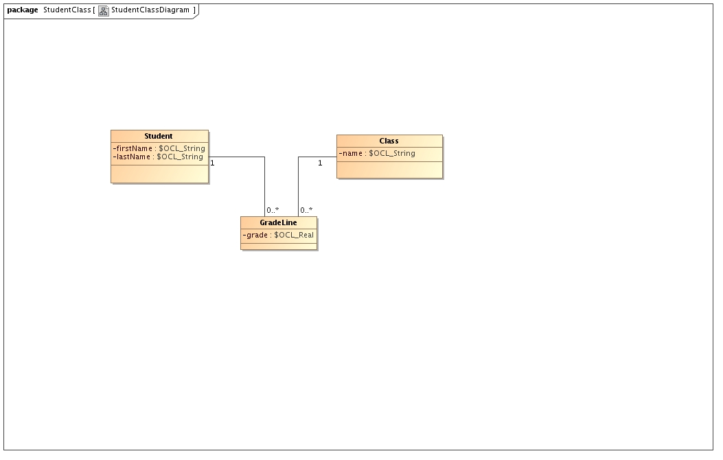
Physical model:
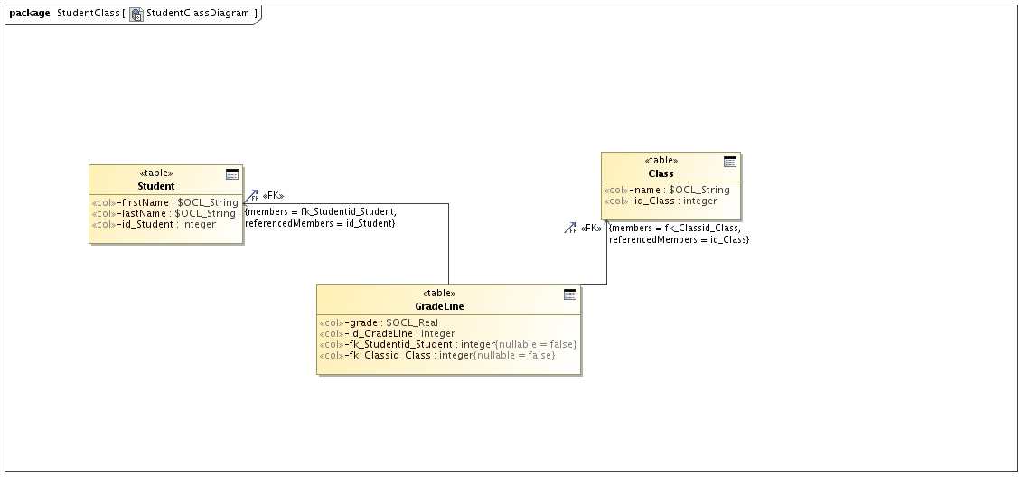
2.
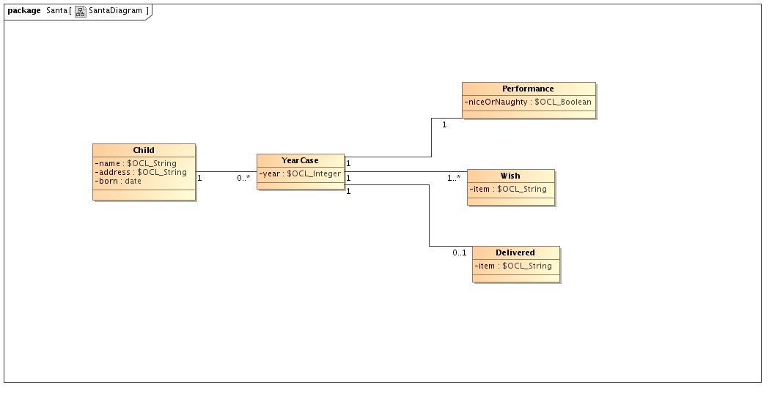
3.
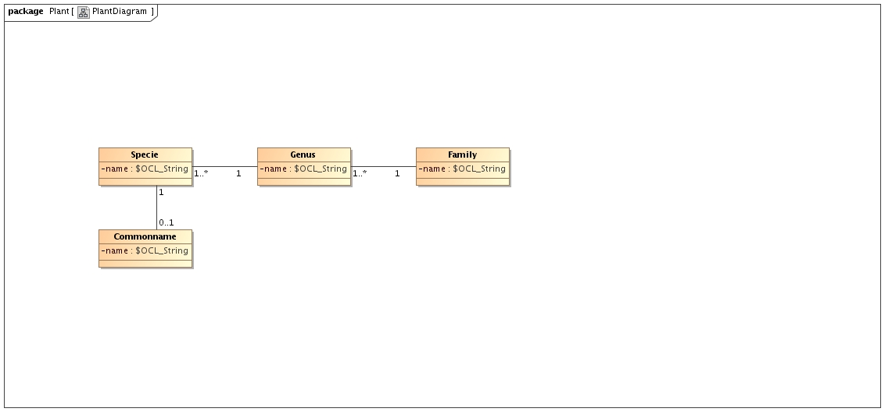
Physical model:
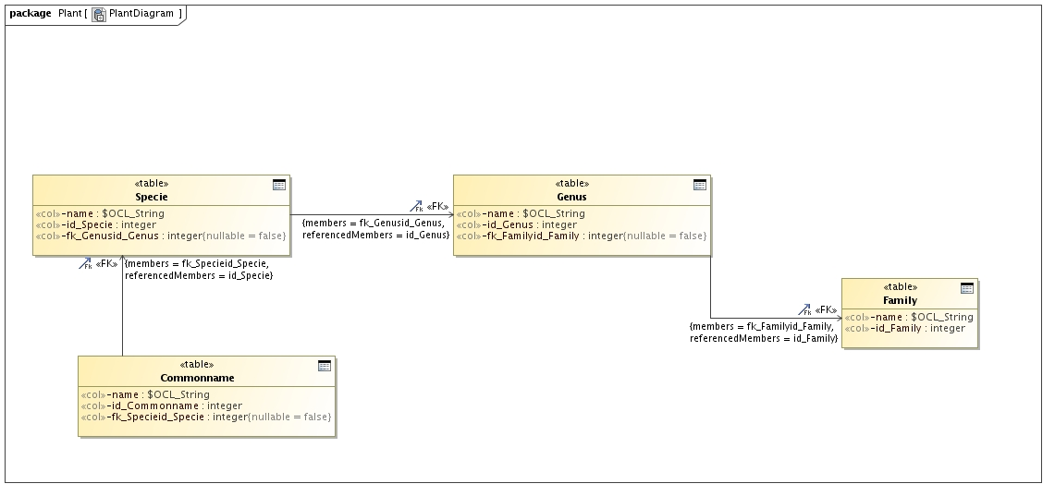
4.
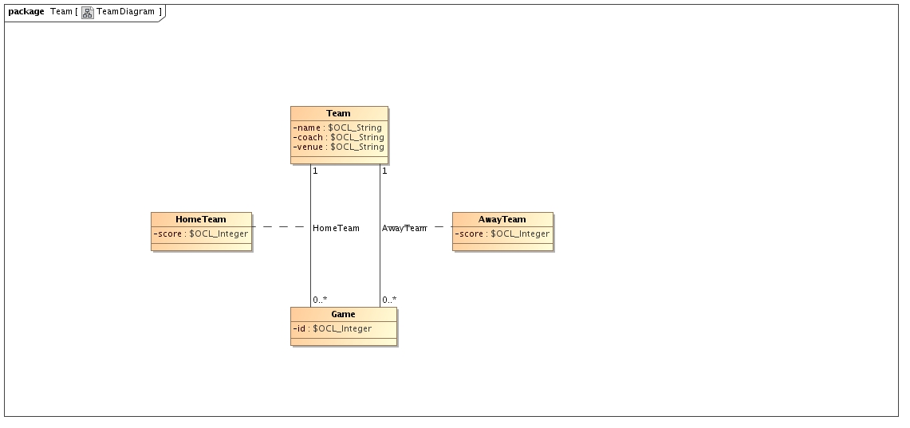
Part 2
1.
Association
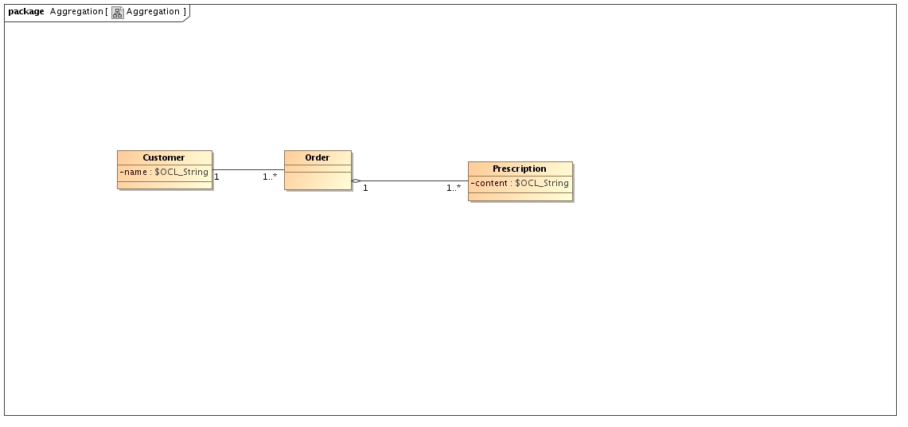
--@(#) script.ddl

CREATE TABLE AggregationTable.Aggregation.Customer
(
name,
id_Customer integer,
PRIMARY KEY(id_Customer)
);

CREATE SEQUENCE AggregationTable.Aggregation.Order_SEQ;

CREATE SEQUENCE AggregationTable.Aggregation.Customer_SEQ;

CREATE SEQUENCE AggregationTable.Aggregation.Prescription_SEQ;
---SKIPPED: Class REMOVED_BY_CUSTOM_TRANSFORMATION

CREATE TABLE AggregationTable.Aggregation.Order
(
id_Order integer,
fk_Customerid_Customer integer NOT NULL,
PRIMARY KEY(id_Order),
FOREIGN KEY(fk_Customerid_Customer) REFERENCES AggregationTable.Aggregation.Customer (id_Customer)
);

CREATE TABLE AggregationTable.Aggregation.Prescription
(
content,
id_Prescription integer,
fk_Orderid_Order integer NOT NULL,
PRIMARY KEY(id_Prescription),
FOREIGN KEY(fk_Orderid_Order) REFERENCES AggregationTable.Aggregation.Order (id_Order)
);

Composition
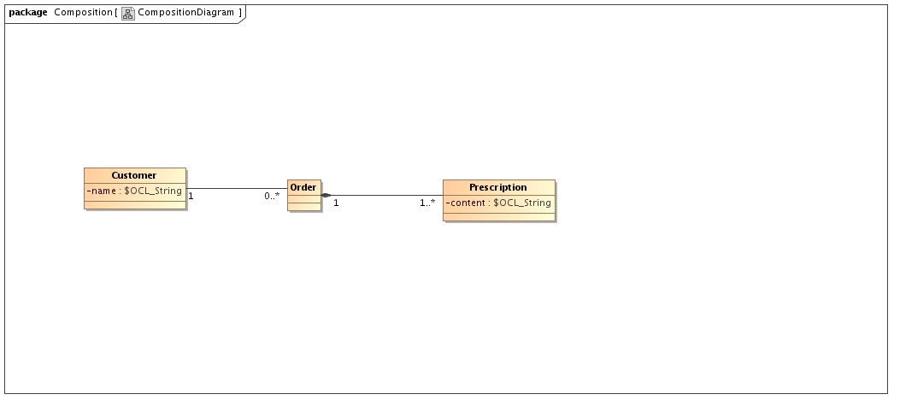
--@(#) script.ddl

CREATE TABLE CompositionTable.Composition.Customer
(
name,
id_Customer integer,
PRIMARY KEY(id_Customer)
);

CREATE SEQUENCE CompositionTable.Composition.Order_SEQ;

CREATE SEQUENCE CompositionTable.Composition.Customer_SEQ;

CREATE SEQUENCE CompositionTable.Composition.Prescription_SEQ;
---SKIPPED: Class REMOVED_BY_CUSTOM_TRANSFORMATION

CREATE TABLE CompositionTable.Composition.Order
(
id_Order integer,
fk_Customerid_Customer integer NOT NULL,
PRIMARY KEY(id_Order),
FOREIGN KEY(fk_Customerid_Customer) REFERENCES CompositionTable.Composition.Customer (id_Customer)
);

CREATE TABLE CompositionTable.Composition.Prescription
(
content,
id_Prescription integer,
fk_Orderid_Order integer NOT NULL,
PRIMARY KEY(id_Prescription, fk_Orderid_Order),
FOREIGN KEY(fk_Orderid_Order) REFERENCES CompositionTable.Composition.Order (id_Order)
);

2.
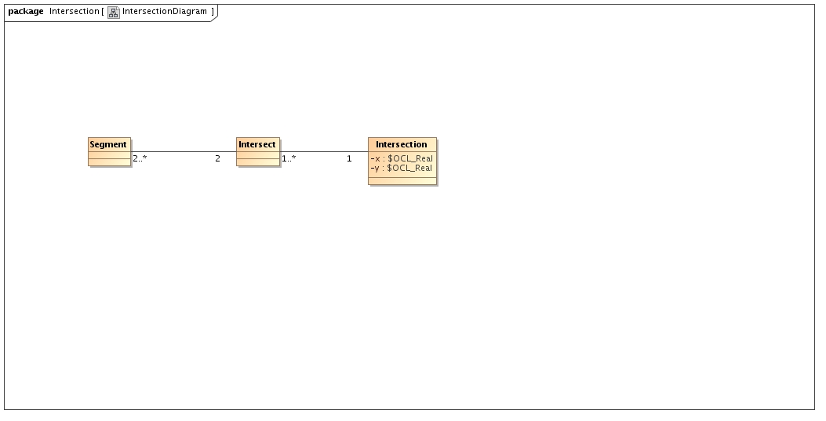
3.
a)
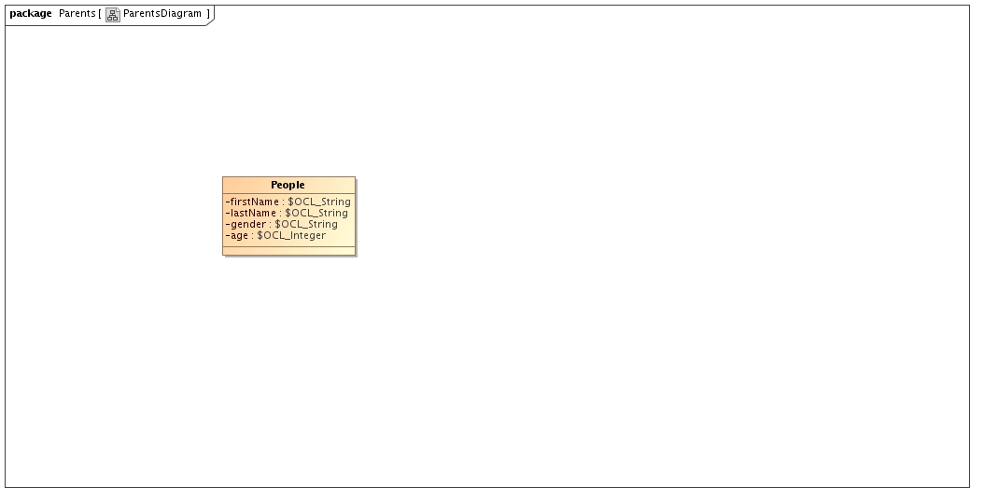
b)
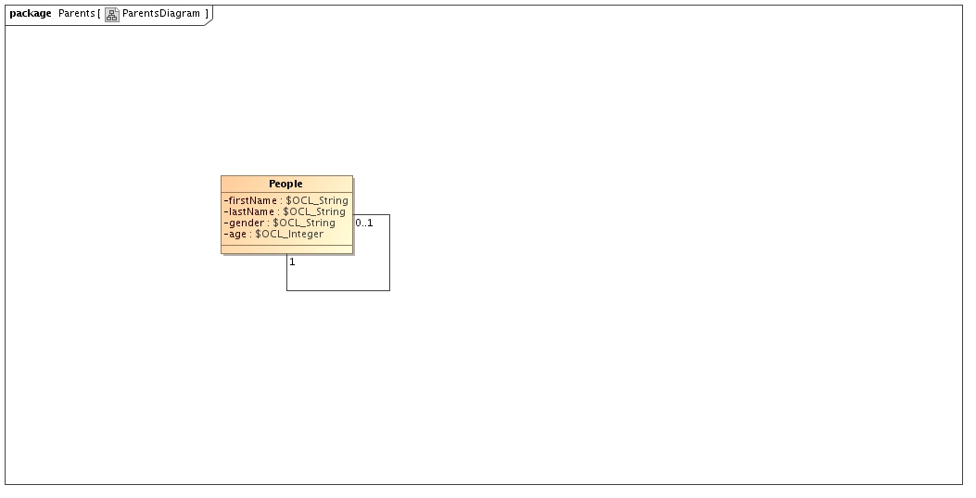
c)
