Lab 4
Name: Shun Zhang
EID: sz4554

Part 1
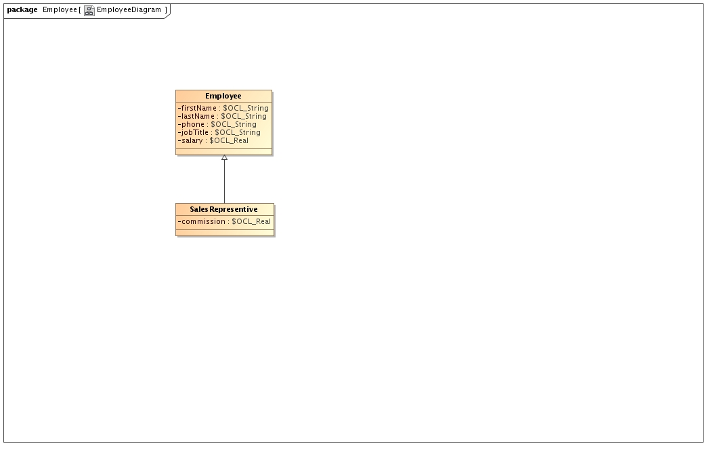
--@(#) script.ddl

CREATE TABLE EmployeeTable.Employee.Employee
(
firstName,
lastName,
phone,
jobTitle,
salary,
id_Employee integer,
PRIMARY KEY(id_Employee)
);

CREATE SEQUENCE EmployeeTable.Employee.Employee_SEQ;

CREATE TABLE EmployeeTable.Employee.SalesRepresentive
(
commission,
id_Employee integer,
PRIMARY KEY(id_Employee),
FOREIGN KEY(id_Employee) REFERENCES EmployeeTable.Employee.Employee (id_Employee)
);

Part 2
To create tables

CREATE TABLE Team
(
teamName varchar(30),
coach varchar(30),
venue varchar(30),
id_Team integer,
PRIMARY KEY(id_Team)
);

CREATE TABLE Game
(
id_Game integer,
fk_AwayTeamid integer NOT NULL,
fk_HomeTeamid integer NOT NULL,
AwayTeamScore integer,
HomeTeamScore integer,
PRIMARY KEY(id_Game),
FOREIGN KEY(fk_AwayTeamid) REFERENCES Team (id_Team),
FOREIGN KEY(fk_HomeTeamid) REFERENCES Team (id_Team)
);

Query statement (the part to get the total scores of a team duplicated. I tried to make t2 refer to t1 but it doesn't work.)

select teamname from
team
join
(select t1.teamid from
(select teamid, sum(score) as sumscore from
(select fk_hometeamid as teamid, hometeamscore as score
from game
union all
select fk_awayteamid as teamid, awayteamscore as score
from game)
group by teamid) t1

left outer join

(select teamid, sum(score) as sumscore from
(select fk_hometeamid as teamid, hometeamscore as score
from game
union all
select fk_awayteamid as teamid, awayteamscore as score
from game)
group by teamid) t2

on t1.sumscore < t2.sumscore
where t2.teamid is null)
on id_team = teamid
