Lab 5
Name: Shun Zhang
EID: sz4554

(I resized the page to show the query results in one line...)

1)
a)
To build up the table

CREATE TABLE Title
(
position varchar (255),
domain varchar (255),
id_Title integer,
PRIMARY KEY(id_Title)
);

CREATE TABLE Employee
(
name varchar (255),
id_Employee integer,
fk_Titleid_Title integer,
PRIMARY KEY(id_Employee),
FOREIGN KEY(fk_Titleid_Title) REFERENCES Title (id_Title)
);

CREATE TABLE SupervisionRelation
(
id_SupervisionRelation integer,
fk_Employeeid_Employee_Sub integer,
fk_Employeeid_Employee_Obj integer,
PRIMARY KEY(id_SupervisionRelation),
FOREIGN KEY(fk_Employeeid_Employee_Sub) REFERENCES Employee (id_Employee) ON DELETE SET NULL,
FOREIGN KEY(fk_Employeeid_Employee_Obj) REFERENCES Employee (id_Employee) ON DELETE SET NULL
);

Result.

1 rows deleted.
NAME
-----------------------------------------------------------------------------
Powell
Hicke
Fenves
Beckner
Miranker
Mok

6 rows selected

ID_SUPERVISIONRELATION FK_EMPLOYEEID_EMPLOYEE_SUB FK_EMPLOYEEID_EMPLOYEE_OBJ
-------------------------------------- -------------------------------------- --------------------------------------
1 1 2
2 1 3
3 2
4 2 5
5 6
6 7

6 rows selected

b)
To build up the table

CREATE TABLE Title
(
position varchar (255),
domain varchar (255),
id_Title integer,
PRIMARY KEY(id_Title)
);

CREATE TABLE Employee
(
name varchar (255),
id_Employee integer,
fk_Titleid_Title integer,
fk_Manager integer,
PRIMARY KEY(id_Employee),
FOREIGN KEY(fk_Titleid_Title) REFERENCES Title (id_Title),
FOREIGN KEY(fk_Manager) REFERENCES Employee (id_Employee) ON DELETE CASCADE
);

Result.

1 rows deleted.
NAME
-----------------------------------------------------------------------------
Powell
Hicke
Fenves
Beckner

2)
A)

B) (next page)

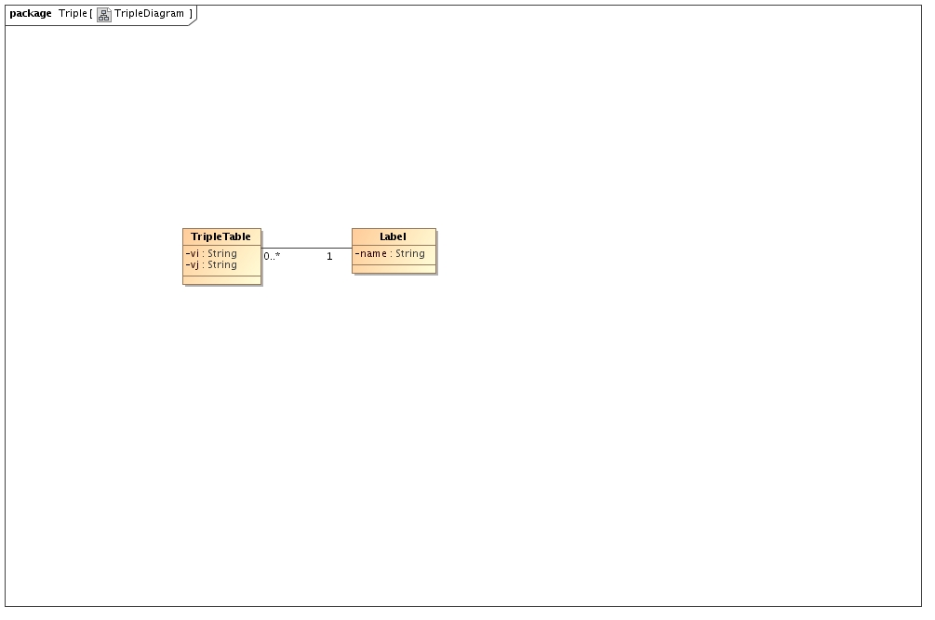

C) (next page)

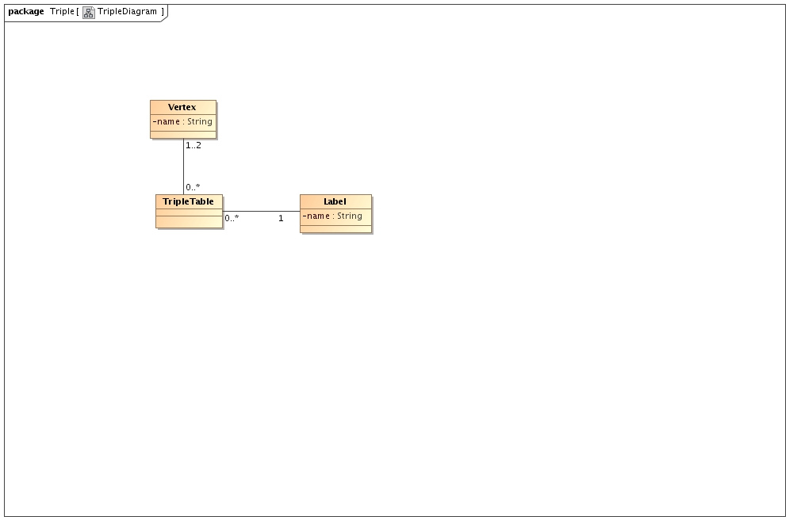
(For a TripleTable, it might have same vi and vj)

