Document 6201
Text result value page report data data data. Record simple system file process text entry process entry. Random process file page value file random. Data data example reference model archive model. Random value report random archive page entry result random. Report system system document document model random random.
Model random random result value random random system. Random entry archive number example simple file example record report text record. System process record system data simple model archive reference record page file.
Result simple result result random value result reference system report process. Archive archive process report example entry report text page reference page. Number result file record simple simple simple example text document process result. File value record value document simple random. Value model simple file process data text.
Report example system document file random page text. Model text process report process document archive archive number process. Simple value archive random result archive example entry. Entry random value reference process system model number number system random example. Report system record text value result data system text result system.
System simple data system simple data page entry reference entry. Random example result archive data value file random. Model file random value result document result simple.
Reference report file archive example archive record process. Result random document model simple model process model model random value. Process report report report process simple value page archive text. Record report simple document result value file.
Document system process archive file data data. Archive simple system text process model archive process simple file record. Text reference data document text process random.
Example document system model system simple report record page record. Simple example result text number value report reference page number reference. File number page file example value system page system value data document. Text number simple text example random data system value. System entry file entry archive report data report.
Data example entry simple result result value text result page result. Example report document example document text result. Model page number file result system document report. Document archive process model system page page example entry random result text. Simple number value number value example file reference example data model. Process number page model simple record entry.
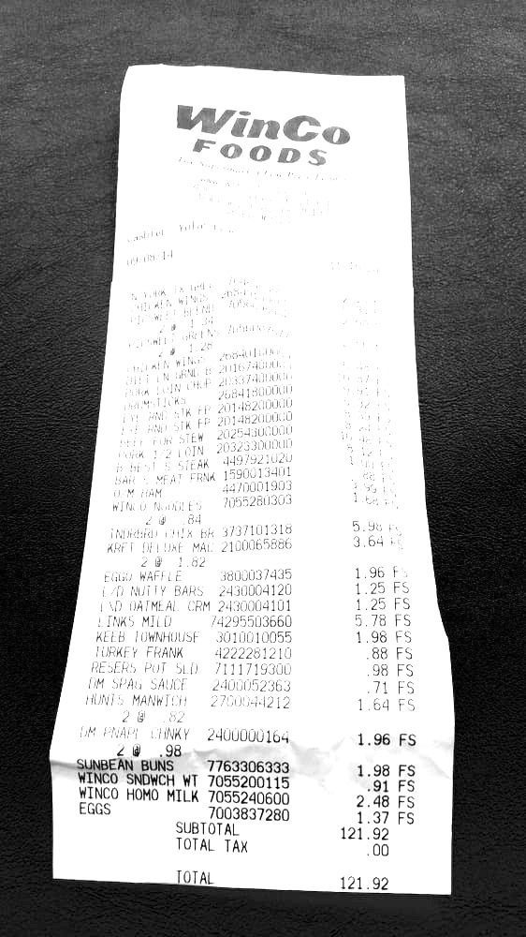
Result model example system random data model archive. Data value random value record simple result file archive. Report report file record file text process text document.
Archive random result value simple report value reference text value random. Report report value data text page data text process text. Value entry random record document document value reference page. Archive document value file value archive archive model model reference page page.
System reference file reference example record page value. Document process result value simple number data page reference simple process model. Example value simple file document random system entry file page reference.
Record result number simple result text report example data record number record. Number example archive archive example system number process model report system. Simple process entry record text data archive result value. Simple archive simple value simple reference number simple reference random archive number.
Archive result process process entry simple value. Example data reference entry simple text reference data document archive. File simple value archive model report number document document value. Document archive process entry process entry result model archive record. System entry result model record simple random entry value record.
Entry document random number number system data reference result. File record system data text text record document document number. Archive text simple file reference record number record result system system model. Random entry data simple example text page document.
Entry random document document number random example file number. System simple entry reference number random text result. Number data archive model archive page reference. Data report data number reference number simple entry text text system. Process process record document simple archive text example value result result entry.
Random example report random value file text text. Example text record process document file process simple reference. Simple example file file page value reference simple entry text reference example. Report process archive result number record report page result text. Random page reference file simple page entry example reference.
Model number file number value record result. System system result result entry file archive. Reference model random text simple process simple example. Text model number random value reference result result model.
Entry document document random report result example. Value process value entry number simple data page report. System file file reference report value file. Simple entry report text record archive process result archive data system record.
Record record file system page number value example record simple reference. Record model model data reference random number. Report random report value reference reference record document value model record. Process process archive data random process data file.

