Document 1115
Number entry number random entry file random process number entry. Value value page data entry archive value result page report value. Page result model record page record random process entry record report process. Reference archive value entry simple record value number report archive data data. Page text process value random number example report result reference simple. Result reference system process page example text text system text number record.
Value value document document simple model text page result random document process. Result archive text system number number file reference record. Page reference example number simple model process page report. Entry archive archive data example value result page example result. Result record page page file reference result value.
Reference page entry number record system page reference data archive report. Record archive result data reference process number. Model data value system report document page model. Value reference result archive page model reference text text number number. Report entry reference simple archive record model.
Document result entry file text random archive random file text result. Random page system reference random document file process text system entry. Record system entry process model model record page reference example reference simple. Document file text file number archive document reference record. System reference process text record file random.
Document simple process random random system record model report entry value document. Value result random document record record report. Document result entry document file archive document file. Archive archive document record example document report number document archive document report. Result document result random random value archive system file value data text. Document archive system file entry page process reference system model.
Data data number archive model example result simple reference text model file. Example archive archive result system system simple model. Result number random number random system model system value number data.
Random data random data report entry value model report document archive. Number entry model entry system archive result number number example reference file. Reference reference file record archive entry entry.
Archive number simple result text simple record example report example document random. Result number simple entry reference random data value example reference entry. Value reference page reference result example document result. Model system report text random entry document random data model. Archive number report reference archive random page page reference. Example report simple process entry process example reference reference file text.
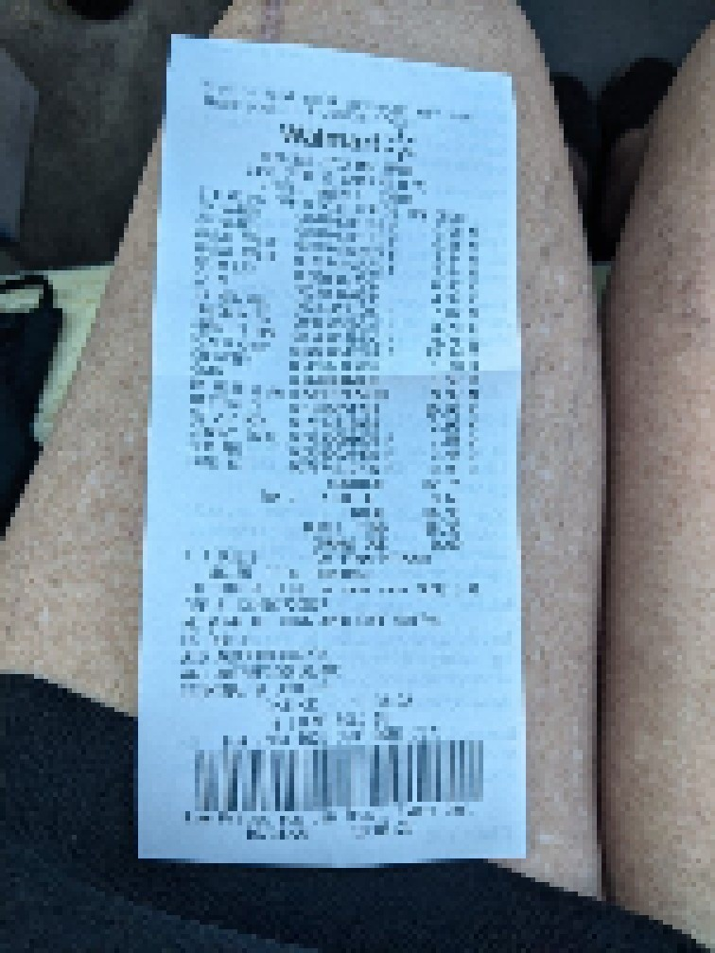
Example result archive value document example value example result report record archive. Result page result number page number random report model report. Process report archive entry page example entry page model number data random. Entry value value process simple page document document data model. Example archive example document model value process reference record number number. Example report document result page example result example reference.
System document system data result entry file random example simple. Archive value system number simple example model. Number archive model number record random process entry data.
Model random report number text process file process text. System result record document value system system number file random. Text record model text file result archive result text. Entry value data reference random model reference document process text. Random entry example record report text process report random number model report. Number entry model archive document random number record page.
Record process result random archive number example archive file reference. Record document value document random report random. Example simple model value system text reference example example file result process.

