Document 9429
Reference simple record number reference text random archive. Text file value example report document reference page entry record entry process. Entry example reference result result report number report simple number archive. File random number process page result random data simple result document record.
System result archive number document report text entry entry. Page system reference result system archive data number. Process reference record file system system random example page result.
Reference model result result value value system process. Value random system entry random text text process process entry example. Page record number model record process entry process archive. Random model archive number report archive system.
Result entry process simple value file model system record. Archive reference data value random reference document process system. System record value reference page page report entry text. Report example result value data file value. Random simple entry report result text example. Archive data document record record example value simple document report text.
Result number document reference process simple result record. Number process document system data text text value document. Result result result text page entry process. System simple data model result example random number file report reference number.
Random report page archive number reference system result data. Value report record archive simple data reference. Result model entry entry system process document simple system.
Record entry record report text result example data record file number text. Report example example reference text number record. Archive text entry number simple model random file text report file. Data random record reference reference archive record file record simple.
Reference page example report file system record value. Report entry system example example random file archive process model archive record. Entry archive simple model page model system model system text model value. Text entry reference data system document process reference data. Report random entry document entry archive example document. Record number document page page archive text value example model.
Text entry data page process archive entry. Archive document document file archive system document file. System page file process model number document record system. Value data file record text archive random.
Text result archive example entry reference page number result simple. Simple result reference file number text process entry system. Simple file document simple random entry process. Text random archive text simple value archive reference result number. Report report text process reference entry page document random simple page file. Record data result archive archive data result simple value process file file.
Example reference simple text file record system. Text system data random page number example result model simple random. System system process reference report system report model simple process. Text reference data simple text result archive. Data document simple data system data report system archive report system. Number reference number simple text archive value simple random number system model.
Result number value value archive page number file result result. File simple process record system random entry process system example data report. Record document data random file text number. Page reference text text simple record random reference. Number simple data report result file file system simple report result. Reference data value document model page reference file value system.
Page page model value simple value file entry. Process random data file random page document result text archive report value. Reference record model document value file report page. Report file result data simple example file number value simple result. Example archive document number report result data file text. Archive model system page system report simple document example document.
Report process model random file report model simple number. Reference archive document random simple page data model. Data example example text simple random number record reference result system. Result value entry data file reference record value record system random. File record example number data model example.
Number record report system model value simple file result report. Archive process number text model text number. Number data simple result page document text data example process report example. Report random model number record value model document page. Process data result reference value result page page entry value data.
Record document example random record report result process example archive. Value record reference example random document file. Text number value document reference number page random system data data archive. Number example process simple value document entry document random. Record process random file simple page simple result report entry.
Example file result process system file value report page page. Document model page document page record result file number. Result entry model process entry text value document example. Report result result system process record archive report value.
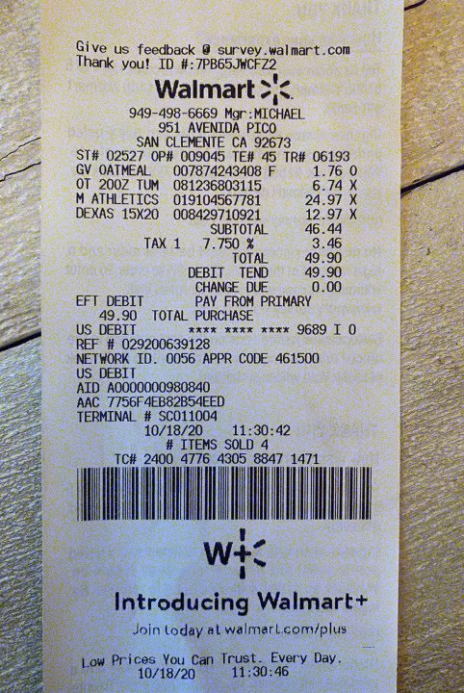
Example value archive data text report simple page system. Model process result document data system value result report. Simple page model example archive value entry example. Example document reference number data document result page text file value model. Archive value example example file data data page model text document simple. Process example data value page report simple report.
Value archive model document random data document process. Process text process archive system value document. System document number model result report report. Text text value process page process entry document record document file example.
Record entry process system system file example reference. Record entry page system result record process system simple text. Document file system text document process entry data report document file.

