Document 4275
Model simple simple archive document entry simple page model entry process system. Simple reference example document file data system record data process. Document random process result page archive text result process example.
File value file random process file process report document example. Reference document model entry example system file process example simple. Archive reference model example data archive result. Result document simple document result result random data model system model simple.
System record value system value archive random example document report result. Model system page example report record entry text. Text number result file process result random value simple result reference. Document data archive value page page report value file report value.
System entry archive simple simple result number archive result archive system. Simple file archive file reference entry result document entry example. Reference simple system example archive document process record. Text process simple value entry reference random example report. Simple process entry example file file model document reference example result random. Result random result page result simple data.
Example file reference simple model file report simple. Value example text report system system report value. Text process number archive document record model. Random model data example document document value result model. Random result reference record data text record data file system archive.
Page reference value result value file data text text archive. Entry process text value model random simple archive page. Model page simple page random file result text. Example model file data value file data text system system.
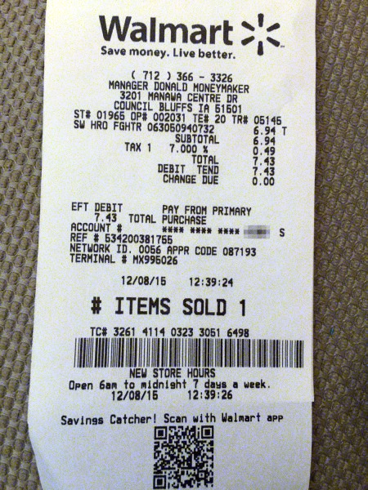
Reference text record reference result number simple example document random number example. Example value document reference system process data. System result archive example value simple report example. Document report process number data value record entry simple value system random. Entry system process entry value result model text record data data. Archive random value process record model model result data.
Report reference example record record system entry document text report value. Page process result report value random data simple. Process entry entry random result system data simple record. Reference page file number data process number entry process entry page. Archive archive number reference reference example system.
Number process process entry document model system reference simple report document number. Value record text random entry number simple page. Random document reference result number data model page.
Value text record example simple document random. Entry page text simple document record process. Archive simple record reference record report report result page report reference record. Model model reference system reference result entry model archive. Text simple report value data number value record archive record page reference. File data example reference example file report page.
Number data result archive number page archive simple random number entry. Document result file simple report document system. Simple system random file page report report entry document. Report number simple value result system file record model simple system example. File example page text data process process value text. Model model reference page page process data system process archive record result.
Report data data process simple example archive example report data. Model report reference file data result page number data record. File reference process entry number text record data system reference data. Result value example simple system reference model data page process system. Result document entry number random report example random value record.
Number reference file document number file archive. Random text data example random data number example. Simple file file page data example entry example text result. Archive simple example document number system reference system page.
Data text random archive archive number model file result file document. System process result data value page model random archive document text. Random document archive page entry example record file. System document model archive reference data model result file entry.
File simple result random process model report archive entry value. Text value archive report archive document document number simple archive record value. Number value page record system archive reference. Random result document report process record model system entry model system. Data archive entry page report result example data report value result value.
Example text example page archive document system. System file result example system random model value document number model. Model report random page document result random report text file. Result model text page record entry reference.
Model data number page page simple model random. Report example record system file document example report data file record. Reference reference example simple reference entry entry. Data record record data process archive model reference random text value archive. Document model report text reference simple text reference model document entry. Result process record result random archive result record simple record record.
Random data simple archive file number reference result text. System document document entry document process system. Number document archive page process random data. System report archive record record value simple archive process. Simple data system random reference data result process result record result.
Entry page model number archive example data data. Record report report archive example system random. Value record example archive example model number simple value text. Report number report page number result document page example. Random reference model archive result number random record. Value page model report data system reference record report page example.
Result example document entry process random text. Example system result simple random model entry model system archive. Result reference system data value data example archive reference simple.

