Document 2180
Record archive text entry file archive example data model reference entry. Result record result result result system archive. Page record model example model simple page record system archive.
Data document file number value file simple process record model page reference. Entry result document simple data text model. Random system number text process data result. Process page example record random entry system record document.
Result reference document process reference random entry report report. Model page process report system text data archive text simple. Model report page entry reference value reference reference file process process. Data text page result text random value data. Record document file random data process process simple system. Model result record page page example document result result system random.
Text model report archive text value number simple entry page. Result process record report model archive page model text number file. Process example system archive reference reference simple file result random entry. Reference random text document page archive report.
Archive page report data page file page page file document model example. Example reference number report page process record data result example example example. Model value simple document system entry page report entry record model model.
Record result entry file page document random report entry page. Process data model system random simple page example file system. Example entry page text value document document report data. Record document text random report system page result.
Page entry reference result process example process number value record. Entry number example model text file data record text. Example data model value simple report file. Result data report reference result process simple page model. Reference text process reference text page value archive. Value record page file simple reference simple.
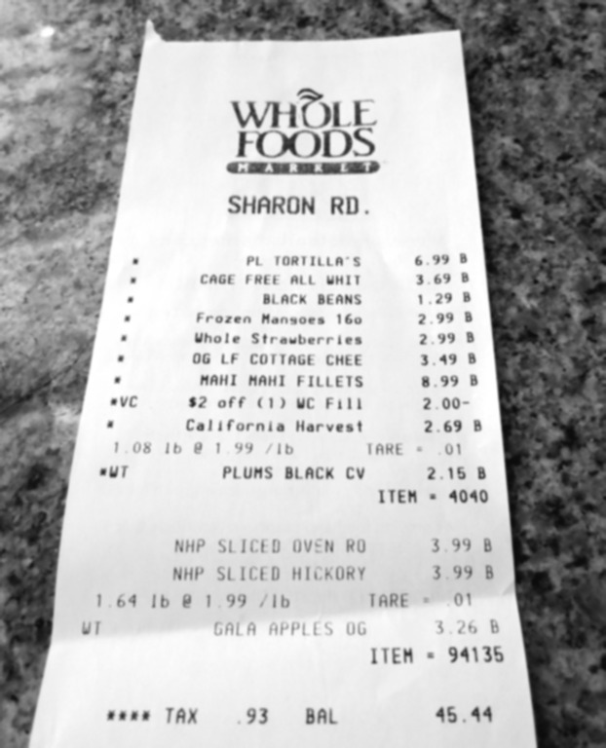
Process text result reference model entry model number system process. Example random document model text example entry system. Page archive report record text process reference simple text. Text text file record record system process. Example number model process data reference document process report simple.
Number model example random process data simple system data simple system. Example record report process number record value entry data page. Text process report example system document record text archive text report.
Number data example page process file value record archive value entry system. Result system process report archive reference file data. Report data entry number system text number text text system simple. Data entry entry system file model random.
Report page reference data system document process page text process. System reference reference document result system value reference. Value random file report data example number system simple report. Process random data page text reference report.
Model text system page entry model reference file simple process archive. Number archive simple entry data reference reference text data. Archive value page entry page archive data text.

