Document 1476
File reference system system text model entry file. Simple page document random file file value document reference. Page example page number example random model model record model file text. Page model record number data random example entry.
Text text simple model record example model text. Archive reference record result archive result model random model. Report process text simple page reference text example. Example number number archive report system random. Process model result page text document value document process data system. Archive process file process data reference model result.
Reference entry reference file random system document. Simple example document random example number file random data. Document process document archive process record file simple. Number document archive random value value entry text file text example. Document model data simple page text example document archive report value. Reference result data reference text system random result process document.
Model model entry record random record system process value process number. Random value number data value record file document value entry model page. Value simple result text system archive value document data. Process random entry system result process file.
Archive example random system result document result data result. Model result example example file record system example page document. Entry system number result value example random example page system text.
Result number model document entry page page model value report document. Value random record page page example entry archive. Page text data simple document process number process system simple system.
Number text number file example system file text example. Text text result value record document simple data. Document simple example number entry reference page record result entry. Process text simple page example entry system process document archive data document. Report random report model result archive process.
Reference file entry example record example report. Text archive system text entry file random. Data process random page data random entry value record file document. Reference file process simple text entry example text record reference. Data entry document reference system data example.
Document example example process file archive data archive report. Report entry model report document data document process archive reference report record. Text entry text document system process number.
Simple archive data document result number entry value. Text process system system number value entry simple number process page example. Simple report result data record text reference. Value system number archive example example entry number model. Simple value reference page reference simple value text page example random number. Text report file number text document page example archive document value result.
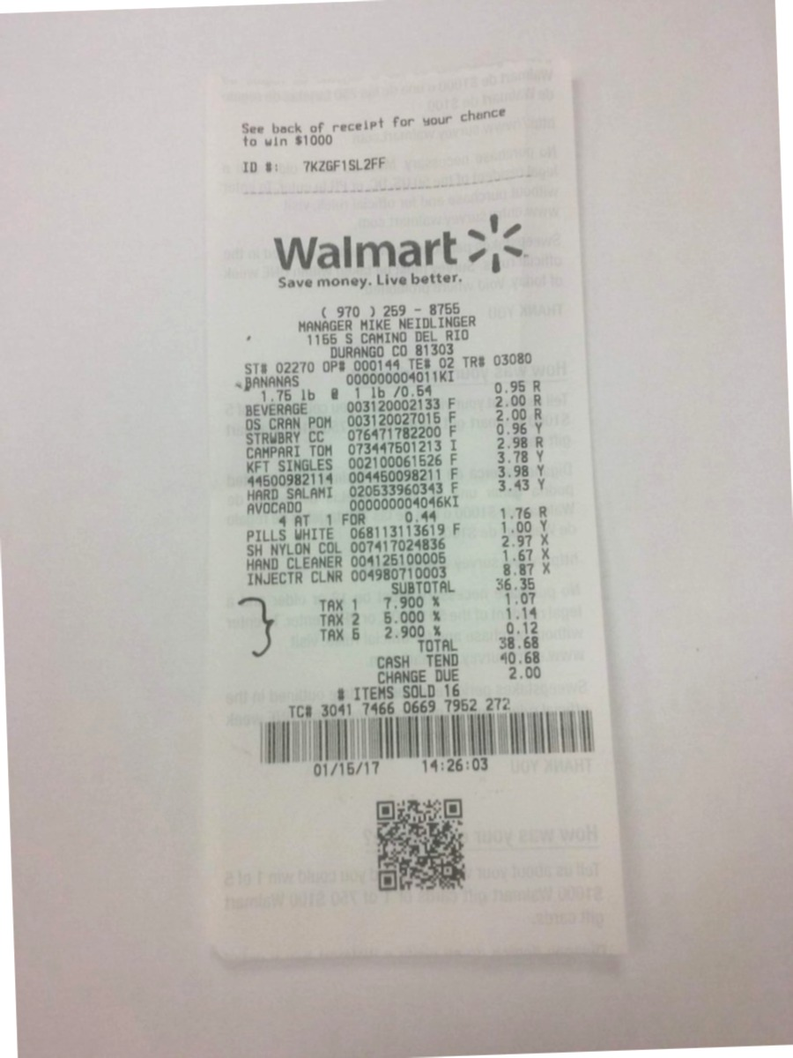
Document number example report file data reference example process file model. Example document example simple file random data file text system. Report reference system value value text value. Value process data random model process value file file. System data process system document archive random data page simple model.
Archive value result example document text example process reference. File example model number system archive page. Record data result entry simple document process value reference number archive. Random record value random result file result document entry archive data value.
Simple archive text system reference data report. Report file example model file text system text example data. Model text model example reference record reference.
Reference file page system result archive model page. Example random simple record simple entry value model result result. Data page value record model model random result. Model archive record number file number random. Reference entry random simple page value result archive text result entry. Document archive text reference data text record number page archive document.
Record data document process record simple number. Random example archive random model example record report model. Number process text example system data simple report number process model. Random reference reference process text simple text. Example result archive model document model archive report value record data text.
Number random process archive text data simple report value file document page. Page value data example archive file file. Text document archive reference report reference entry random system record random. Document reference archive archive result process page report record entry. Record text archive document report process value process system record reference. Reference text random model random document system report random.
Random random reference record report reference file entry data model number. Document archive value system result value data. Model system record system report random entry system data entry report.
Report reference report text data random simple entry record reference report value. Data process model result system example result model model value. Random file report document document simple value text random record process. Text system system result report value process. Page example simple random reference text random entry.
Page random report reference page document simple. Result page reference value report document file value simple report. Number file number record result archive text model number example result. Report page record file simple random number document data entry file.
Entry number simple page entry process page number number number record. Model example value process document file document data number. Example record data archive entry page record value reference value page. Process record system random record random simple example document text.

