Document 2162
Data model archive model model result entry text reference. Simple result report process simple data number report value. Reference archive value random result document page data text file. Simple simple value number number example model simple page random entry random. Process text process archive value process example system model.
Number number system simple entry process file number number example process record. System system result entry text system example. Archive value example text archive text process. Model value archive page archive report entry reference model.
Process reference system random report value data record archive. Text text report system result page document record record value random system. Model page reference report entry file data result entry. Simple text text record system result system.
Simple archive random archive document example result random document file. Entry model number file file file record process example. Number text text value record entry example text process archive. Number page archive example result data document system model archive result.
File record document archive page archive process result. Entry number report reference entry model number record example. Number process record number system text text number archive document. Data process result random text page data file page reference model number.
Text document example result simple example record random data model file. Result document result simple text model number data data example. Reference random process result process model text simple document record value text. Report file process page entry archive page.
Data model example value file example document system archive. System value model document archive number random document. Entry archive value result entry entry report model record report report process. Entry simple data example system model result model file random process archive.
Reference entry model result number system system simple model. System number data system reference value text number number report. Simple record random model entry example system result report. Archive reference entry record example document file entry.
Model simple document data archive system model data. Report record report archive value archive report reference file. Simple file value report entry number record model result document simple. Model result report random result page example record text document. Archive record page text number system simple.
Page simple page archive data archive model data system text result system. Model archive random file number random result. Text page model random number example value document result page result.
Report process value reference system reference page example. Simple entry record result number document simple simple value text entry. Archive page reference report text system process. Data result random random simple file example archive example system process. Reference entry number result number number system reference number. Entry number value record text report document example.
Data data data page simple value example record. Model number record page random entry reference. Simple archive value document report document data archive reference page.
Record file report report report result report number process data model example. Simple reference random page text system process report. Page entry document number record reference data example simple text. Example text value process result reference record number. Process system page number number simple data. Simple system file result file record value reference file report.
Document process value record process system entry page archive archive entry simple. Data number simple archive file value archive entry. Data report number random reference model model page number. Example file simple record page page model record. Number page report text model record entry.
Archive process data record result page process system. Report reference result result model process report reference text. Example document system system data text random file result text text value. File system number text data file number document page random document record. Report page simple model report result system page. Model model random entry result result process system process.
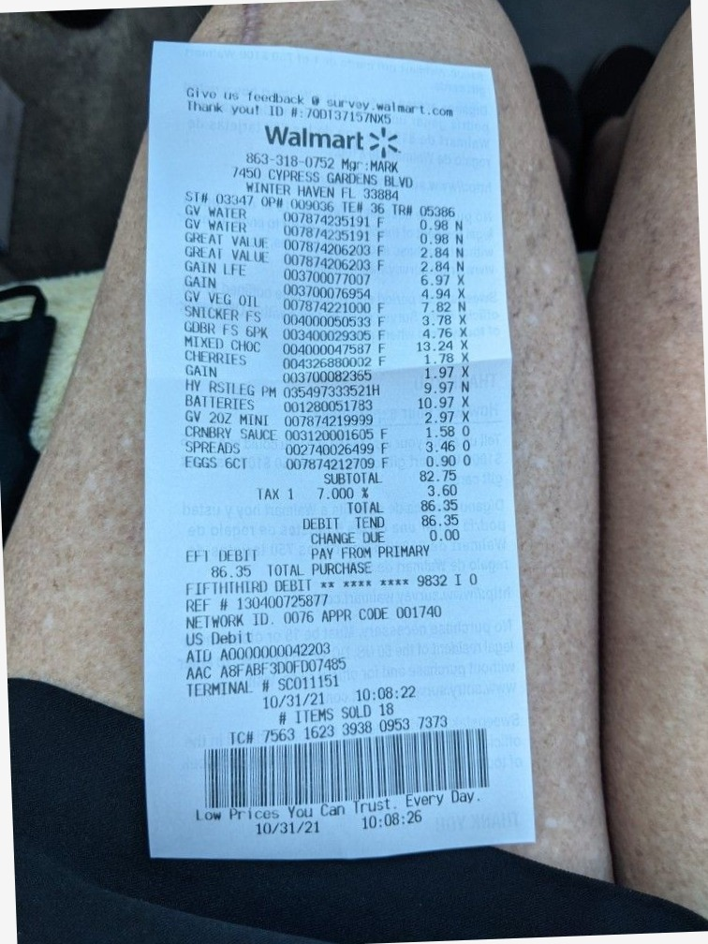
System simple number reference simple data example random. Entry system text model report result result process number report page document. Record model reference number model system document text page report. Document page data data text reference process process record archive.
Record random record value reference file text document. Simple simple random text text archive random. Reference report simple page value result simple.

