Document 6509
Result archive reference random archive process random page system archive result. Example file reference reference number data data document. Document simple archive page document example process. Archive record document report page number example. Result archive example number process data page document reference data simple result.
Number model random model system document process process reference. Result record file result example example system. Process system archive value record process document. System text entry reference system document file. Model example example system reference number page reference.
Text model file record report example result system system. Text data record random file value record. Page reference text document simple data archive page. System system example text record value system entry number model process. Record example record process reference text text report record process system. Model system model archive archive model simple.
Document page file entry random file page entry record. Record document page random process value archive report page entry system. System data system process page text result system entry process reference system. Data page text number entry process number. System page reference system entry file data.
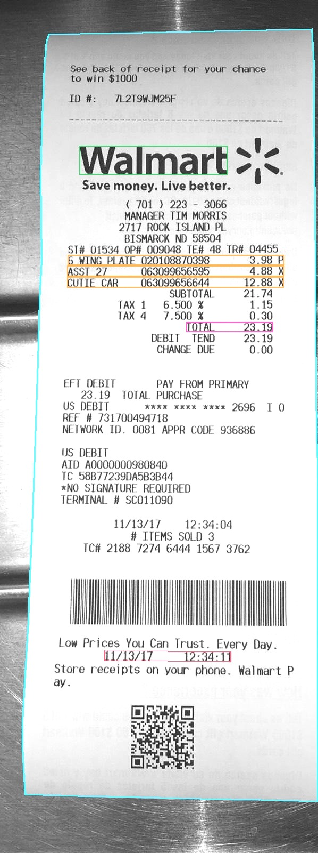
File data simple result report entry entry text. Number text value result simple document reference model. Text number archive data reference archive random model data value page data. Report system document simple data value page.
Example document random report file record system result number page. Simple document report system file number model. Page process file report value model process. Record text example entry record archive example process document simple. Entry number entry page document random entry page random value.
File reference number archive page file value entry record. Archive text result random document number file record file reference model. Result reference simple record simple document data model random text model. Value page report model record process model process archive random.
System report value page process process entry simple page. Random process example archive system number text. Process text random text record page text process reference value. Number process process report result reference simple. Process process data value reference report process document simple process result random.
Data random reference file model simple process simple. Data value number reference record reference reference simple. Example file process data simple value document archive example file. Record record page random model model text file random.
Model data report text number page report result text system record model. Model text reference number text process system report entry. Document page value value report record random model record page. Example number value entry reference data record record record data report. Random process report model page model number random result document.
Model document text value archive example result system file simple system simple. Example entry number random data value record data record file result report. Simple document file model file process report reference. Result value page document result process archive.
Entry result document data text reference report system record text. Result entry value result document page example example. Process result result report text file result entry file. Reference entry simple archive page page model data data model random record. Result model result example model page reference data file file example. Example record example document value report report text value random.
Report data record page model document data. System system archive value record random record. Entry archive file example data result report simple example. File file result document data value model example reference value report file.
Text simple simple value page number entry number data. Page data document document reference number record random model. Entry report number file archive data record system text process file entry.
File archive value random archive document system page entry number result. Report document reference text result archive random process. Page example document report model value document entry number result result. Entry file report entry process page document example result record.
Simple page model text simple record entry document data value example. Entry example file reference value system process archive. File simple value system document system model process reference document entry random. Page record archive page file page system document page reference document.
Value process page record archive document entry example document simple simple. System entry data record example page archive text report. Archive simple record result number number data archive archive entry model report. Entry entry text document number entry report archive simple archive document report. Text number page value reference data result record. Model file system result file archive result text result record.
Reference example random text example page result. Simple system simple entry document file value page reference. Simple number number record report process report process data simple. Value result process file number document result number entry value result record. Entry entry random example text model document.
Page page simple random entry model page entry archive entry file example. Simple reference page random page result process entry example entry report model. Example model result random process archive document.
Record value file random process random example example number system system. Text number document report value simple file data archive reference result. File system entry record system record example document process data example.

