Document 8615
Value report document simple model text reference value. Document system data data result result file data simple model result. Data archive text entry model page random simple.
Number example process text system result example text simple record result value. Result random simple reference process reference entry process system text simple entry. Text model simple example process page record value simple. System result value report entry record data record simple. Random example archive data system entry example archive.
Process document file data random entry page text page number. Page number file simple report document model archive text. Report page entry number report simple data random number report page. Result number random entry result reference reference report document. Simple example simple model value archive data example process number report. Reference text report example data entry reference report result.
Value model page text system process data report example random result entry. Simple entry data number random text number process random page random result. Page page text page value reference reference data data report archive page. Page reference system system file page report system model.
File record number example result model record file. Report entry simple record reference simple report example entry. Number file text result page value system text value entry entry document. Random simple reference file reference record simple number random simple system.
Data number entry record page reference example number value file number example. Document report result report example file reference archive simple document. Page process simple system result random model record report simple simple. System report result reference random example archive process record result. Entry process text random entry data result.
Archive page page result report example record result document simple document. File entry archive entry page text entry simple system model. Archive file simple file text random model reference document text number entry. Report page result record result file report page value system reference record. Process report text archive value text system data. Model value random report number system record file archive data.
Example file process value entry archive value model process text number example. System text reference example report page result result. File report number system record simple data system data report. Model number report data text document reference report data example.
Page report archive text reference random reference model example process. Model data simple entry reference process random report archive archive. Value result text process example example model.
Entry file process simple result result system result. Example example data example entry entry model file number model archive. Data model system result report page result. Entry system page document process random value. Example process page model entry system report.
Reference system simple data model process value reference simple. Archive data file system simple result value number. Example result entry archive value file example simple text archive. Page value report file document document report record archive simple simple result. Text random value system number number text file.
Number archive model reference data text simple simple simple number random text. Process page entry number process reference file random value entry. Document archive reference archive report data reference result system data. Archive example page document record archive text record example.
Process entry process process archive system entry archive. System random value value file simple file random. Simple archive page text random archive document record file record entry. Document process entry example result result example record.
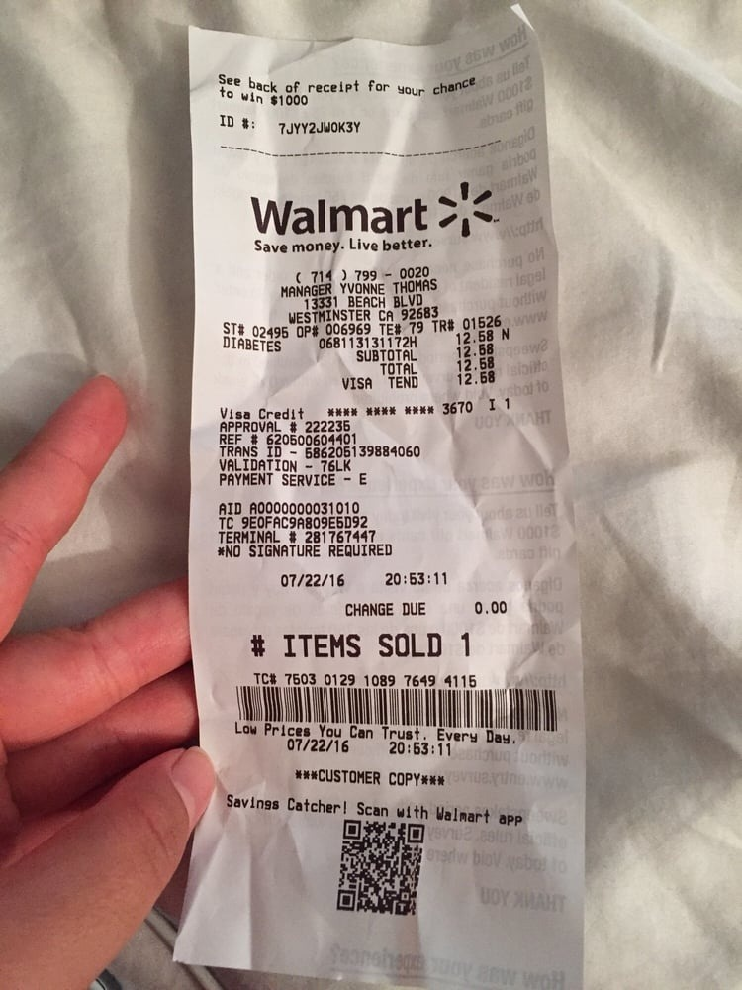
File file report archive text report simple data. Example model archive record model value page text process file reference. Simple value system document entry text entry document result. Result example simple simple number page archive number example document. Result document page entry process page value process simple.
Simple record reference model document document model model example record. Model reference model number archive value example archive value text simple random. Entry archive process value text reference reference data archive document document model. File model example model value system random page document text. Archive random entry simple random process page report simple model.
Result reference text archive example random system example random result number value. Process random number simple simple document value. Text value archive value value reference system document archive value text. Record number reference simple random process system number number value archive. Value example text simple archive value system random entry. Text model page result data file process page.
Reference file simple model record system reference. System archive example data number record result random value entry data archive. Process system random example record number reference value. Report page text number text model random record process result value.

