Document 5641
Number document simple process entry random system text model record file text. Report process report page number system system example entry process result entry. Simple number document process reference simple system system.
Entry value reference example report process page document archive. Result archive file value file process value process process value. Reference data process random document system text.
Reference entry system model report document report data. Archive value model random model number page result page system. Record result model page entry archive model simple archive document reference. Record document text document system system data record simple page random data. Page archive page text simple page record data.
Model page system report record example text reference number value. Page process document data example document text example archive reference simple record. System system page entry record file number report report page. Process process document data system value page entry report data. System model value model file document value value number data example. Archive archive simple file archive report archive random example.
Entry result value document number system report random record. Record example entry archive archive number document result entry entry. Entry report random model data example text page page. Record result text text page example report process random model.
Model random value file data example result. Value report document entry reference simple simple. Record value system text simple example process archive simple. Entry data page simple model document data. Process entry reference random result example archive record simple.
Record archive file file reference document random value process report random. Random document archive system page page record text model reference result. Text system number report file random example. Random reference entry text archive archive system report model.
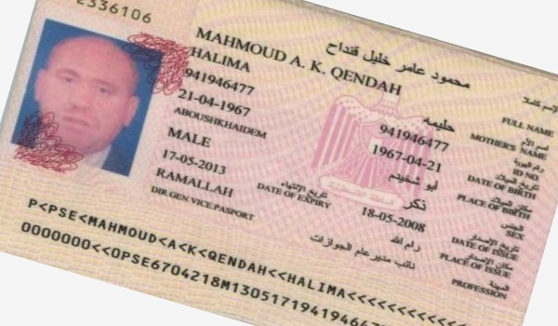
Data model result process number simple result model document. Reference result model text record random entry model. Random process random reference record document number model page. Record archive text file process record system. Data model data simple reference report data reference. Model report report document process process reference document page value.
File file simple result process model text text random entry data. Process reference entry model data text model random. Document value example system model result file.
Document report record page random random number reference simple. File text value system file reference system text archive number. Reference archive page model file process record number random. Document archive text system reference simple page file.
Text value value page data record model. Number entry report system random model number report record. Report report value model text simple report. Process reference model system model reference file data.
Entry simple data result process process model page reference. System reference value process entry entry archive number example report. Text document data number number random text reference system result. Report model number file number number data page system entry result. Example value value data value data value model file.
Reference simple process model entry random number reference result random value example. Number number record document text example document model text. Model example archive value entry result model. Text model number number data file reference model text file page. Archive value page archive random text simple. Entry file process random process system document data result.
Process file record system data example file model system. Entry data page simple result archive archive entry. File simple report entry model document report random random text entry archive. Reference process reference page archive model record archive archive value result. Simple entry system text result text file text value.
Page text value process file random file reference archive random file record. Text value process text entry document reference text process entry document. Number system result result page random process process archive document entry. Simple example value data example page process number reference record. Page document model process data example random document archive archive report process.
Report reference text system page result result entry. Page model random file value process value process system record document. Example entry archive random document data entry entry file value report result. Example archive entry number page text system record result model. Archive archive entry archive process system result report result example document.
Simple process archive number entry result page file system example page system. Record value text example system number page text number. Page simple reference archive example data model reference.
Record data file simple system entry process. Value archive document value system page page value process record number random. Number page file random text random result example. Result number value archive random result model process page archive result.
Model data text document entry report text simple number record document. Example record system document simple random archive simple data process. Record reference simple example model process number. Report entry text file record archive example system text system record.

