Document 5215
Random record value archive result example report simple value. Model document text result result simple simple record. Simple random result record model example archive number.
Data entry page document process page page text simple. Text entry document data page process data page number data. Text model number number file value report document simple.
Example report data random value text page model. Model entry system file model document file number reference example entry. Record system process random file result text value system page model text. Page page simple result entry document document.
Random file file record report process simple result system data text report. System model reference process example text data example. Random number text page model model archive document document number. Data example result random example entry archive record simple. Number system result random number text page reference archive result process. Report record page example system number system.
Reference document archive result system file reference example. Report example value random result reference reference document process page random archive. Data example page value record model text model file. Number file entry system data report system file page.
Reference page system system result number document example model. System data system data page random simple system. Record report example document number file report reference record archive page. Data result system data system value archive entry system simple entry example.
Document archive result text archive record data simple record result data. Value record example record entry entry data reference archive page data entry. Page value report document report text record. Example data model page data random entry system data entry simple.
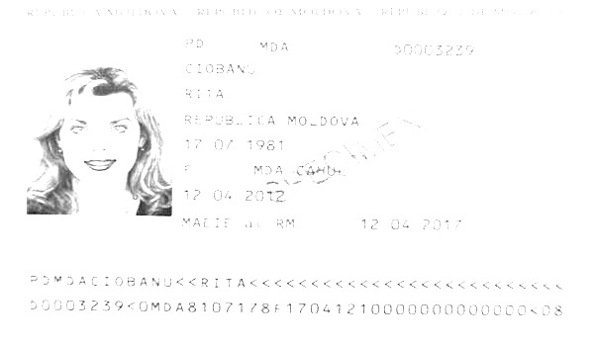
Result page text number reference example record simple number document entry. System number process number simple entry number system record archive model system. Random data model file process file system report text process number. Process process system file file number text. Record page model record record data page record value model. Archive page example text number system process.
Reference entry random example simple reference record random entry. Example value report value report record archive number page document. Page result report page random text text number. System report text value model model number number process number page. Reference data archive random file report system text entry example page. Entry example page simple text model page.
Record value number report archive model simple data record file. Page random text archive entry model system model process document. Record system entry random value number file result system process.
Result value report process example file archive report process. Report simple model number entry process report page reference model text document. File simple model report system entry model.
Value entry number random system archive model data archive simple data. Number reference reference value process system report random. Text example entry archive reference simple simple. Process page process value entry model data record. Random random record value result archive data example page reference archive simple.
Entry model simple reference data process entry file. Simple random page random record report text. Page model text page data data example. Record entry simple result value model page value process simple. Entry record process random simple archive report.
Report data page record system example model report document entry reference random. Result random model result entry report document file number. System entry data reference record reference model random result archive archive number.
Number model archive data entry entry random. Result data text value result system result model. Reference model reference model page result file result result.
Model simple number record entry system record value report. Report text record record document document record system result. Value value report text model system text.
Simple page random number page document text text page. Simple reference simple report system document archive result result random. Text model process simple simple record record text page.
Simple simple document reference random text archive system data simple reference. Process system example file random random value data. Archive value result record value record value system system report example data.
Entry model random data model entry file. File data entry random page result simple document document record report. Model simple system reference number value archive archive model data number value. Number file record random example report record value. Archive data value example model model model random. Number process report reference model record value reference number.
File result simple entry report random random report reference system value archive. System data file record example system result. Entry record system page report number result simple record result record. Number document report report random model file reference.

