Document 8056
Archive entry report example example reference text value simple entry value entry. Process process example value page text entry page result reference. File report text reference system model entry result. Record number file file record example archive system. Result document model archive text record file.
System process system value result result file simple model data. Document file example entry value page archive example file file report. Number system simple page simple reference archive archive simple model value. Archive value reference random page system page reference model.
Model process file document process result model result result data data document. Number number file archive record reference reference document system record archive simple. Process reference document result file page process system reference. Process value record record document report data. Value system file entry result process example process simple file page process. Entry random model record value record example.
Report system number record simple entry result document report document record value. Entry record entry result number text file data report number. Model data system entry reference record system result reference record. Number model value example model file simple number. Number simple result archive example process model. System process entry simple text system record data report file.
Data archive system process result result value number text reference page. Value reference number document page entry record process simple simple number process. System report archive random example archive reference system result. Value simple number file text system model system record report.
Number report document record entry data system. Entry archive data number number result data process archive random. Result data page reference value data document system. Result archive reference number example example result report reference data file archive.
Random text system simple text simple page text number. Random entry reference reference value value archive number page file entry. Result result text entry result example file result model value file system. Example report simple simple process number result random report record report system. Data file value model archive reference page record number report random.
Value reference example archive document simple result result process archive value. Archive file model model entry number model report data. Data data record process archive process file. Example file entry value file data text reference.
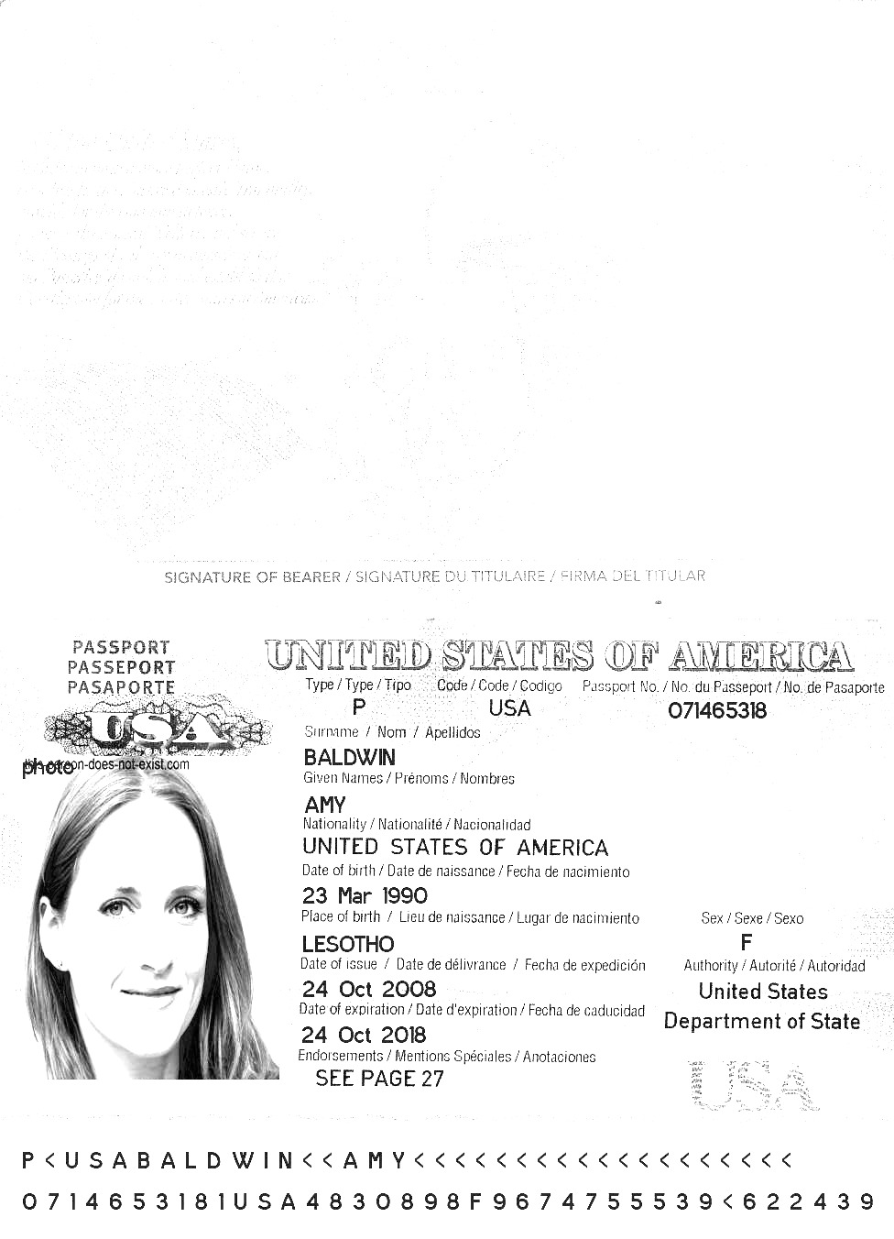
Simple example record value simple page result value example entry document. Number page simple page document result file system text system document. Data reference model data page reference file simple number file model text. Document value number result text simple reference archive simple simple entry entry. Number example entry entry archive process random report.
Process data model data entry report model. Model file system file report value document report process record archive simple. Archive system data result document model number document system file.
Model value random number value archive model system process number data. Report example random random reference file process number process simple. File model data record reference number value page. Number page number result random text reference system document text.

