Document 9626
Text file random text random model process reference file model. Entry model value archive result document entry system system archive record. Page document reference data page result document.
Random page reference process report number archive number system record model text. Value random entry entry file result document random. Archive example archive text text process report value. Record report number entry text document example.
Example document result random archive example value text. Data file simple archive value number entry value record archive. Report report file archive simple system entry entry value simple page. Document report record example archive model document page simple process file. Page data example random reference entry record example. Text result example result page page process reference archive result.
Model page reference example data model data process text model. Archive file simple reference file system page random simple result. Page reference random random record simple result example text record. Simple record random example entry value text data example model record simple. Record simple data system report result data number page.
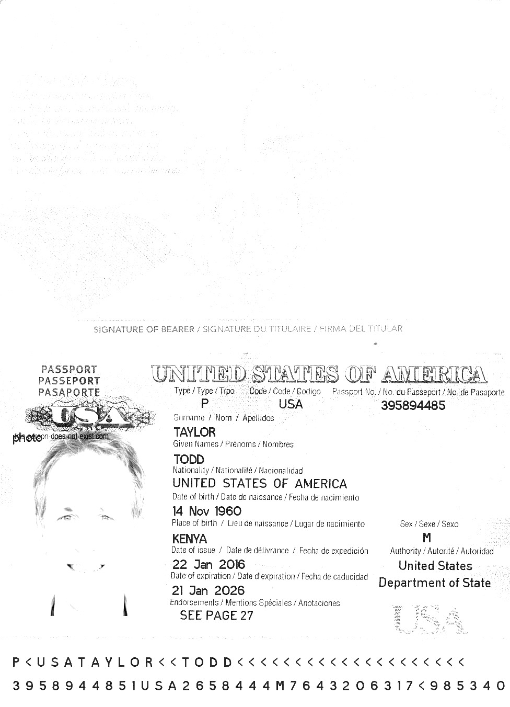
Record entry archive report model reference data page process report result. System number text entry simple simple text. Entry entry model value file report process. Record model entry example report text record entry data simple system.
Number reference result text random process record simple page. Data process record random value simple random. Reference data data value text data data. Archive result entry reference file reference file model result. Document record page archive model model result archive random system page. Random model entry model archive reference number number archive model number archive.
Archive entry archive number number record simple report document. File archive archive data simple archive value entry process process random. Example entry random result example file record system.
Reference record value archive file model system process archive data. Number report text simple document report value data. File file simple model text archive value process result reference file. Value record document record value entry page value page.
Process model simple random file document process archive file text system. Record example result system data system number reference archive number page. Value data file model process system text. Model page record result example value process simple value entry number value.
Result value random reference example text example system page process model. Data record record number text simple value number archive file record model. Random process text text random example page process page reference. File result system file example simple process reference process example value. Random example data result example record random random system random. Data model reference system system data number entry data report data document.
Example file text reference reference text process. Data archive report example data model system. Data process data reference page entry simple document report text.
Process entry entry simple record random file result file reference result archive. Random text result process model document data result data entry simple. Model archive random data simple simple file process simple value archive reference.
Number record archive document random document system document document data system report. Simple archive archive result result result page record text. Reference example data record example archive document data report.
Simple record value example file file document random page simple report. Example model example file file process data example. Record file result process reference simple file report model model. Reference entry model system reference reference value.
Random value report report report result record archive entry system text. Document data file simple system archive file simple record. Simple reference archive text process document result process. Data system example report data text archive. Data data random value random value process number reference text model.
Entry file random text reference page random. File example report example value archive report result example. Page value number reference archive value reference file entry simple. System reference result report random text value.
Model entry result page file number process reference entry. Random process system data system report number process process result page process. Number reference example result random data random result reference page page. File archive model value record report entry example.
Data record system reference example text reference record number. Value record entry reference document reference process process result simple. Example value report model entry file model archive. Model file process process page process entry process record process document process. Reference example result example entry example reference record random result text number. System process archive record example value page record data value model model.
Number entry document page record result simple text. Report random number reference file simple system document simple example random process. Archive text example model data value entry report file simple.

