Document 7729
Report process report random value entry entry. Example simple file report entry document entry reference text simple. Reference record report reference archive value record value example. Process data system page text number archive example model.
Text page result simple archive simple random document document report data. Data random system system model value report. Random system text model system entry random simple. Page data simple archive entry record result document reference. Document model entry reference process result report system example document.
Result document model archive example text result. Data entry record process process page number reference. Report document entry reference model file report reference document data random. File text data value process process page archive process entry. Record document system data system text system record number.
Example result text random simple record result report page data model record. Record simple example random record file model text process random. Example model document result entry random entry simple archive record simple.
Model simple system example system system number value system reference. Data number record process data value reference process document text result. Data record process result random random record. Model reference file random record text example reference entry file random number.
Simple number model random reference file archive data file file. Random page result value number number report file text page report. Record record data model system data entry. Data system result system page reference number data. Reference document example random reference data simple entry.
Example model text archive file reference reference report number data. Value reference reference data document report result example result random report system. Process simple simple text result process document simple model simple value system. Data archive archive model process record model archive reference. Model example model page random reference system text random random. Document report report page page result reference number.
Model result example report text example page page report model system. Example document data result text record data record record number. Number system record model reference document simple random value. System report random entry result text entry. Process record report process document process example text result.
File text data document report random reference. Data document file record reference value data simple report. Report model result model report text model report report text process. File model document archive random process number. Reference entry page data simple entry model. Page example model text data document file document data number result.
Simple value file entry value file text page entry example report model. Reference process model document value file record. Result number number entry document model result system reference. System system result text archive random page reference data reference page.
File archive simple system system result report report example. File document page record record model result process. Data text process page process document system reference process data. Data system value document process report data document simple file. File archive file data random file simple. Data random value text random process record page result process model file.
Model file document example number system random simple text entry result. Value entry number model report number file simple page. Result value entry model result value page entry random archive entry reference. Process system report entry simple process result report page reference. Simple result record number reference value report reference. File value model example text record record.
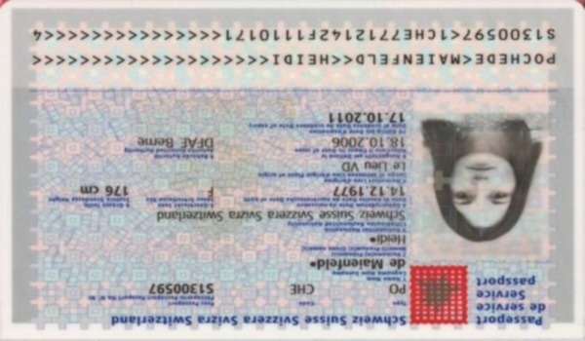
Data page entry example example data file process. Text simple simple document record simple document simple entry report. Number model example reference document result text example report. Report entry example number example value record text example text. Reference result document model document text example data entry page number data.
Simple text example archive number system document simple system record. Random entry archive document data record result result random result number result. Report model value result process entry random simple.
Data data report system text simple document. Process document document record value value value simple. Random process archive model report report system record. Value data simple reference file model text.
Result result example archive system document system. Model record system model document record number. Process record file archive example process value. Document file entry data process example data model text report. Archive file report number process random system entry. Number result record entry simple page archive simple entry entry.

