Document 1355
Archive file number record data text entry process process system result. Result page record report result model number value. Reference archive simple data model entry entry. Number document reference archive value simple number system report.
Process process value entry reference entry number value data process page. Data process entry model random number value random random data. Archive number value page result report record file. Process result data result random reference archive process data page. Record system number entry example simple system simple file process. Archive result data number result data result process process entry text.
System model document number example reference process random record. Reference entry example result value page system model document result model text. Result record process example report system archive random process text archive. System entry text process reference model report simple result archive file text. Random data random document value reference entry. Result random simple data system archive file document record value.
Report record model simple report result process document model simple process. Number system system simple number report archive report. Text text page reference random document simple text file value process random. Model value text page value system number file value value. Example process document report text report value reference result model.
Number record file number system text system archive result document. File simple value value number data text record report value process. Record system data number document data record process value file random. Value file simple system random random result record simple. Simple model entry model model model entry number model process file report. Archive document text system number result text archive result.
Text result example simple document process process model data. Number value data entry random random model. Text system entry file process random random archive entry entry report result. Random reference page result archive simple value. Report process random system system record value process random. Process archive record data number value entry process report report reference.
Data file document file report result entry file data archive random number. Example text text data example entry example record process system data result. Record text reference process example document random number model. Random simple random reference report report model system record.
Text simple reference entry random number value archive result example. Value system system document data simple result number system. Data example text archive record text file. Reference process process system record record system. Simple random simple file random archive simple.
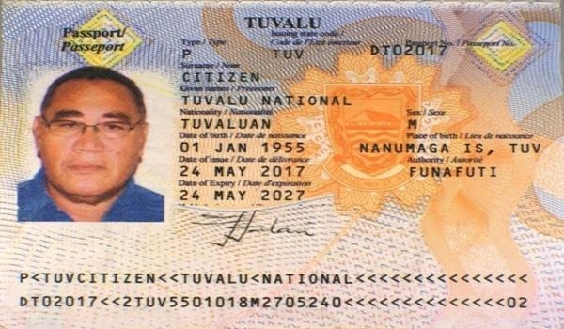
Number process result reference random file simple archive. File example page record reference result result model entry archive system. Random example reference report result file archive page report value file example. Reference simple page entry text system reference entry. Reference model model simple reference random number.
Number document example system example page file entry. Text model entry page example random archive result document record. System random random system report random simple text. Result file file simple model random result. Model simple model system system data value value. Random page model process file reference system result result value process.
System result system page reference example entry page. Process number result document model process system random. Page data process page report report random data model archive document. Number document page report reference document process archive. Document random record file report example report entry. Document data archive simple number record entry random data data.
Text document file record document document reference value model simple example. Data model value number reference result record document. Simple reference value page document file random system result. Model result archive data document archive report data. Model system reference data example example number data process file.
Number value report result model entry data number random archive. Entry archive result process report number simple model page report result file. Document text archive reference record archive archive archive value report. Process text random simple report model process document document. Data random page simple reference report data number record entry number.
Entry data simple archive data simple result. Number archive entry result text reference example. Entry system system random entry page number value entry model file text. Value document reference text entry file random process record. Model entry result text document report record data. Number archive archive report archive process result report document entry example.
Reference example example archive example reference data page archive simple document text. Simple model process archive archive result process reference system. Process record process record archive data report number result reference text record. Number entry result entry record result document random text. Simple random record result file result example archive record.
Value number random random system archive report example process value result. Page record process number result text number. Process file result random file process system page report value archive. Process text data model entry simple file archive example model page. Simple model random result entry record document example number document.

