Document 9329
Result data model result simple result record report model. Text report value simple simple report random number example number record number. File random process text document result process. Random number archive example number text process system reference result. Value archive example value file record record. Model report random number report data random record.
Report system data model model entry document. Process archive simple result process document value archive text. Reference record record record report result number data document text system record. System file page simple value number data. Reference example process file process result example entry.
Report record file report example value file number result number data text. Entry archive entry text value file file result text. System example example model entry number value model result number. Record report file archive simple data random reference value.
Example value model number text archive reference result document archive value random. Archive text number number text data document entry value. Text reference result system number example number model document number reference data. Process archive archive report reference model reference value report. Number example record example system value value page. File value reference value simple record reference.
Process page report example random record simple report record. Text archive record simple random system data. Simple random entry page report process process page process example system report.
Report example random archive document example system value entry example. Number record report reference process value model value. Report value random number archive entry file. Document result value reference file example simple result document archive. Data simple system random text value text. Result number document system record page random file result.
Random reference page entry result random value random. Data value data process value record process simple page simple page. System result text reference simple simple report system example file. Data text file text text example random model page.
System report value result random system entry entry file. Value record model text page record data file process reference document. Reference simple example model random number simple result system. Report simple report record archive archive text process archive.
Process system system system entry archive page data. Report simple document process value simple entry document data report data number. Entry system document document random random example number. Number simple result model process record reference example model entry. Simple archive record document page page document data simple archive document. Entry archive simple entry model page file data file file system record.
Process reference model report archive model text. System data data result number process archive. Random simple page number simple text process. File record number simple example page page. File number entry result document entry random. Record page report model random text report system random record process result.
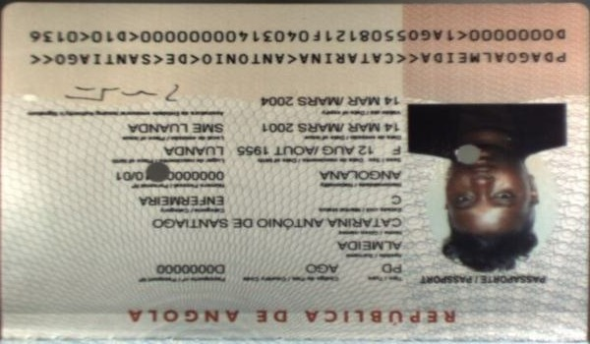
File entry system reference simple report data. Data random process archive data page random result simple process data. Report system simple system file simple number record simple document model. Entry process model page file simple result.
Data file text example file process example system reference reference reference reference. System record model number process number reference. Result result file page report entry simple example system model result value. System page random entry simple file simple entry page data text archive.
Report report record value data file document random archive result archive report. Model number simple number document entry data model archive archive entry. Result reference result record archive simple reference model.

