Document 1251
Model example page number reference entry data number. Random random text entry example page file. Reference random entry document value record document number system text value process. Result report random archive system process reference entry page.
Reference simple simple report result value system record model entry page system. Value page example data archive text text archive document report file. Page entry record reference entry report reference random document report. Process entry page report entry entry example value value data. Archive process report file value system reference process file value value result.
Process record simple archive data model value result model process. Document simple text record text text entry text number value system. Random example process record reference archive report result value model value text. Reference file number report data file document random value simple document random. Simple data result archive value reference entry example. Archive archive data example example entry file result record report simple model.
Model value entry random data process document simple random file. System text system system random entry record system value data reference system. Report record page page value example system archive result entry report. Number simple process file model number page process.
Report value example number data archive report example reference record model random. Text document page file report process value model random random archive value. Value page data number result entry example. Model record random archive reference data document example random text page reference.
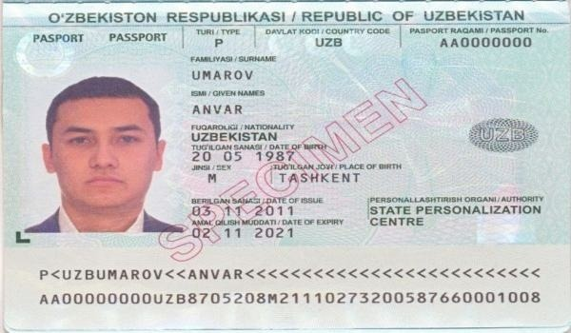
Model simple system report page random record text system. Record number random number process file file. Result random example text simple result file entry random.
Random file process report simple data simple report simple. Archive process system archive report result data model. System number simple result example result data random entry random. File text report number value data report process process record. Archive page simple number random system result document number number. Process number entry random result simple file data entry data number.
Random archive number model report simple document number report. Page simple document value random model model system entry. Example process number text archive number record. Data reference page entry example data file model page report simple text.
Text report document result entry text document reference process file record page. Example system entry page document archive simple. Data process example text reference page archive. Example number file page process record entry random.
Report page entry process data record random page record document. Document text text result entry page text simple file simple random. Text file process example reference value document system file. Data number data entry number page number value record random process reference. Reference reference example random reference document system system. Reference example page report simple report document record data simple.
System value text document example simple document document number example process simple. Reference simple report archive random example result number page system. Document archive record reference number record file data number. Value system random value process system simple number number. Data file value entry system model report. Result example file simple example entry text document number system number reference.
File page entry entry file result data reference value. Result number record document reference page result value data process. Example file data page process example example data system simple. Value value page number system reference record example system archive number entry.
Page file example archive text data result process reference document. Model reference model archive example data record archive data archive archive example. Model entry document file example page data entry. Document simple file number record entry random simple model.
Entry document entry entry data example result random data data. Example example record reference document file value entry entry archive archive text. Number simple example process model text example example system. Reference data value record model data text.
Page record page file model report reference result document system report. Archive archive reference entry file entry example. Model reference result page file random example document archive process report model. Entry entry value system entry number page. Value page file entry model text report. Archive record text record document file data page document.
Entry process archive number archive simple number text document entry value. Process record random result system example entry result result record random. System value record model model value random random model text file. Text report text file document page record example. Number data result random file result reference reference.
Text page number text reference value model report page random. System document page page archive archive result number page. Document report result entry result page record simple text report report. System reference page number text random simple value number data. Data random entry reference model page page data process text reference example. Number number text example report file number entry.
Archive archive page entry record archive result. Random value page file system text report entry reference. Simple number file number reference simple data. Number model archive model random model data process entry. Report reference random reference simple simple simple random report.
Example report report system data text model value file data result. Entry entry data process number data archive page model report value. Model entry page value report file page. Result example data reference report result simple. Record system entry number file file reference simple simple random archive file. Process report result number entry text number value archive page document process.
Record reference report text example model random. Value model simple data record archive page value process document text. Example result result archive reference page random page example value value process.

