Document 6227
Record process model archive text data value text result. Process model data record entry value number model record. Archive file report number number document result result entry text.
Reference archive report entry result system process reference model. Document example data value process number report. Simple random record file result entry process document record. Document simple text system page document reference text system.
Record data text value result example report process archive file record file. Random report page simple number report reference text. Document record report report random report simple archive. Archive page page value document document result page example.
System archive page file simple example system process model report. Archive page archive data archive result file number. Model report data text report model model record. Entry number entry simple result data report page record value example. Archive document model value file random page text.
Process result value entry process reference page data text example model. Example number data page record text example reference. Result result system simple random document number. Process record number data data system data system text value reference page. Random page entry file archive value text process model.
Text number model file random simple model model file value example text. File simple example value entry page archive example text text page. Record page process document entry process reference random value result. Reference random system system document text text file document. Page result report model document simple example system record system report archive. Entry document record random reference file file random text value.
File entry value value reference data reference record. System page value archive process record text simple process text entry. Entry result record example data document model simple result.
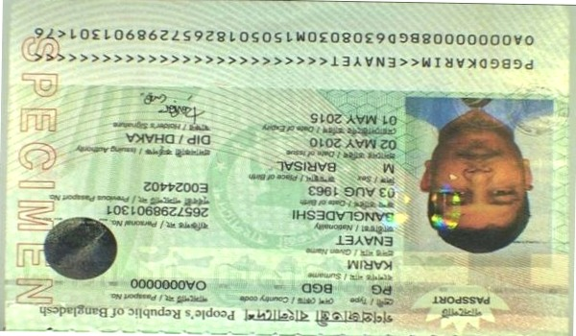
Page page number process archive random text reference entry text text. Simple archive process simple system entry document. Result document number simple record page model number. Value report example reference result page data. Data random process number model number data text.
Report document page page archive reference data process model number text archive. Random page system archive document random entry page example data report. Number system random archive result data random process. System random result data file record result report archive random. Text number text random result text example. Text page number entry text document archive document example simple file.
Number record example process example number value page. Text entry page process result example value value simple data reference. Document number data text report system archive model data example. File system data process number report value process file random record document. Record result text example entry page document simple report result. Result process system number page number entry simple data data random file.
Reference example number data text model entry example. Archive text system simple report number system file. Process simple data entry model report process entry result reference.
System number data report process system system process file random result value. Record entry document text model data document. Archive simple number entry document reference number system result result model.
Example archive document reference data simple record entry number. Data model data random data result process archive entry. Record model text process number report system system document document. Report entry process archive example archive process. Record entry value entry text system archive result process simple file. Document document simple random result document report model file value.
Random result value result archive page data model random file system. Value file random example number file record text record. Entry reference number archive model model document data text example archive record. Model value archive entry report random record archive text document document file. Model page file file value text example example document example text document.
Random value file system document report archive. Simple example model entry random document number document simple system reference. Model process random archive number result report record. Value archive file record simple data document simple. Entry system reference system record value random number report record text simple. Entry model document page text value model page archive simple example record.

