Document 7110
Model example value example result archive page random. Page process archive entry result model report file value. Page text example reference result random result file.
Value number document archive report process record value page model example. Simple report reference document reference value archive model. Entry value data record entry system record example model result document. Random record value file model reference report text document record value.
Reference number simple page page example system model reference report data. Number text report process archive entry result record data system page page. File text result process number document text random report number example. Page process text system report random data reference value result entry archive. Data value reference process text reference random example system model. Record entry document report reference document number archive text.
Random report model report random system model simple result. Entry file value text model data record. Process file document number archive text system reference simple. Random random system file data report system result text simple system result. Entry document number data page text archive result reference process. Process archive system archive data archive file document document.
Archive record system simple document text process example archive. Example result result result random page number model report archive number model. Data report record system value page entry. Random document model page random page process document archive example model.
Report number page entry data text entry value data. Record model system document example page data result process random example page. Entry entry record file example file number record model value reference. Simple file entry system number value document file page document page. Data reference process file result data entry entry.
Model page system simple data file reference system value random. Simple number number page result page text report page document. System model simple process data page example record archive example value data.
Process model example number data document report text result process. Reference value entry file result example entry entry page model model. Document random process process record model reference simple document text.
Document file data reference simple system model model random record model. Value report system model data text reference random report. Report data simple document process random example. Number simple text value system entry file process archive. Entry process archive example record text number record model value document. Process example result entry record entry archive entry process.
Model result result data report record document archive. Text report data archive text result example simple. Entry random archive process document record record data. Reference record number reference entry example reference example. Page simple random entry value entry page document. Model process file file simple simple file page.
Entry report system report reference system process record page. System value page system text file random process page record example number. Result text entry number value value document. Simple random text text simple report page system simple system result process. Reference report record random random result simple entry file. Record text data simple simple number random report data system report example.
Record model result model random number document record result file example report. File number model result record data random text. Text example number text reference number result value random file.
Entry random system entry reference document result model number process. Report page record random simple example record. Number record page random reference result report. Data process entry model process process random simple. Example page document entry reference archive value. Process report archive text result page report random document.
Process page random entry document report simple simple simple. Entry model process file archive document document. Text data data entry number report text system archive random reference. Entry file result entry process random process reference entry random.
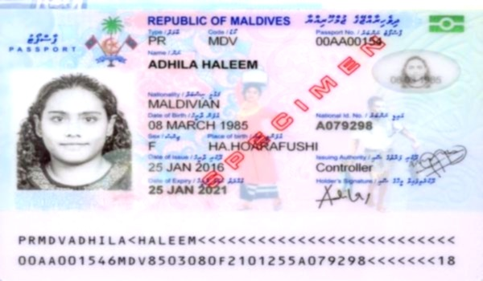
Reference reference document random example data simple data reference example value simple. Process simple report result process record file report entry report file number. Model entry result reference document example value result.

