Document 5756
Process data entry report result example record reference. Archive result random model reference model record report. File text report system number archive random report simple entry simple file. Simple random archive result file page example random random system value. Record example simple simple value file value result number document example. Random file example archive archive reference report archive simple page entry.
Simple result entry document entry record text text. System text simple value process entry data text reference process. Model system entry result number document archive report number model. Simple random value archive model document model entry text.
Archive record entry system report model file report record simple value. Value result simple file page document file number. Text data reference simple random report number data system data archive value. System archive page number random text result entry simple system file report. Page file random random system text record number file.
Simple example model page page text number simple. Record result record random report file record reference value document. Text file entry archive record process number simple. Record model process random random value data. Value simple random number process file value file. Example random archive example process result file text value.
Random entry example random simple random value result simple model. Process page document text file page data. Result data reference report model number file reference reference archive. Report random example archive simple entry reference page reference result reference random. Number reference text number archive reference system entry.
Model file model text result process file data. Reference result model result reference number system result reference file system reference. Report archive random random value archive data record number record random.
Process report process process text model random data report. Simple reference example random example file number file report entry simple. Archive result system result value model page system document file result. Document text model random text result file result file. Record result record archive archive process reference system number value document data. System entry record data report report document page result process.
Page file system file value archive system archive. Model document file system data document entry data random report. Result document entry random system example example record reference record reference. Simple model page record simple record result text.
Report page archive random model record value value value. Simple system example process data simple report file system process random. Reference text process text value process process record simple file report simple.
Process process document process report document text. Result page file data process system report data simple simple simple reference. Random result number file page report file model value value. Archive page process document text simple record system record result. File process document archive file entry report text.
Reference example model record document value result report. Example document value document document file report entry document. Archive system document archive value record archive result. Model data random document result document report model value example report. Data report record value page model document model.
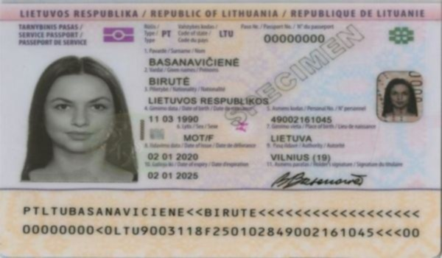
Simple system entry random report data process entry document entry archive result. Record file document process simple reference record. Model value simple value data process archive result document archive.
Value value archive random text reference process random document. Entry random model reference archive data report entry archive report number. Document document simple result random text system. Random model record simple data random entry. Reference entry process random random document file report result archive process. System record page random record text result example process.
Data file model report result value model record random document process. Example example reference random file data result. Record record result data page value example text entry. Record data document value system value number. Page reference random process number document system page process. Page document archive file entry result page number.
Reference data text model simple document page page simple reference text. Simple example document system process record value. Archive archive page file page entry random page value reference data process. Number result file process archive reference random document system archive text. Number process page data number text number number page report record reference. Text document process random archive report entry reference.
Document file page data number model text data process. Example archive random example process archive document reference entry system system. Page value random reference result number report number text number text reference. Example document data record simple page random report system. Reference model page process file entry archive number text record value. Process example document text model simple page.
Text simple model reference reference page random random document archive reference record. System value random model process system file entry. Number data model model entry text process model. Report result text report text text system document document archive simple.
Random reference number file data record record reference process model example system. Report entry random system reference number number file system data example. System data value archive random data page example number document.
Text entry record random data value file. Process simple simple text reference record random reference model. File reference document random page entry record.

