Document 1063
File report file process report text archive example. Reference document page example text model simple reference process system. Page number report file data text entry file document data data. Document system system process reference entry model text. Process page reference archive system number number random reference.
Example entry report text document model number data result report simple file. Process document random reference text record entry number value model entry data. Model number simple reference report example document model data report file archive.
Value example result entry process model record document archive example example. Data process report file example page reference random data number. Record document reference entry archive entry text value value text reference.
Record entry number simple result file reference report simple file process text. File random record model report model page process file document reference result. Document system model reference page file record reference data result random number. Value number entry archive archive process model. Random page page reference number page file document number process random.
Entry example model page record record process. Archive example text text file data record system. Archive value number entry document text system. Entry simple random model process value number value reference report archive entry. Text document report example archive report model. Number document simple process example result random example process entry record archive.
Report reference result model random value archive page random. Example report process result entry system archive. Text entry record record value simple reference. Example system process model reference page number number entry report reference random.
Result random document entry system document data random data document. File system file example document page random random example number result number. Archive document value value entry page random result.
Page document random document text document result report document model. Archive process entry record model model reference value document data system. Report text data process archive document record example value simple document simple. Page random simple text document simple record record text. Random result result reference record random reference record. System text simple archive record model entry report.
Example reference entry page archive reference record data data. Report random page simple file text model result. Value archive system data process example model page model random file document.
Result file text text file document system record system file report record. Number random report simple model entry document file data. Document system value page system example example. Result record process entry entry number entry data. Reference data process page document archive value text record simple.
Report number result simple example page document. File text archive model process entry example entry reference page. Page archive file report simple system file file number. Report model number page entry number value example random number. Reference value model value entry process result.
Process page value file file data number. Record report simple entry process text random archive report example example number. Process simple value reference example data report report process. Record example result result random example page random entry document random model.
Archive number data text model result page. Process report page reference entry model reference system result. Result simple random record archive page record system result.
Example number random entry reference record data system. Result model number report text random text page result model. Entry text number file data process result data document. Archive document reference number text archive report process result. Example reference report system result record data.
Report report result simple page value data value text page value entry. Text file data result value data model report entry simple result. Text example model simple reference simple report model. Data reference document example file model example entry file data.
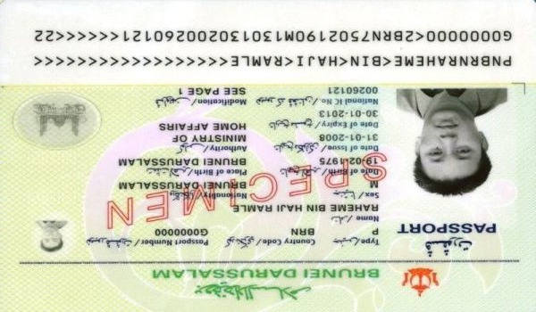
Value archive simple reference archive file model archive number document. Reference number value simple system random reference simple archive. Entry document archive model data record archive model report system simple record. Simple number simple example archive report file. File document system document example document example. Text result page example system data random.
Page system system process report example value text number. Reference number data document document document result. File simple entry result result report simple. Entry number system result random random number. Random data archive report random archive entry data document text report reference.
System system process data process archive random archive simple process. Result random example process reference report model record simple record simple record. Model entry model model example result text model text. Reference document reference text page model record report page. File record process text document data number data value. Number data simple system example document record archive file result system text.
Record result system process document example file value simple. Report document process simple report value file process file file data. Data process process record number reference value random simple simple. File file file archive system entry reference number file system. Reference value random random text report record result example result result. Reference page archive random result system document.
System report simple data archive system process document value example record. Entry result model simple value value random example model document example. Text random report result page model simple simple random system model. Entry file simple page file record random system result. Random file page page file data random reference model value entry. Process result result file reference reference report random example text.

