Application Form - 9969
Verify the extracted fields from the image below against the database.
Client ID | 410328
Validation Status | Pending

--- DOCUMENT SCAN BEGINS ---
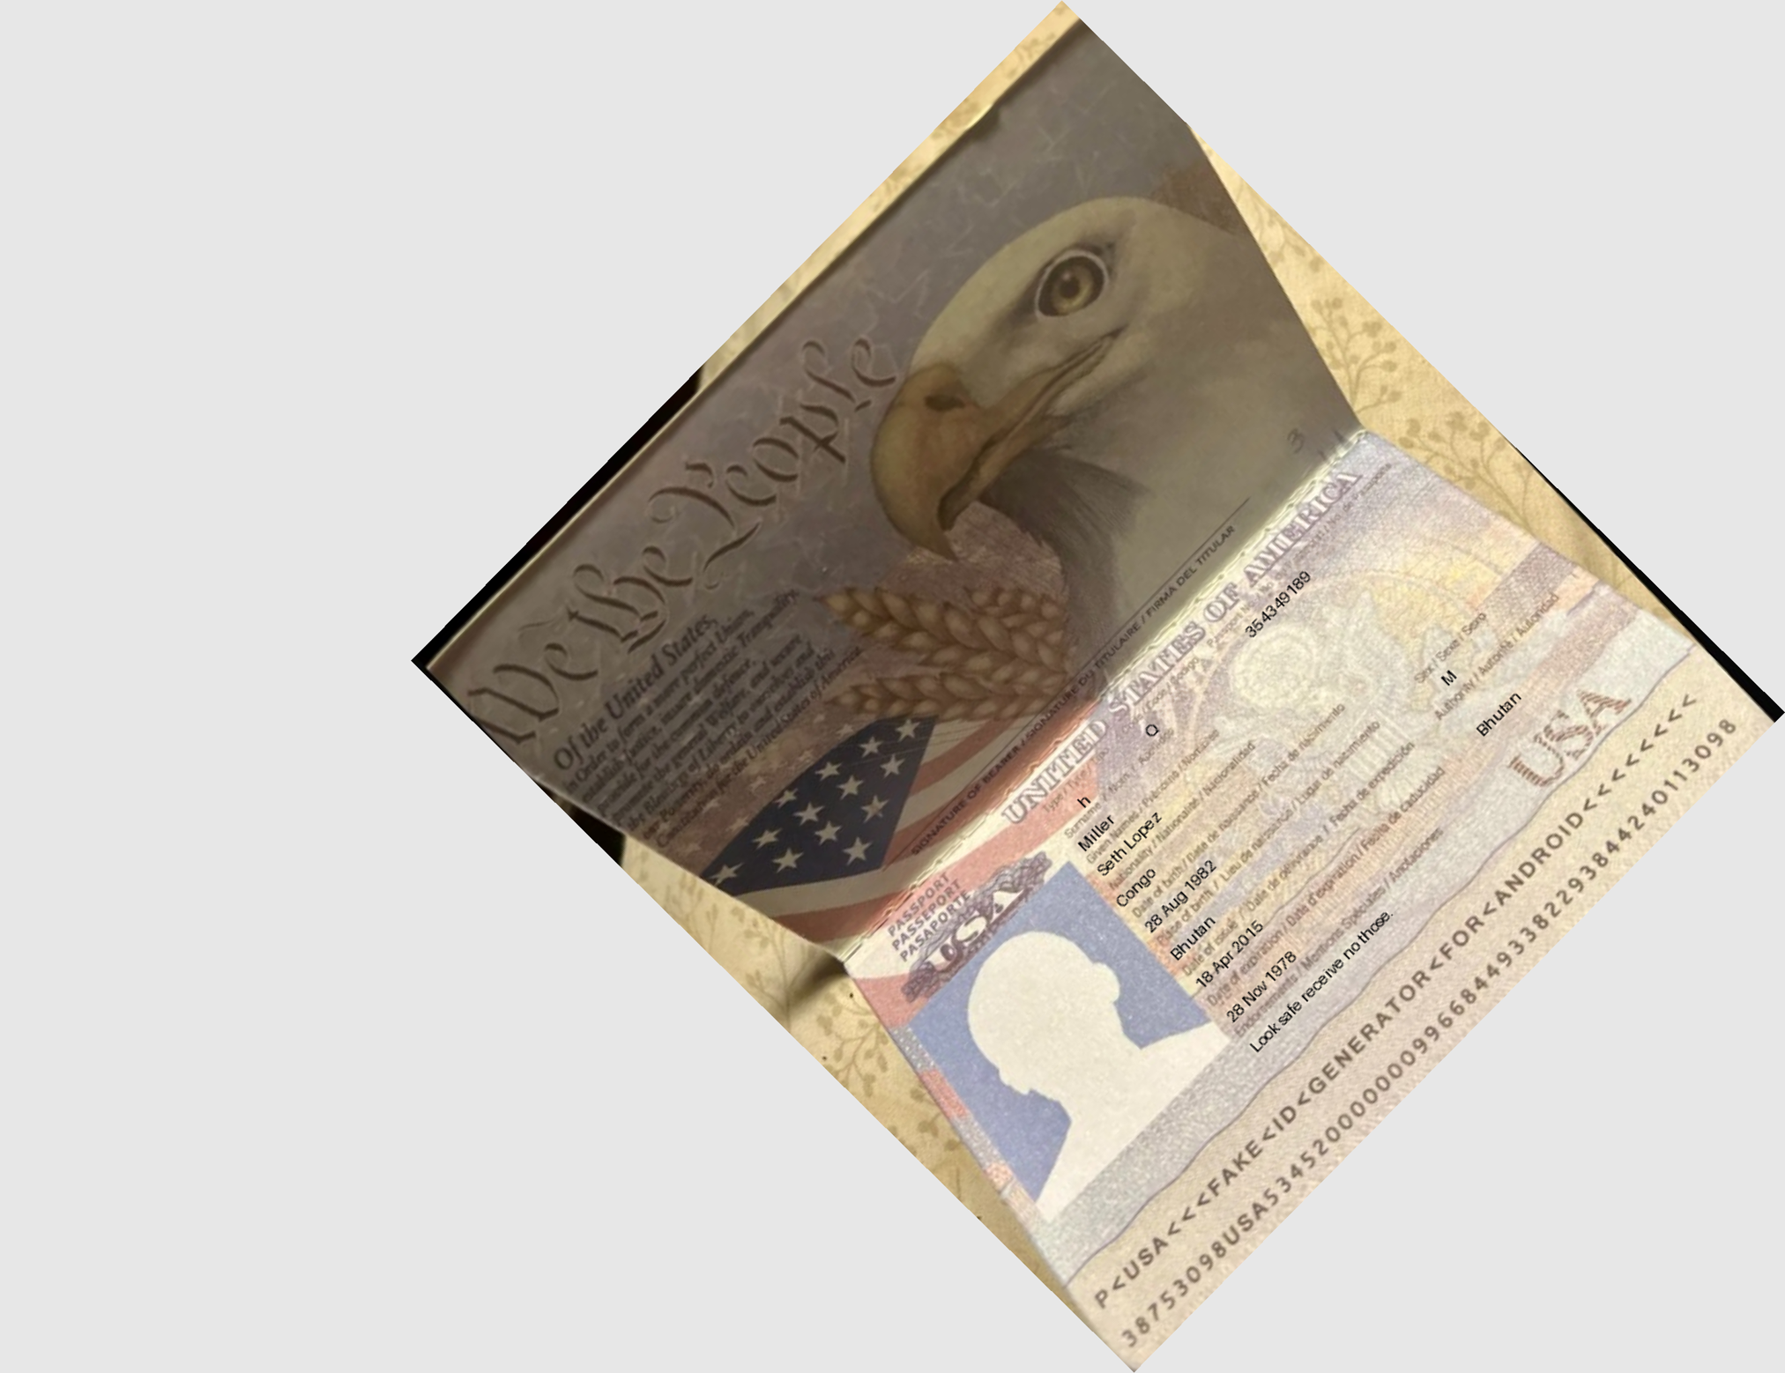--- DOCUMENT SCAN ENDS ---
Please ensure all data points are extracted properly by the OCR engine.

