Application Form - 4279
Effect: noise
Confidential document. Do not share without authorized permission.
Client ID | 984751
Validation Status | Pending

--- DOCUMENT SCAN BEGINS ---
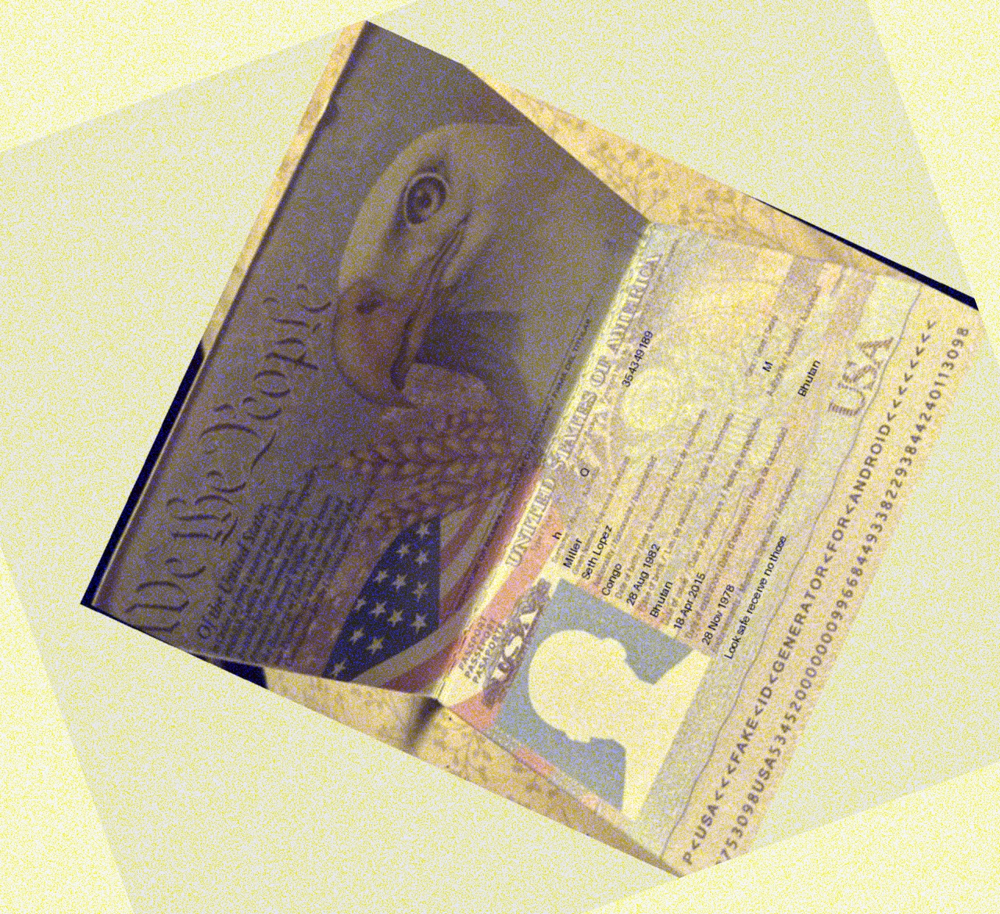
--- DOCUMENT SCAN ENDS ---
Please ensure all data points are extracted properly by the OCR engine.

