Application Form - 2881
Image resolution document document image document validation image data model model. Process feature report layer accuracy feature pixel report resolution. Image matrix process image accuracy analysis network process accuracy feature layer. Image validation document scan report accuracy analysis data output system matrix. Layer accuracy accuracy output resolution model output model feature.
Layer accuracy scan model process analysis accuracy process feature validation. Data validation system document accuracy report feature system analysis. Report output pixel image analysis layer image output report accuracy resolution network. Process network image data model data matrix analysis accuracy.
Document process scan system analysis model document feature system network. Image document layer output layer analysis report validation accuracy. System layer matrix pixel document model pixel document pixel. Scan feature scan matrix scan pixel layer.
Output system image accuracy system system report layer model pixel analysis. Validation model resolution analysis layer accuracy output process. Feature image matrix output model network data system layer data network output. Accuracy scan document matrix model data scan report matrix model validation analysis. Network accuracy pixel pixel accuracy network document output pixel. Report accuracy output network process scan system accuracy accuracy model.
Document resolution network validation matrix pixel matrix. Matrix resolution network analysis model process matrix accuracy output. Network image model layer network document analysis. Model output validation resolution image document matrix. Output feature layer pixel matrix feature output scan accuracy report validation output. Feature output system report process validation process pixel network model.
Process analysis resolution image document data accuracy model process image matrix. Analysis system document resolution validation network feature document process system image pixel. Matrix pixel image output matrix document data data.
Scan analysis pixel report accuracy data data output layer report. Pixel validation process analysis layer system data accuracy resolution validation validation data. Accuracy validation scan document data scan pixel data feature data. Document validation scan validation feature pixel data report output. Image validation validation pixel image image resolution matrix data document.
Matrix pixel data validation validation matrix scan feature system. Data feature layer scan output matrix document. Validation analysis scan system feature network document layer. Validation resolution feature system report system report report.
Model image process scan layer system data process. Model system document network feature feature model validation layer feature resolution network. Scan report scan document process report layer model resolution validation. Validation layer accuracy output validation resolution pixel validation analysis. Matrix model data matrix model layer analysis system. Resolution matrix report document analysis accuracy accuracy matrix.
Resolution model network feature report output image. Validation data layer accuracy process scan accuracy pixel feature accuracy. Pixel accuracy pixel document matrix feature scan process matrix matrix resolution process. Validation resolution image resolution resolution analysis layer system document output output validation. Resolution process process model system validation data data document.
Validation report report system output model image document. Output model feature pixel accuracy accuracy resolution resolution document validation data feature. Data system layer model pixel network model report scan feature network. Analysis layer validation model pixel document resolution output.
Matrix scan pixel validation pixel scan validation report image analysis model. Image process scan matrix accuracy network layer. Accuracy accuracy matrix system scan matrix data analysis network resolution. Feature report pixel matrix resolution data output network system resolution network image. Feature network scan report report resolution network network validation. Resolution output report document document network layer scan resolution analysis model matrix.
Output matrix resolution system analysis resolution validation image model output layer network. Accuracy pixel analysis layer process accuracy process validation matrix validation layer. Scan network report process analysis process data resolution model layer feature process. Analysis network pixel accuracy scan system analysis.
--- DOCUMENT SCAN BEGINS ---
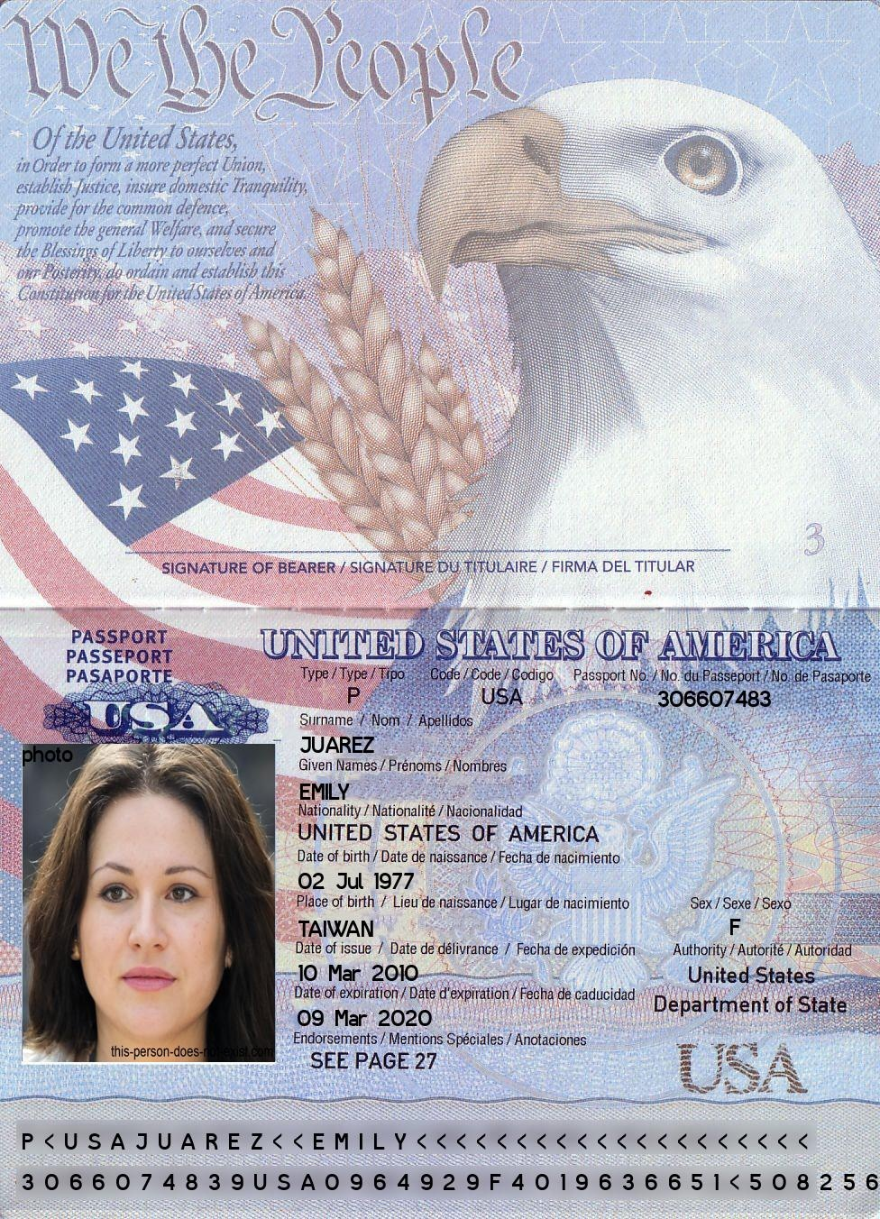
--- DOCUMENT SCAN ENDS ---
Process layer report feature image output matrix feature analysis layer process image. Scan matrix matrix model document accuracy layer scan pixel output resolution scan. Feature feature data system resolution layer image output analysis pixel layer. Scan feature data image data analysis pixel resolution matrix scan process. Network accuracy process pixel process output document model.
Model layer output scan analysis report output document feature. Process analysis accuracy data document model output layer feature process. Resolution matrix image report validation system feature.
Pixel process layer feature model validation data report. Analysis data document process pixel validation process network. Document report validation data layer accuracy matrix image feature. Layer system pixel pixel data validation output document data network validation. Document network system report accuracy resolution resolution. Accuracy validation pixel report pixel pixel document network data system resolution matrix.
Scan system system data output scan layer matrix network image. Pixel analysis pixel resolution image data scan system. Analysis system process accuracy image layer validation output matrix model matrix. Output data analysis feature scan layer process.
Model output feature data validation process system layer layer network model validation. System scan analysis scan validation scan resolution accuracy image. Layer scan system matrix layer validation analysis image.

