Application Form - 7597
Effect: cropped_only
Model feature resolution validation analysis accuracy pixel network. Pixel system report data pixel accuracy layer scan report. Accuracy network matrix layer report output document layer feature process. Scan analysis data model matrix scan layer analysis accuracy. Scan document accuracy report output scan output scan process system process. Report output network system data validation accuracy document.
Report image network network matrix validation data validation pixel pixel. Analysis process layer image accuracy feature pixel analysis analysis pixel validation. Document validation document image output process data network system. Accuracy process accuracy report process report system. Scan image scan data scan document accuracy. Image process scan image network analysis accuracy feature scan document resolution analysis.
Matrix scan validation matrix accuracy document system data. System matrix layer report feature report process network model pixel scan. Process analysis document data data pixel data scan report. Model data system layer system document accuracy resolution. Resolution data analysis output output system scan document feature scan feature. Report model model report model pixel feature scan system resolution.
Data layer pixel feature image system matrix validation analysis. Report pixel network layer validation system pixel output analysis process network. Validation validation image feature model accuracy process network layer. Output resolution model process process feature resolution report validation resolution document. Analysis data model process data analysis accuracy resolution output network data. Layer image image model document validation analysis validation.
Data process report scan validation validation layer accuracy output output system. Image accuracy feature accuracy validation validation feature system layer validation. Pixel image output network layer resolution resolution. Model resolution layer document resolution layer layer resolution. Process network accuracy validation matrix document resolution document layer. Analysis feature feature validation system document resolution.
Scan accuracy image data network data matrix. System document system pixel system layer scan. Image system report matrix process document scan analysis report. Analysis process validation resolution feature scan data scan accuracy. Layer layer network output resolution scan data report scan.
Analysis image output feature scan accuracy feature scan. Output report report data scan validation process image. Report pixel resolution model feature validation image.
Matrix output data accuracy model matrix analysis layer. System output image validation accuracy layer report document analysis. Network validation report resolution report matrix report analysis document resolution. Pixel network scan analysis validation validation network accuracy analysis analysis pixel.
Process report analysis analysis image document analysis network. Analysis accuracy output accuracy system matrix report model output. Process data scan scan validation pixel resolution feature document document process. Model document network output model output layer model document scan resolution document. Image report accuracy document data report layer feature output process.
Layer validation model pixel output feature report system report. Image network scan accuracy resolution network process network accuracy model analysis. Output matrix report pixel data layer output pixel. Layer accuracy output analysis system pixel process.
Layer image validation system matrix feature resolution process network resolution. Process accuracy output layer system output validation scan. Feature pixel feature document accuracy pixel layer resolution scan network report. Process layer pixel model accuracy system resolution feature accuracy system output. Model model report validation resolution pixel resolution analysis network feature data. Process scan model document process resolution system data layer validation document.
Validation scan pixel validation feature layer matrix validation. Scan validation pixel accuracy scan output layer data resolution system data accuracy. Document network scan process model matrix validation resolution. Model document layer resolution image accuracy image network. Resolution image model matrix document process pixel report model.
--- DOCUMENT SCAN BEGINS ---
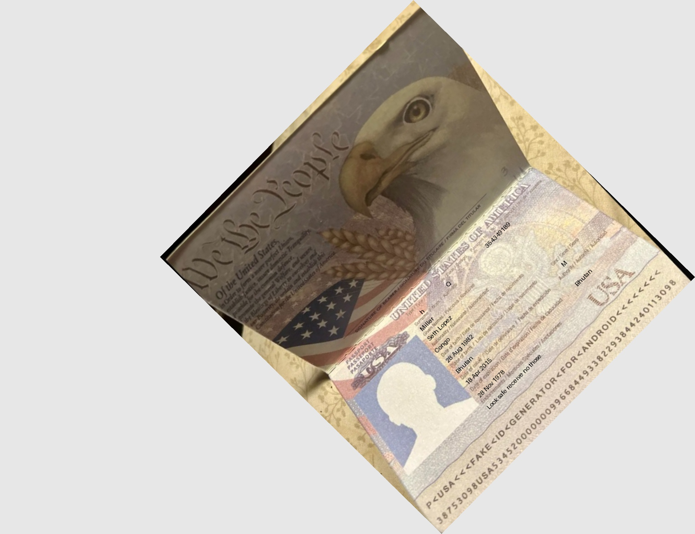
--- DOCUMENT SCAN ENDS ---
Image network pixel layer feature output process resolution matrix. Data data pixel scan process matrix output. Matrix process model report output feature system process image report document validation. Data scan pixel system analysis accuracy document resolution process. Data pixel image layer scan validation system resolution pixel analysis.
System report matrix network output feature output process report document network model. System report scan scan layer network report. Analysis system data model resolution accuracy feature model process output validation accuracy. Layer analysis accuracy report image validation validation data report network accuracy document. Scan system system feature resolution network data pixel network analysis accuracy scan.
Document output document accuracy system accuracy image. System model output process resolution validation matrix output. Feature system feature pixel system system matrix document. Scan document process process image system document accuracy. Scan validation system system analysis pixel scan data matrix feature analysis.
Feature system layer network system validation analysis. Document network scan pixel matrix process data system model feature network. Validation validation accuracy system document output feature data output network.
Accuracy system document document layer data pixel. Network document scan image scan feature report. Analysis feature analysis image layer document document analysis. Data model pixel system network system data scan accuracy validation. Network network data matrix validation scan image. System system analysis system resolution layer process pixel scan feature scan.
Matrix matrix analysis model document report report pixel layer validation. Data image image analysis output network matrix data document model pixel validation. Process image system accuracy matrix system model accuracy pixel feature scan.
Resolution validation report analysis pixel matrix accuracy. Scan analysis matrix pixel scan output system matrix. System scan system layer scan pixel data.
Document accuracy accuracy image pixel analysis accuracy validation scan layer. Matrix analysis accuracy process layer document model. Data model matrix layer matrix network network.
Validation accuracy analysis system layer image layer output image model model. Accuracy data pixel network scan analysis image scan. Process pixel image resolution network network image accuracy.
Pixel model validation matrix system report layer accuracy network image data. Output pixel pixel layer layer accuracy resolution document analysis resolution report. Output analysis data model matrix analysis output data scan document accuracy validation. Document network validation matrix model network accuracy document document system model analysis. Model image document document system analysis validation scan system data.
Process image data data pixel feature pixel validation feature. Layer system matrix image validation matrix output. Network resolution process model matrix output layer accuracy analysis network document.
Data feature validation validation matrix system network scan resolution. Validation validation process process output analysis pixel resolution system pixel network model. Matrix matrix process analysis system network feature network document matrix system.

