Application Form - 5833
Effect: blur
Confidential document. Do not share without authorized permission.
--- DOCUMENT SCAN BEGINS ---
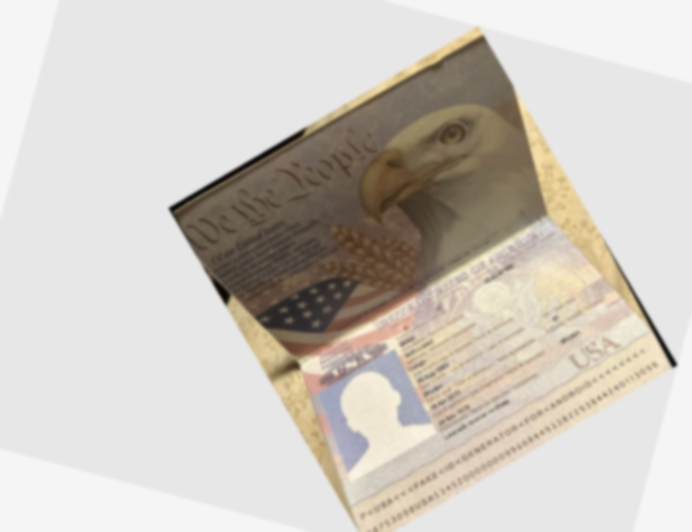
--- DOCUMENT SCAN ENDS ---
Please ensure all data points are extracted properly by the OCR engine.

