Application Form - 6273
Effect: noise
The following scan was provided during the registration process.
--- DOCUMENT SCAN BEGINS ---
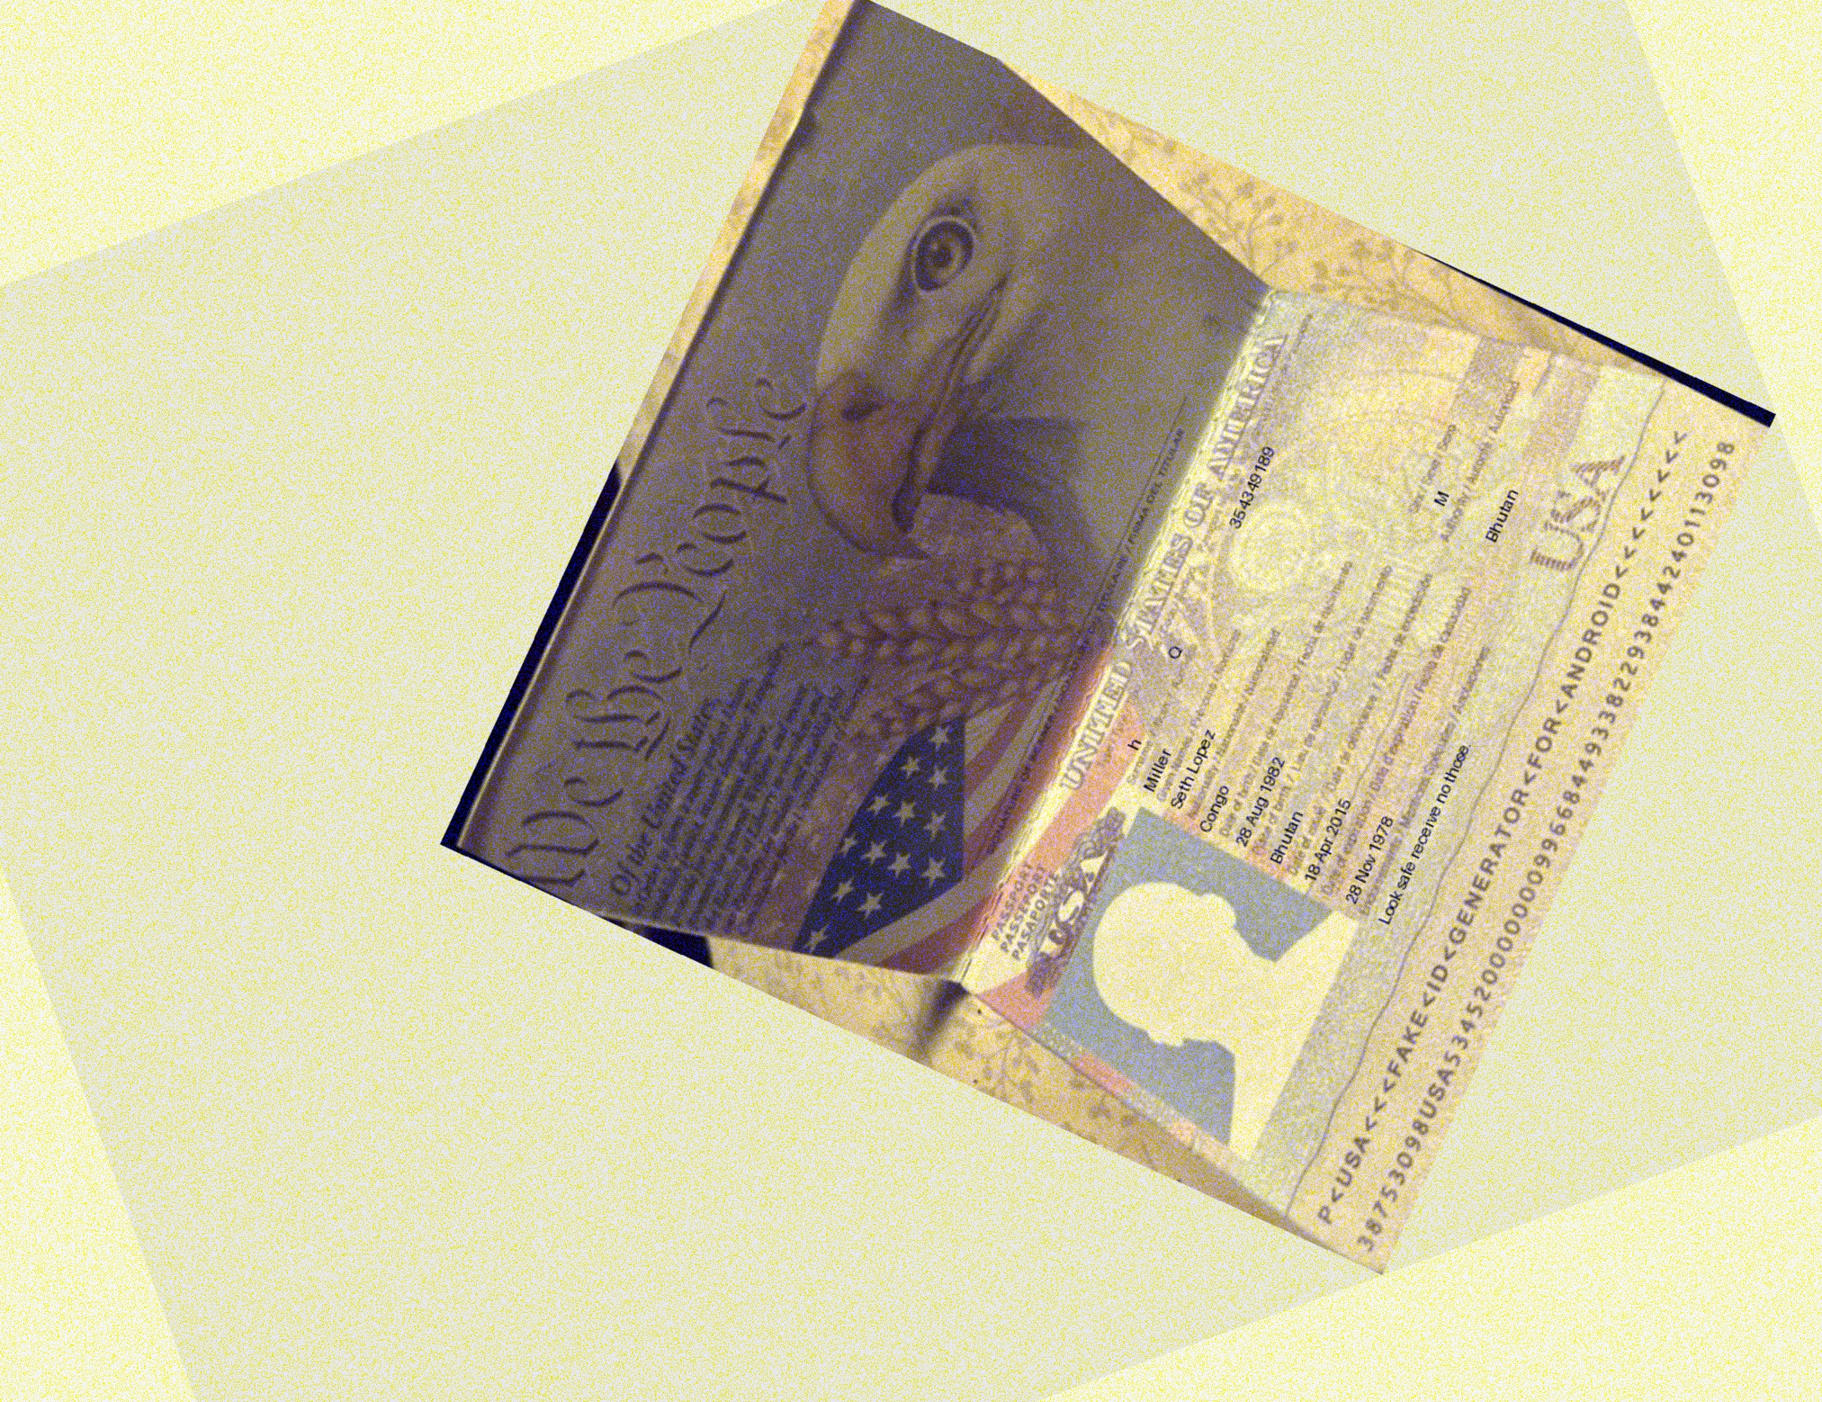
--- DOCUMENT SCAN ENDS ---
Please ensure all data points are extracted properly by the OCR engine.

