Application Form - 3526
Verify the extracted fields from the image below against the database.
Client ID | 966591
Validation Status | Pending

--- DOCUMENT SCAN BEGINS ---
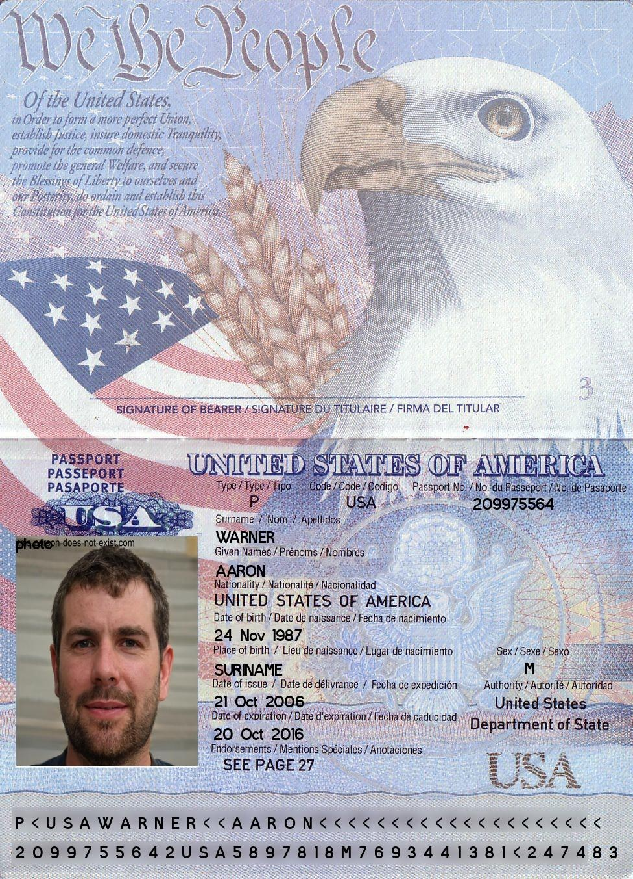
--- DOCUMENT SCAN ENDS ---
Please ensure all data points are extracted properly by the OCR engine.

