Application Form - 6478
Please find the attached identification document for the applicant.
Client ID | 895156
Validation Status | Pending

--- DOCUMENT SCAN BEGINS ---
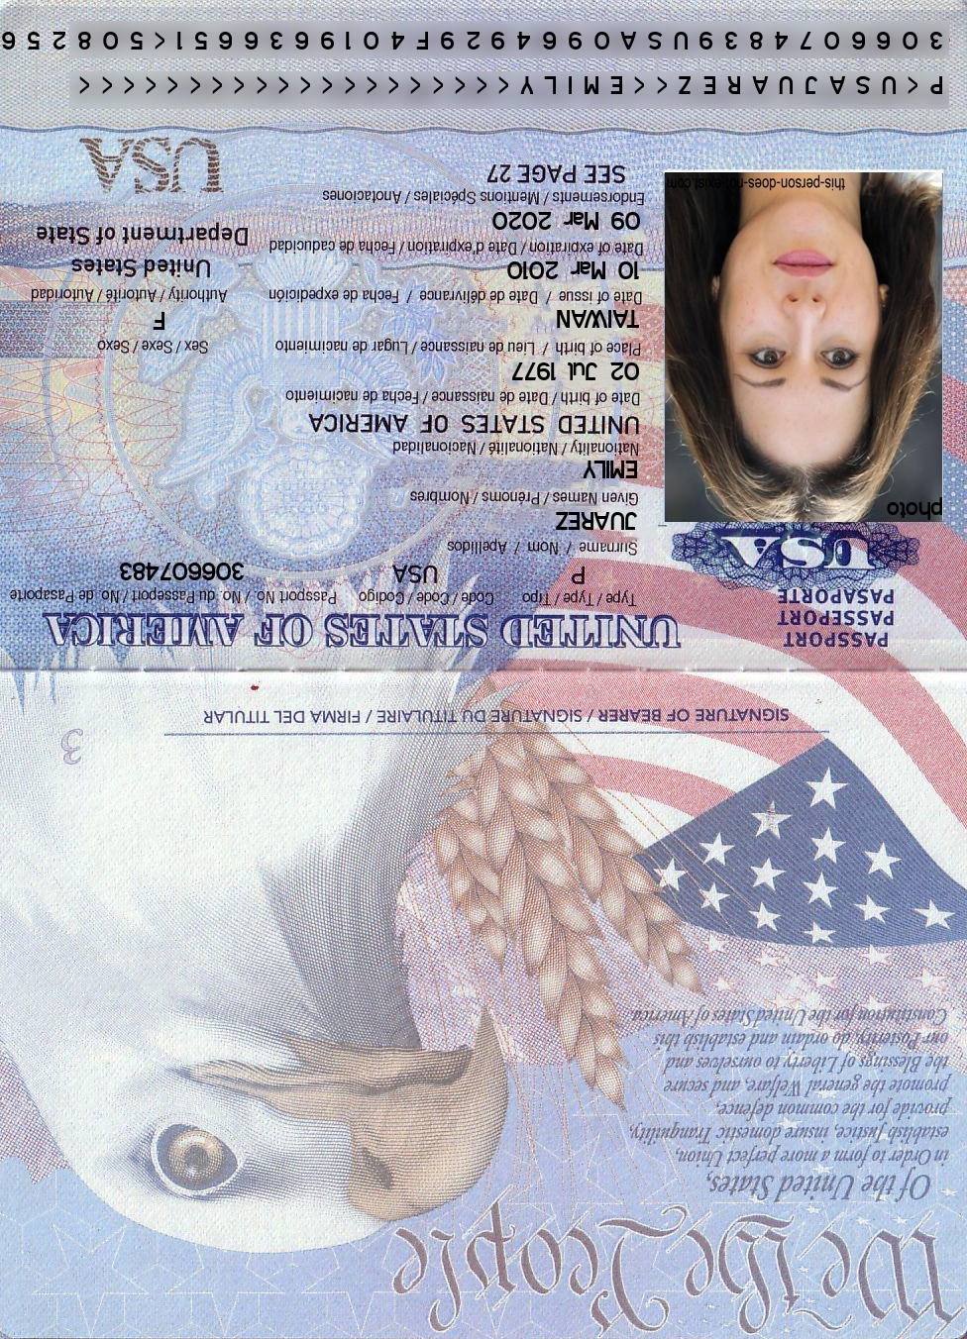
--- DOCUMENT SCAN ENDS ---
Please ensure all data points are extracted properly by the OCR engine.

