Application Form - 2533
Verify the extracted fields from the image below against the database.
--- DOCUMENT SCAN BEGINS ---
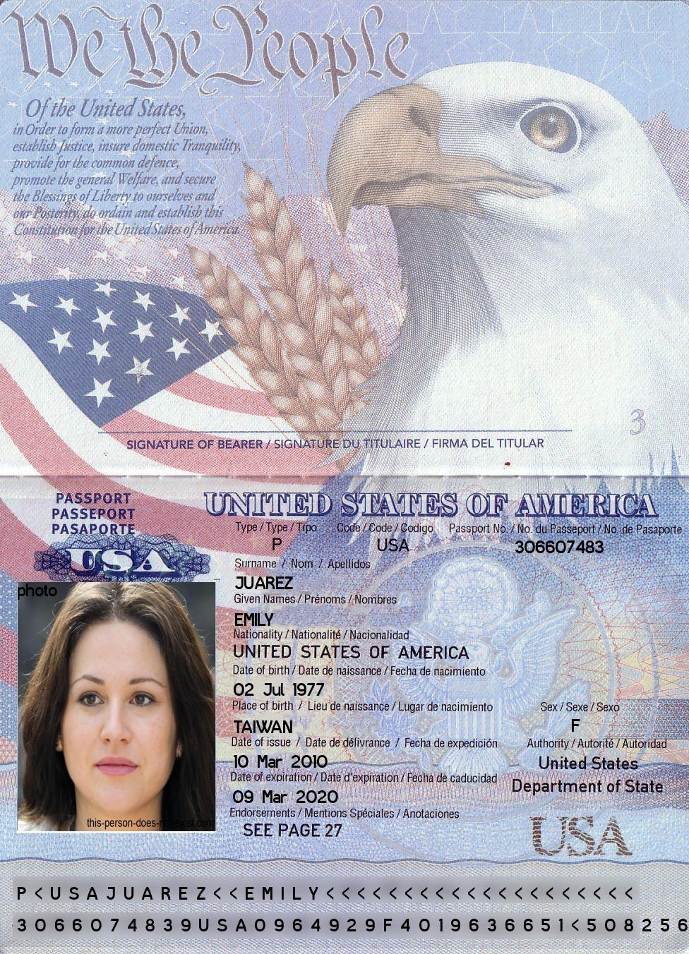
--- DOCUMENT SCAN ENDS ---
Please ensure all data points are extracted properly by the OCR engine.

