Application Form - 3007
The following scan was provided during the registration process.
Client ID | 789872
Validation Status | Pending

--- DOCUMENT SCAN BEGINS ---
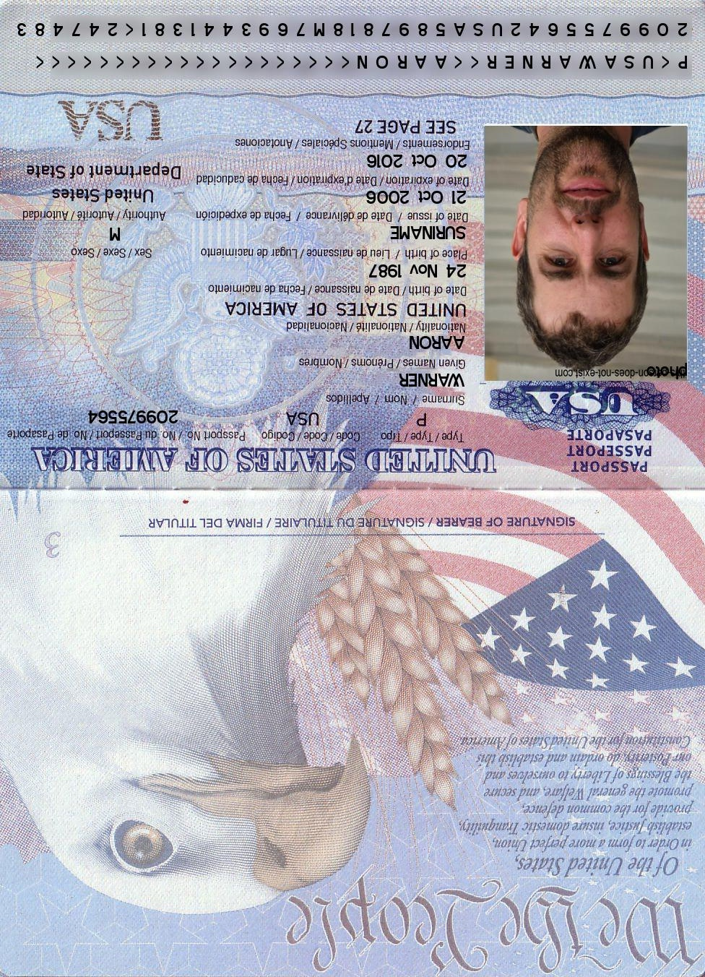
--- DOCUMENT SCAN ENDS ---
Please ensure all data points are extracted properly by the OCR engine.

