Application Form - 1413
Confidential document. Do not share without authorized permission.
Client ID | 999210
Validation Status | Pending

--- DOCUMENT SCAN BEGINS ---
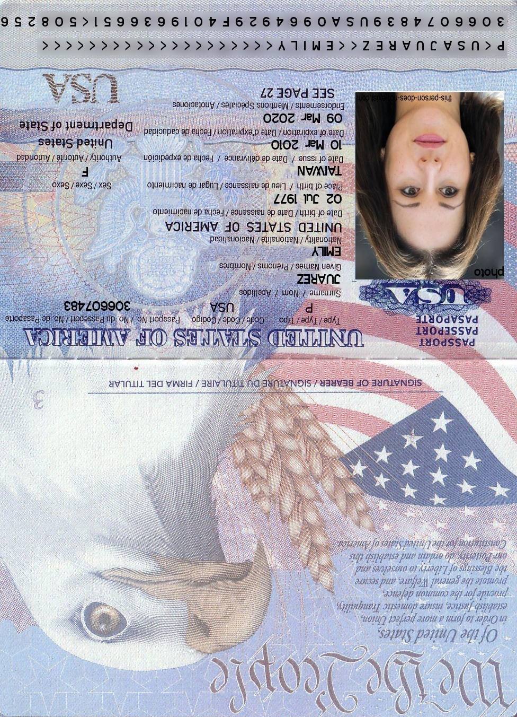
--- DOCUMENT SCAN ENDS ---
Please ensure all data points are extracted properly by the OCR engine.

