Application Form - 1501
Applicant submitted the passport copy for identity verification.
--- DOCUMENT SCAN BEGINS ---
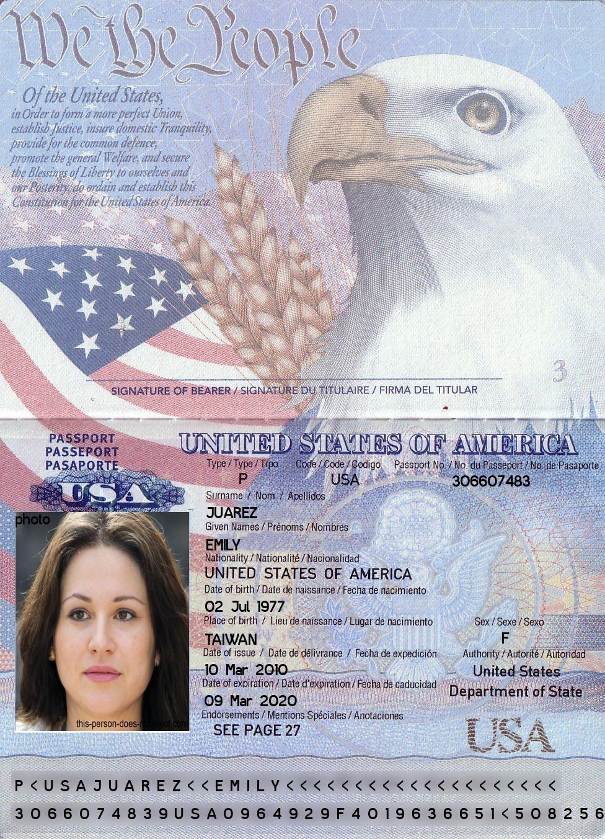
--- DOCUMENT SCAN ENDS ---
Please ensure all data points are extracted properly by the OCR engine.

